Curriculum Plan: Year 5/6 – Autumn 1 2026

Hello and welcome back to a full packed Autumn term 1! We hope you have had a lovely Summer break, and everyone is ready for the AutumnTerm. This half-term will see our Year 6s going on residential and a trip to Quarry Bank Mill Museum. Please see below for the topics that your children will be covering up until October half-term.

As always, if you ever need to speak to your child’s class teacher, you can always grab us on the door in the before or after school. If not please feel free to email the school on info@dukenorfolk.derbyshire.sch.uk and address it to your class teacher.

Thank you as ever for continued support.

UKS2 Team

Attitude: Being Me in My Word

Spirit: Love

Knowledge: See below

English  This term we will be:  Continuing our work from transition day on The Mysteries of Harris Burdick where children will be writing a missing person’s report and a witness statement regarding his mysterious disappearance. We will also be reading and focusing our written work on ‘Street Child’ by Berlie Doherty.  As well as working on:  - Spelling (Spelling Shed)  - Reading (Individually and VIPERS)  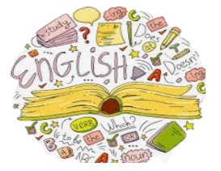  - Speaking and Listening  - Research skills | Maths    This term year 5 will be working on:  - Place Value  - Addition and Subtraction  - Multiplication and Division  This term year 6 will be working on:  - Place Value  - Addition, Subtraction, Multiplication and Division  As well as:  - Arithmetic  - Times tables (TT Rockstars)
Foundation Subjects

Science: Hom important is our heart and circulatory system?
History: What impact did the Industrial Revolution have on our local area?
DT: What makes bridges strong and fit for purpose?

Computing: How could we create a resource or strategy to help other children limit the negative effects of technology?
RE: Why do people think God does or does not exist?
French: Portraits – Describing In French

PE, Swimming and Forest Schools  PE Days:  Oak class:  Tuesday (Swimming), Thursday    Willow class:  Monday, Thursday  Beech class:  Wednesday, Friday (Forest School)  This term we will be working on:  Fitness  Swimming  Adventurous Activities (Forest School)  Please ensure your child has the correct PE kit in school, as well as having hair tied back, and jewelry removed. | Trips/Visits/Visitors  In the Autumn term we have the following visits or visitors (more information will follow):  Quarry Bank Mill  The children will be able to look around the historic mill and appreciate the working conditions the Victorian workers experienced. They will also get to experience life as an apprentice.  Year 6 will be going on their residential to Quarry Bank Mill.  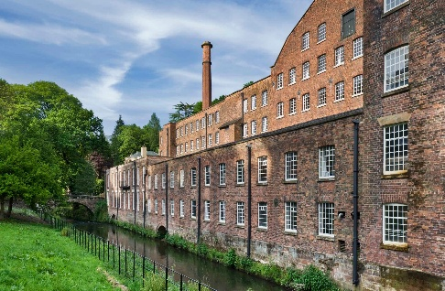
Home Learning
Reading: We value reading as one of the most important skills that your child will learn during their time in Dukes. We recommend that you try to read with your child each evening, if possible. Make sure you sign their reading records so that we can reward them for their efforts (and yours) in school.
Homework: Your child will need to log in to ‘TT Rockstars’ to access their weekly Maths homework and ‘Spelling Shed’ to access their Spelling homework. Year 6 students will receive SATs workbooks later in the year. Expectations around these workbooks will be made clear when they are given out.
How you can help
Even at Year 5/6, it is important to read with or to your child for enjoyment. Help your child to learn spellings. These are tested on a Friday.
Encourage your child to be organised with homework/letters/equipment. It is good preparation for secondary school.

Talk to your child about what they are learning in school.
Read newsletters and messages and subscribe to the school calendar.

Please also support us with our high expectations of behaviour, independence, and uniform.

