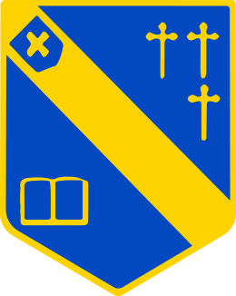
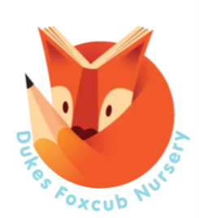
Duke of Norfolk
Early Years department
Foxcub Nursery

We hope this booklet provides you with much of the information you need to help your child make a smooth and settled start at our school. If there is any information you need that isn’t provided here, please look at our school website which has lots of information about all aspects of school life.

Welcome to the Dukes family!

Our theme across the Early Years Foundation Stage (EYFS) department is linked to our beautiful school forest. We have 2 classes, the Sycamore class, and the Chestnut class. Information about your child’s class and the staff members linked to that class will be sent via the school text messaging system once the classes have been confirmed. The Foxcub Nursery children will be placed in both classrooms and will be taken into the Foxcub room where the children will sing songs, share stories and number time with our nursery teacher Mrs. Blower.
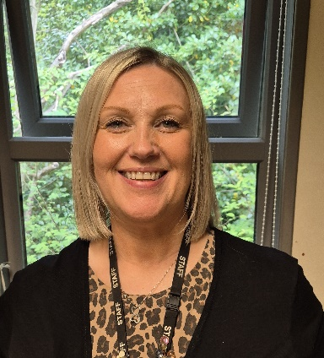
Daily times and routines
8:45am – doors open
9am – morning registration
9:30am – Singing/stories/social time
10:30am – snack
10:45am – maths stories/songs
Mrs. Blower
11:45am – lunch break
1pm – afternoon registration
1.10pm – free choice activities and planned learning/topic time
3pm – story time and singing
3:25pm – home time
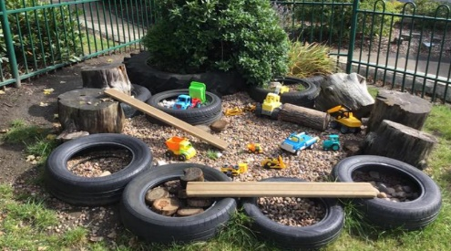
General information
- Each half term, you will be able to access a curriculum plan on the school website, showing you what your child will be learning.
- In our school, we use the highly successful phonics programme, Read Write inc. In the Summer term Foxcubs will learn the letter picture in preparation for Reception.
- PTA (Parent Teacher Association) – all parents are automatically a member of the PTA and we hope you will all try to get involved.

- In EYFS, our key method of communication is through an electronic platform called Seesaw. With your permission, Seesaw enables us to send messages straight to your phone, along with pictures and videos of your child learning in school. Other ways we communicate with our Dukes family are via notes and letters in your child’s book bag, the school text messaging system, regular school newsletters which are posted on the school website and our school Facebook page.
- If your child is unwell and cannot attend school, please contact the school office before 9am on 01457 852635 or email absence@dukenorfolk.derbyshire.sch.uk
- The government currently provides a fruit snack for every child up to year 2, this can range from bananas, pears, apples, tomatoes, and sugar snap peas.

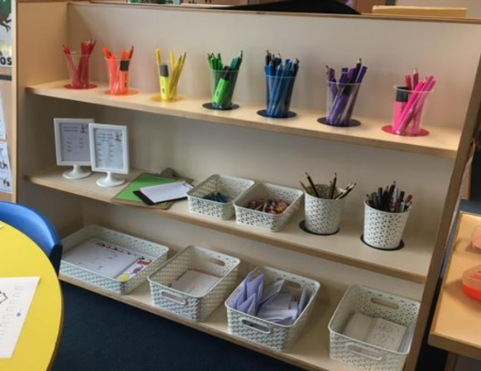

School dinners
The children eat their lunch in the dinner hall each day. As they enter the hall, the children pick up a tray and walk to the kitchen hatch to choose their dinner. A lunch menu is in your pack or you can access it by going onto Derbyshire County Council website. It’s a good idea to talk to your child about what is on the menu the following day to help them decide what they would like to eat. The children are encouraged to try new foods and eat as much as they can. Whilst the majority of our children have a school dinner every day, they may bring in a packed lunch if they prefer. Reception children are entitled to government funded ‘universal free school meals’ so your child will not need to bring a packed lunch unless your child would like one. Meals for children in Nursery are unfortunately not funded; your child will need to bring a packed lunch or you may pay for a school meal which is currently charged at £3.25 per day. You can pay for these on the ParentPay App.

Top tips for starting school
- As parents and carers you are your child’s first teachers. You have a powerful influence over your child’s early learning. You can support your child at home by:
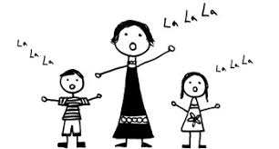
- Singing lots of nursery rhymes and playing around with familiar songs, changing words and phrases.
- Playing with alliteration. Your child’s name is a good place to start, for example ‘Milo makes music,’ ‘Carly caught a cat,’ ‘Jolly Jessie jumped,’ ‘Daddy is doing the dishes,’ ‘Mummy munches a muffin’.
- Collecting items that start with the same sound from the park, garden and around the house.
- Going on a listening walk – listen to different sounds: cars revving, people talking, birds singing, dogs barking. When you get home, try to remember all the sounds you heard.

Early reading
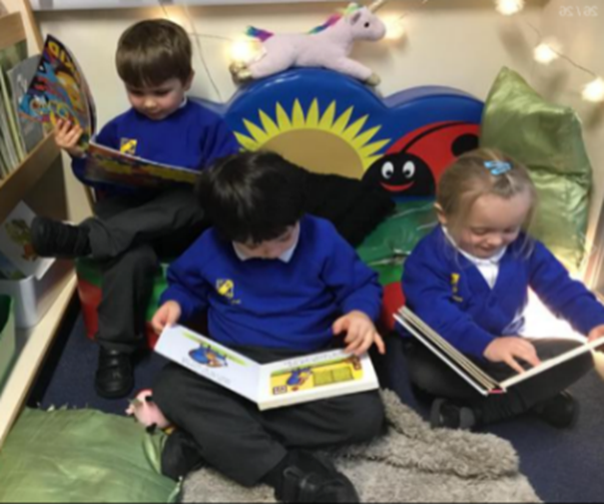
- Share lots of stories. Make it a special time, using silly voices, using loud, soft, scary voices etc to bring the stories to life. Talk about what is happening in the pictures.
- Try to make sure your child sees you reading.
- Join the library if you haven’t already.
- Read favourite books over and over again!

Early writing – The importance of mark-making

Your child will notice adults and older siblings around them reading and writing and they will want to copy them. Mark -making is the first step towards writing. Mark-making in the early stages is closely linked to physical development. The more opportunities your child has to develop large and small movements in their arms, hands and fingers, the easier it will be to make marks with a variety of tools. Activities such as digging, ‘painting’ outdoor surfaces with water and a large brush, sweeping, and swishing a scarf through the air in different shapes will help develop large motor movement. Small or fine motor movement will be needed to hold pencils and pens correctly. Hanging out the washing and playing with pegs, picking up little pieces of cereal and grains of rice with fingers and tweezers will help develop the pincer grip needed for writing.

Talking
Talking is a vital precursor to reading and writing. Ask and answer questions, talk about your day or retell your news together to other family members, talk about yesterday or upcoming events, make up stories, talk about what you are doing (for example while cooking or tidying up!) Encourage clear speech sounds, if your child is finding some sounds difficult, repeat the correct sound clearly and let them watch your mouth forming the sounds.

Things your child will need
- Water – we encourage children to bring a bottle of water with their name on to drink during the day (no juice please).
- A coat with a hood – the children will go outside every day, even if it is raining, so please ensure they have a suitable coat.
- A school bookbag is essential. Your child will be given a school bookbag when they come for their first “Stay and Play” session – a gift from us!
- These bags are suitable for any letters or work to be brought home in, and a change of clothes. Please do not use rucksacks or any other large bags as we really do not have the space for them in school.

School Uniform

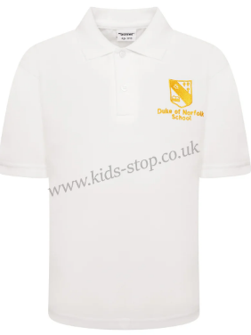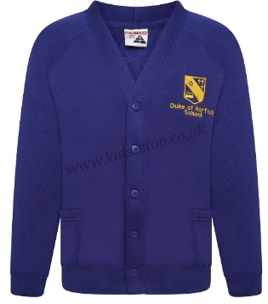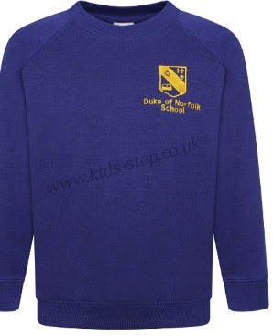

All children are expected to wear school uniform. Please ensure that all items of clothing and footwear are marked clearly with your child's name. Please put your child’s name on everything – one sweatshirt looks very much like another!

School uniform can be purchased from Bulldog Fashions in Glossop. Reception children will need a white polo shirt (with or without logo), a royal blue jumper or cardigan, grey trousers, shorts or dress/skirt. It is suggested for Nursery children that they wear black leggings or jogging bottoms.

PE Kit

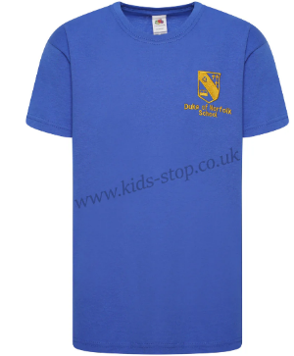

Reception children will need a plain royal blue T-shirt (with or without school logo), plain black shorts, black pumps/trainers. Nursery will only need a pair or pumps or trainers.

And finally…
The Early Years Team are here to support you and your family. If you have any questions or comments, please speak to us. We are usually available to talk to you at the end of the day once the children have all been released, or you can contact us using the SeeSaw app.

We cannot wait to meet you all and we are looking forward to another exciting year in the Early Years Foundation Stage!

