- All new vocabulary will be displayed on Working Walls in the classroom environment.  - WAGOLL to use for whole class teaching demonstrating the skills and vocabulary expectations.  - Learning is progressive and therefore texts and skills need to be taught in chronological order.  - New ambitious vocabulary will be introduced and pre taught by staff weekly using a range of adjectives, verbs, nouns, adverbs. |  |  | “Dictation gives children opportunities to practise and apply their spelling knowledge and segmenting skills, without having to compose sentences by themselves. It requires them to distinguish between the sounds they hear in order to choose the correct graphemes to represent the sounds and to form the letters correctly.” Research and Review, May 2022
Autumn 1
Science How does the Earth move in relation to our moon, other planets, and the Sun? |  |  | History - How was Henry VIII able to break with Rome?
Text  and Genre | Retell  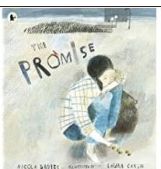 | Diary Entry for the start and the end of the story. |  | Retell- Field trip to the Moon  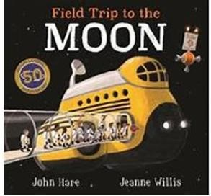  (Written from the point of view of the aliens?) | Non- Chronological Report- The Planets  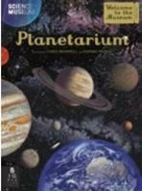
Year 5 Genre Progression | Describe setting, characters and atmosphere.  Describe the character and include their feelings using show don’t  tell. Use show don’t tell to build  suspense. Use short sentences for  tension. Cliff hanger questions.  Use dialogue to convey a character and advance the action.  Use organisational and presentational devices that are relevant to the text type, for example, underlining / uppercase. | Past perfect tense.  Organised into paragraphs, with the day’s events developed and expanded through descriptive detail.The opening locates the events precisely in time and the piece concludes by looking ahead to the following day.  Language choices to reflect the theme (historical etc.).  Include a quote.  Move between tenses within paragraphs – own choice. |  | Key influences in the person’s life, (their relationship with other.  people and who inspired them).  Historical famous characters. Link to whole school theme / local hero. | Independent research.  Select own sub-headings.  Use examples for presentation/structure.  Include a glossary.  Consider audience (fun, factual etc).
Year  6  Genre  Progression | Author’s style of writing and use appropriate author’s voice  Consider purpose and audience Changing tenses – flashback | Multiple entries  Include suspense  Changing moods and emotions  Maintaining tense and writer’s voice  Subjunctive form  Active and passive voice  Formality for effect  Consider the audience, purpose and write using the appropriate author’s voice |  | Own inspirational character  Own research / link to interviews  Includes links to inferences of the time | Presentation/structure to be independently planned  References sources of data  Independent research  Use a range of presentational devices (table, diagram)  Include questions for intrigue/to entice the reader  Author’s style of writing and use appropriate author’s voice Consider purpose and audience

Y  ear 5  Grammar and  Punctuation | Insert whole sentences to describe setting and characters.  Use show don’t tell to build suspense, to introduce a dilemma in a story and convey a character’s emotions.  Include direct speech in my stories  but changing where the reporting clause is in the sentence |  |  |  |  | Link sentences and paragraphs using coordinating and subordinating conjunction.  Use noun phrases with a modifier, choosing words carefully to really ‘show’ the reader what I am describing. |  |  | Use relative clauses beginning with who, which, where, when,  whose, that or with an implied (i.e.  omitted) relative pronoun.  (I think this skill is still relevant.) |  | Use a colon to introduce a list within a sentence.  Punctuate bullet points consistently in non-fiction.
Y  ear 5  Grammar and  Punctuation | ( | beginning | , middle, | end | ).
Year  6  Grammar and  Punctuation | In narratives, describe settings, characters and atmosphere.  Inverted commas and other punctuation to indicate direct speech. |  |  |  |  | Use commas to demarcate relative clauses, reporting clauses, embedded clauses and to separate the subordinate clause from the main clause where the subordinate clause comes first.  Make purposeful choices with adverbs, adjectives, ENPs and adverbials to make writing more descriptive. |  |  |  |  | Use colons to introduce a list and punctuate bullet points consistently.  Use sentences with lists to give a number of pieces of information succinctly (e.g., component parts, features of locations…)
 |  |  |  |  |  | Handwriting Year 5 - Adapt handwriting style according to the purpose of the writing.
 |  |  |  |  |  | Handwriting Year 6 - Maintain legibility and consistency in joined handwriting when writing at speed.
Year
5

Spelling

Year
6

Spelling

Autumn 2
Science – How do living things evolve and change over generations? |  |  |  | History - How significant was the English defeat the Spanish Armada as a turning point in British history?
Text and  Genre | Character Description  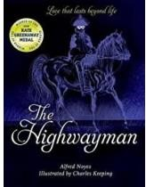 | Setting Description | Tim’s Diary Entry the night of the betrayal.  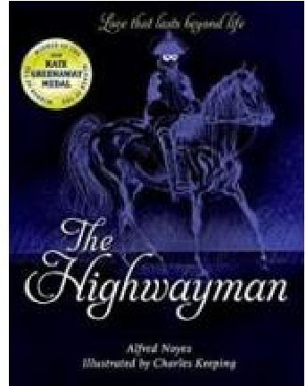 |  | Instructions for a Happy Ending  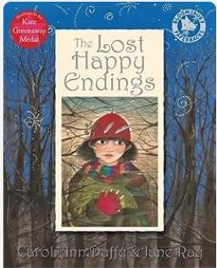 | Own version of The Snow Hare or other winter animal.  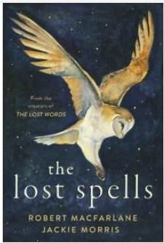
Year  5  Genre Progression | Written in the past / past tense.  Describe the character and included their feelings by using show don’t tell.  Including speech and moving the action on. | Include two adjectives in my fronted adverbial of place.  “Under the ancient, crumbling bridge,”  Using rich description to interest the reader such as metaphors, personification, and onomatopoeia. | Past perfect tense.  Organised into paragraphs, with the day’s events developed and expanded through descriptive  detail.The opening locates the  events precisely in time and the  piece concludes by looking ahead to the following day.  Language choices to reflect the theme (historical etc.).  Include a quote.  Move between tenses within paragraphs – own choice. |  | Informal / formal instructions could be humorous or formal.  Hook the reader in the introduction  Sophisticated / appropriate use of adverbs / adjectives Awareness of the audience Add a recommendation.  You may want to close your eyes for this next step. | Acrostic poem  Each line starts with a capital letter that spells out the poem’s theme vertically.  The letters that spell the word can also be placed at the end or within the line.  Like any poem, acrostic poems don’t need to rhyme, but all the other poetic devices like  alliteration, similes and rhythm can be used in them.
Year  6  Genre Progression | Written in the past / past tense.  Describe the character and included their feelings by using show don’t tell.  Including speech and moving the action on. | Power of three fronted adverbials Personification of the weather  Evocative language to create a mood, strong feelings, memories, or emotions back Consider the audience, purpose and write using the appropriate  author’s voice | Multiple entries  Include suspense  Changing moods and emotions  Maintaining tense and writer’s voice  Subjunctive form  Active and passive voice  Formality for effect Consider the audience, purpose and write using the appropriate  author’s voice |  | Develop an introduction – add background.  If appropriate add personal advice using parentheses  Select own title, headings and presentational devices  Use pictures, diagrams, flow charts and symbols (if appropriate) to present information independently  Use brackets to add asides  Author’s style of writing and use appropriate author’s voice.  Consider purpose and audience.

Y  5  Grammar and  Punctuation | In narratives describing settings, characters and atmosphere and integrating dialogue to advance the action. | Use more sophisticated metaphors to describe things in my writing.  Use a metaphor as an opener.  Use personification.  In narratives describing settings, characters and atmosphere and integrating dialogue to advance the action.  Use ISPACED (ing word, simile, preposition, adverb, conjunction, ed word, dialogue) to open a sentence. | Confidently use the correct tense throughout a piece of writing  (even if it means a change of tense). | Include complex sentences, which start with a subordinating conjunction followed by a comma. |  | Consolidaton of previously taught skills.
Year  6  Grammar and  Punctuation | Use a range of figurative language  (metaphors, onomatopoeia, personification). | Use a range of figurative language  (metaphors, onomatopoeia, personification).  Use simple sentences to build tension. | Use hyphens and ellipses. | Use sentences with lists to give a number of pieces of information succinctly (e.g., component parts, features of locations…)  Add a comma to avoid ambiguity and change the meaning of a single clause sentence with adverbials. |  | Consolidation of previously taught skills.
Handwriting Year 5 - Adapt handwriting style according to the purpose of the writing.
Handwriting Year 6 - Maintain legibility and consistency in joined handwriting when writing at speed.
Year 5

Spelling

Year
6

Spelling

 | Spring 1
 | Science- How do plants reproduce? Sci 3e: Can you classify plants and explain your reasoning? |  |  | Geography – How have earthquakes and volcanoes changed the landscape of Iceland?
Text and Genre |  | Diary Entry of leaving Home  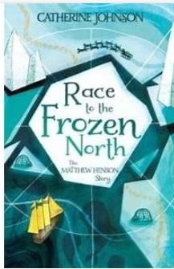 | Retell |  | Explanation Text- Volcanoes  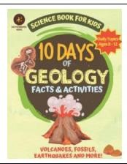 | Own poem based on Rudyard  Kipling’s ‘if’ poem.  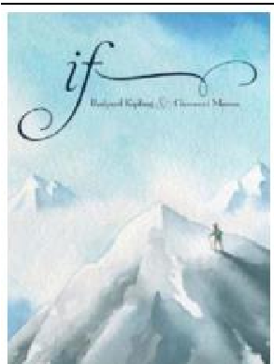
Year  5  Genre Progression |  | Past perfect tense.  Organised into paragraphs, with the day’s events developed and expanded through descriptive  detail.The opening locates the  events precisely in time and the  piece concludes by looking ahead to the following day.  Language choices to reflect the theme (historical etc.).  Include a quote.  Move between tenses within paragraphs – own choice. | Describe setting, characters and atmosphere.  Describe the character and include their feelings using show don’t tell.  Use show don’t tell to build suspense. Use short sentences for tension. Cliff hanger questions.  Use dialogue to convey a character and advance the action.  Use organisational and presentational devices that are relevant to the text type, for example, underlining / uppercase. |  | Passive voice.  Wider range of cause-and-effect conjunctions.  Effect and cause conjunctions because / as / since / for They cannot be made quickly because of the intricate designs. Put into context.  Compare and contrast vocabulary.  The sun is an amazing 864, 000 miles in diameter, unbelievably stars have been found which are 100 times bigger.  Glossary.  Draw the reader in.  Independently start to consider presentation. | Free Verse  Free Verse poems tell a story, describe something or explain an emotion  These poems do not need to rhyme or use a structure  Figurative language language linked to the topic  Capital letters at the beginning of each line  Free verse poems do not have a certain number of syllables per line They do not rhyme, and other language devices may be used  Lines can be single words, phrases or sentences Own vocabulary  choices
Year  6  Genre Progression |  | Multiple entries  Include suspense  Changing moods and emotions  Maintaining tense and writer’s voice  Subjunctive form  Active and passive voice  Formality for effect Consider the audience, purpose and write using the appropriate  author’s voice | Author’s style of writing and use appropriate author’s voice  Consider purpose and audience  Changing tenses – flashback  More ownership  Independent research and presentation  Decide where diagrams, illustrations, or a flow chart would help explain.  Author’s style of writing and use appropriate author’s voice. Consider purpose and audience. |  | More ownership  Independent research and presentation  Decide where diagrams, illustrations, or a flow chart would help explain.  Author’s style of writing and use appropriate author’s voice.  Consider purpose and audience.

Year  5  Grammar and  Punctuation | Use ISPACED (ing word, simile, preposition, adverb, conjunction, ed word, dialogue) to open a sentence. | Use show don’t tell to build suspense, to introduce a dilemma in a story and convey a character’s emotions.  Adding a new line whenever a new person starts speaking.  Use speech within a piece of writing to move the story on. |  | Use the past perfect form to mark relationship of time and cause. |  | Consolidation of previously taught skills.
Year  6  Grammar and  Punctuation | Use adverbials to move time in a narrative (Later on, Meanwhile). | Use extended reporting clauses in speech to show character’s thoughts, actions, or feelings.  Recognise when reported speech is more appropriate than direct speech to maintain pace or move the story on.  Use senses to “show not tell” settings, characters’ feelings, and thoughts. |  | Use colons, semi-colons and dashes deliberately, according to formality, context and the effect that is trying to be created. |  | Consolidation of previously taught skills.
Handwriting Year 5 - Choose the writing implement that best suits the task.
Handwriting Year 6 - Maintain legibility and consistency in joined handwriting when writing at speed.
Year 5
Spelling

Year
6

Spelling

Spring 2
Science – Can you explain the difference between the life cycles of different living things? |  |  | Geography – How can we reduce our carbon footprint?
Text and Genre | Retell  Broken- Rock, Paper, Scissors.  Short animation from the Literacy Shed  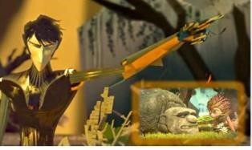 | Setting-In the garage for the first time.  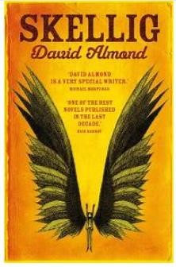 |  | Letter to Mina  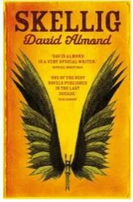 | Information Text- Why and How we should reduce our carbon footprint.  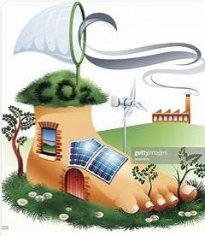
Year  5  Genre  Progression | Describe setting, characters and atmosphere.  Describe the character and include their feelings using show don’t tell.  Use show don’t tell to build suspense. Use short sentences for tension. Cliff hanger questions.  Use dialogue to convey a character and advance the action.  Use organisational and presentational devices that are relevant to the text type, for example, underlining / uppercase. | Include two adjectives in my fronted adverbial of place.  “Under the ancient, crumbling bridge,”  Using rich description to interest the reader such as metaphors, personification, and onomatopoeia |  | Include a range of tenses – own choice.  Include colloquialism  Cohesion; referring back, pronouns  Consider the audience, purpose and write using the appropriate  author’s voice | Include facts and opinions  Use modal verbs and degrees of possibility.  Facts and statistics.  Persuasive openers.  Rule of three.  Conjunctions of cause
Year  6  Genre  Progression | Author’s style of writing and use appropriate author’s voice  Consider purpose and audience Changing tenses – flashback | Power of three fronted adverbials  Personification of the weather  Evocative language to create a mood, strong feelings, memories, or emotions back Consider the audience, purpose and write using the appropriate  author’s voice |  | Include a range of tenses – own choice.  Include colloquialism  Cohesion; referring back, pronouns  Consider the audience, purpose and write using the appropriate  author’s voice | Introduce the debate with background information.  Argument for the issue with supporting evidence.  Phrases of debate.  Facts and statistics.  Technical vocabulary.  Passive voice.
Year  5  Grammar  and  Punctuatio | Understand the importance of cohesion in my writing in fiction writing. I use place, time or manner adverbials to ensure cohesion in and across paragraphs.  n | Use ISPACED (ing word, simile, preposition, adverb, conjunction, ed word, dialogue) to open a sentence. |  | Use show don’t tell to build suspense, to introduce a dilemma in a story and convey a character’s emotions. | Ask a rhetorical question to appeal directly to the reader.  Use modal verbs and adverbs to show the possibility of something happening.

Year 6  Grammar and Punctuation | Integrate dialogue in narratives to convey character and advance the action. |  | Consolidation of previously taught skills. | Consolidation of previously taught skills. | Use adverbials to introduce an argument (Firstly).  Use adverbials to form links between arguments and develop arguments, to signal an illustration of a proceeding point.  Use linking adverbials (adverbials of cause) in an explanation text to show reasons or results.  Use adverbials to introduce a concluding paragraph (Having considered all of the arguments… In Summary, To conclude,).  Use adverbials in different places in a sentence (On one hand…. whereas/yet/however…).
Handwriting Year 5 - Choose the writing implement that best suits the task.
Handwriting Year 6 - Maintain legibility and consistency in joined handwriting when writing at speed.
Year 5

Spelling

Year
6

Spelling

Summer 1
History –  Science- How do some materials change state? |  |  |  | Geography – How can humans adapt to a place (e.g., living/surviving in a rainforest)?
Text and Genre | Descriptive Writing- Colours  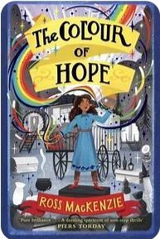 | Character Description | Formal New Report on the ‘tradegy’. |  | Instructions- Collecting moonlight from a moonpod. | Persuasive Letter- Why Sandy should teach magic | Re-write a chapter from another perspective
Year  5  Genre Progression | Describe setting, characters and atmosphere.  Describe the character and include their feelings using show don’t  tell. Use show don’t tell to build  suspense. Use short sentences for  tension. Cliff hanger questions.  Use dialogue to convey a character and advance the action.  Use organisational and presentational devices that are relevant to the text type, for example, underlining / uppercase. | Written in the past / past tense.  Describe the character and included their feelings by using show don’t tell.  Including speech and moving the action on. | Indirect speech.  Main body.  Verbs selected for meaning and effect.  Precise vocabulary choices.  Paragraphs and caption.  Journalistic words and phrases.  By-line (who wrote it).  Conclusion (plan for the future). |  | Informal / formal instructions could be humorous or formal.  Hook the reader in the introduction  Sophisticated / appropriate use of adverbs / adjectives  Awareness of the audience Add a recommendation | Include facts and opinions  Use modal verbs and degrees of possibility.  Facts and statistics.  Exaggerate.  Persuasive openers.  Rule of three.  Conjunctions of cause | Describe setting, characters and atmosphere.  Describe the character and include their feelings using show don’t  tell. Use show don’t tell to build  suspense. Use short sentences for  tension. Cliff hanger questions.  Use dialogue to convey a character and advance the action.  Use organisational and presentational devices that are relevant to the text type, for example, underlining / uppercase.
Year  6  Genre Progression | Author’s style of writing and use appropriate author’s voice  Consider purpose and audience | Written in the past / past tense.  Describe the character and included their feelings by using show don’t tell.  Including speech and moving the action on. | Précis key events Lead the reader to reflect on the events Skilfully  manages of shits in time (past, present and future)  Appropriate presentation  Reconstruct, interpret and communicate events  Passive voice First-hand accounts  Paints a vivid and dramatic picture  Distinctive voices of individuals  Thoughtful ending  Closing editorial comment adapts a more personal stance |  | Develop an introduction – add background.  If appropriate add personal advice using parentheses.  Select own title, headings and presentational devices  Use pictures, diagrams, flow charts and symbols (if  appropriate) to present  information independently Use brackets to add asides  Author’s style of writing and use appropriate author’s voice.  Consider purpose and audience. | Include facts and opinions  Use modal verbs and degrees of possibility.  Facts and statistics.  Exaggerate.  Persuasive openers.  Rule of three.  Conjunctions of cause | Author’s style of writing and use appropriate author’s voice  Consider purpose and audience Changing tenses – flashback

Year 5  Grammar and  Punctuation | Use rich description for interest,  (metaphors, personification, onomatopoeia)  Use a metaphor as an opener. | Use rich description for interest,  (metaphors, personification, onomatopoeia)  Use a metaphor as an opener. | Use a rhetorical question to make the reader think.  Use an embedded relative clause, marked with commas for parenthesis.  Know the difference between direct speech and reported speech. | Use brackets to add parenthesis. | Use a comma before the relative clause if it is providing extra, nonessential information and is after the main clause. | Use dashes to add parenthesis.  Use short sentences to build suspense.
Year  6  Grammar and Punctuation | Make purposeful choices with adverbs, adjectives, ENPs and  adverbials to make writing more descriptive. | Make purposeful choices with adverbs, adjectives, ENPs and  adverbials to make writing more descriptive. | Use quotes for effective purpose in newspaper reports – to add  authenticity and make them more memorable.  Use the passive voice to make the object more important in the  sentence than the subject.  Exercise a conscious control over levels of formality (particularly  through manipulating grammar and vocabulary). | Exercise a conscious control over levels of formality (particularly  through manipulating grammar and vocabulary). | Use the perfect form of verbs to mark relationships of time and cause. | Consolidation of previously taught  skills.
Handwriting Year 5 - Maintain legibility in joined handwriting when writing at speed.
Handwriting Year 6 -- Maintain legibility and consistency in joined handwriting when writing at speed.
Year 5

Spelling

Year
6

Spelling

Summer 2
Science – What happens to our bodies as they get older? |  |  |  |  |  | Geography – Who were the Mayans & how did their empire grow so rapidly?
Text and Genre | Retell  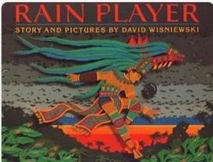 |  | Diary Entry  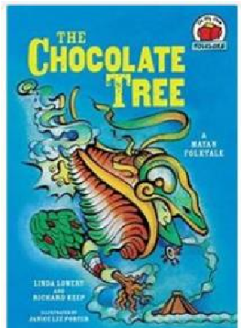 |  |  | Non- Chronological Report- The Mayans  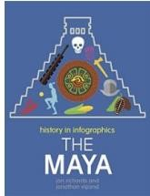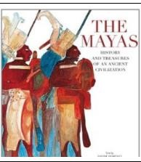
Year  5  Genre Progression | Describe setting, characters and atmosphere.  Describe the character and include their feelings using show don’t tell.  Use show don’t tell to build suspense. Use short sentences for tension. Cliff hanger questions.  Use dialogue to convey a character and advance the action.  Use organisational and presentational devices that are relevant to the text type, for example, underlining / uppercase. |  | Past perfect tense.  Organised into paragraphs, with the day’s events developed and expanded through descriptive  detail.The opening locates the  events precisely in time and the  piece concludes by looking ahead to the following day.  Language choices to reflect the theme (historical etc.).  Include a quote.  Move between tenses within paragraphs – own choice. |  |  | Independent research.  Select own sub-headings.  Use examples for presentation/structure.  Include a glossary.  Consider audience (fun, factual etc).
Year  6  Genre Progression | Author’s style of writing and use appropriate author’s voice  Consider purpose and audience Changing tenses – flashback |  | Multiple entries  Include suspense  Changing moods and emotions  Maintaining tense and writer’s voice  Subjunctive form  Active and passive voice  Formality for effect Consider the audience, purpose and write using the appropriate  author’s voice |  |  | Presentation/structure to be independently planned  References sources of data  Independent research  Use a range of presentational devices (table, diagram)  Include questions for intrigue/to entice the reader  Author’s style of writing and use appropriate author’s voice Consider purpose and audience
Year  5  Grammar  and  Punctuatio | n  Consolidation of previously taught skills. |  | Consolidation of previously taught  skills. |  |  | Use brackets to add parenthesis.
Year  6  Grammar and  Punctuatio  n |  |  | Write in the subjunctive form, use the verb ‘were’ instead of  ‘was’ to create a more formal sentence. |  | Add a comma to avoid ambiguity and change the meaning of a single clause sentence with adverbials.
 | Handwriting Year 5 - Maintain legibility in joined handwriting when writing at speed.
 | Handwriting Year 6 - Maintain legibility and consistency in joined handwriting when writing at speed.
Year
5

Spelling

Year
6

Spelling

