- All new vocabulary will be displayed on Working Walls in the classroom environment.  - WAGOLL to use for whole class teaching demonstrating the skills and vocabulary expectations. |  |  |  |  |  |  |  | - Learning is progressive and therefore texts and skills need to be taught in chronological order.  - New ambitious vocabulary will be introduced and pre taught by staff weekly using a range of adjectives, verbs, nouns, adverbs.
Autumn 1
History - How did invaders and settlers shape Britain
Text and Genre | Retell  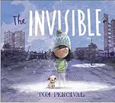 |  | Retell  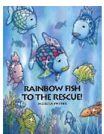 |  |  | 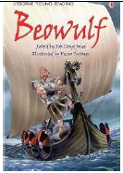  Diary- Grendel’s point of view |  |  |  |  |  | 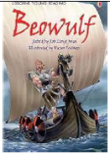  Retell- |  |  | Setting- The Last Viking  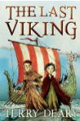 |  |  | Retell  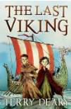
Year 3 Genre Progression | Title to make the reader want to read the story  Description of character OR setting |  | Title to make the reader want to read the story  Description of character OR setting |  |  | Varied language to convey thoughts and feelings. Adverbs as openers. Addresses the diary directly. Includes opinions and facts. Informal, chatty language  Ambitious words to describe people and settings. Talks about secret / private feelings and opinions. includes events that are important to the writer. |  |  |  |  |  | The battle in the Great Hall  Title to make the reader want to read the story  Description of character OR setting |  |  | Similes and metaphors  Fronted adverbials for place and manner  Adjective, adjective  Powerful verbs |  |  | Title to make the reader want to read the story. Using paragraphs to organise my writing  Include one piece of simple speech with inverted commas.  Detailed description of character OR setting
Year 4 Genre Progression | Independently structuring paragraphs around an idea  Show not tell for character’s emotions  Detailed description of character and setting  Still limit speech |  | Independently structuring paragraphs around an idea  Show not tell for character’s emotions  Detailed description of character and setting  Still limit speech |  |  | Talks about feelings, reactions an opinion. Author explains reason for their actions. Ends with the authors present situation, wondering what they will do next. Varied language to convey thoughts and feelings and opinions (Show don’t tell). Justify why things happened. Select and maintain the appropriate tense (within given paragraphs). Use a rhetorical question with a subordinating conjunction. |  |  |  |  |  | Independently structuring paragraphs around an idea  Show not tell for character’s emotions  Detailed description of character and setting  Still limit speech |  |  | What did they see?  Show don’t tell to convey a character’s emotion |  |  | Independently structuring paragraphs around an idea  Show not tell for character’s emotions  Detailed description of character and setting  Still limit speech
Year 3  Grammar and Punctuation | Use more exciting adjectives and expanded noun phrases to help the reader clearly see what I am describing.  Use a comma to separate adjectives when describing a noun.  Revision of Year 2 commas in a list. |  | Use powerful verbs to make my writing more interesting.  Revision of Year 2 coordinating conjunctions (and, or, but) |  |  | Begin to extend sentences to add more detail by using a variety of subordinating conjunctions at the start of a sentence to write a complex sentence. Before, After, While, As (+ Year 2)  Revision of Year 2 contractions.  . |  |  |  |  |  | Use similes to add description to my writing. |  |  | Use adverbs of manner as openers (fronted adverbials)  Use prepositions as fronted adverbials  Begin to build cohesion by choosing the right nouns and pronouns to avoid repeating myself. |  |  | Write compound sentences by including co-ordinating conjunctions (or, and, but, so, yet).  Use inverted commas at the start and end of speech. Put the reporting clauses at the end of speech. Use an exclamation mark or a question mark before the closing inverted commas when the reporting clause is at the end of the speech.
Year 4  Grammar and Punctuation | Modify a noun phrase with an adjective.  Use ambitious adjectives to enhance the nouns in the writing.  Use the Standard Form of English, drawing on my knowledge of Subject Verb Agreement. |  | Choose the most appropriate verbs to accurately describe to the reader what is being described.  Revision of Year 3 coordinating conjucntions. (Year 2 + so, yet) |  |  | Extend sentences to add more detail by using a variety of subordinating conjunctions (All of Year 3 + during, since) at the start of a sentence.  Revision of contractions. |  |  |  |  |  | Use more sophisticated similes to describe things in my writing. |  |  | Use a comma after a fronted adverbial.  Modify a noun phrase with a noun or preposition  Choose the most appropriate nouns and pronouns.  Use prepositions as fronted adverbials and include an adjective to give the reader more information. |  |  | Use the acronym FANBOYS to help me remember coordinating conjunctions  (All of Year 3 + for, nor).  Revision of Year 3 speech  Use a comma, an exclamation mark or a question mark before the closing inverted commas when the reporting clause is at the end of the speech.
Handwriting Year 3 - Use the diagonally and horizontal strokes that are needed to join letters.
Handwriting Year 4 - Understand which letters, when adjacent to one another, are best left unjoined.
Year 3
Spelling
Year 4
Spelling
Autumn 2
Science – Can you explain the meaning of the words dark, light, reflection, and shadow? |  |  |  |  |  |  |  |  |  | History - How did the monarchy in Britain change in the time of the Anglo-Saxons?
Text and Genre | My Shadow  Robert Louis Stevenson  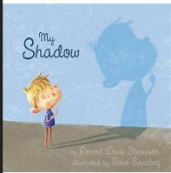 |  |  | Retell  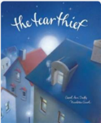 |  |  | Own Ending to the Story |  |  |  |  |  | Retell – Lin Yi’s Lantern- Brenda Williams  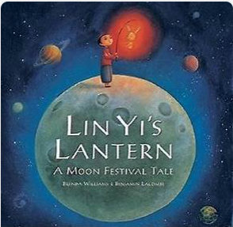 |  |  | Retell  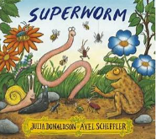
Year 3 Genre Progression | Free Verse  Free Verse poems tell a story, describe something or explain an emotion  These poems do not need to rhyme or use a structure  Figurative language language linked to the topic  Capital letters at the beginning of each line  Free verse poems do not have a certain number of syllables per line  They do not rhyme, and other language devices may be used  Lines can be single words, phrases or sentences Own vocabulary choices |  |  | title to make the reader want to read the story  Include simple speech with inverted commas. Limited speech  Detailed description of character OR setting |  |  | Stick to the theme given, Use a story map (template given). Select own appropriate language Add my own title. Simple speech using inverted commas Paragraphs for time. Develop character through action and description. A beginning to introduce the characters and setting. A build up to give hints and clues about what is going to happen. A dilemma when something goes wrong. A resolution where the characters solve the problem. An ending to say what happens next. |  |  |  |  |  | title to make the reader want to read the story  Include simple speech with inverted commas. Limited speech  Detailed description of character OR setting |  |  | title to make the reader want to read the story  Include simple speech with inverted commas. Limited speech  Detailed description of character OR setting
Year 4 Genre Progression |  |  |  | Including build-up, problem, resolution (Story-map)  Independently structuring paragraphs around an idea  Show not tell for character’s emotions. Detailed description of character and setting  Direct speech to move the action on. 3 part speech – what they said, who said it and how they said it (adverb). Still limit speech |  |  | 3rd or 1st person  Use rich and varied vocabulary Paragraphs for time and/or events Show don’t tell  Speech with varied reporting clauses |  |  |  |  |  | Including build-up, problem, resolution (Story-map)  Independently structuring paragraphs around an idea  Show not tell for character’s emotions. Detailed description of character and setting  Direct speech to move the action on. 3 part speech – what they said, who said it and how they said it (adverb). Still limit speech |  |  | Including build-up, problem, resolution (Story-map)  Independently structuring paragraphs around an idea  Show not tell for character’s emotions. Detailed description of character and setting  Direct speech to move the action on. 3 part speech – what they said, who said it and how they said it (adverb). Still limit speech
Year 3  Grammar and Punctuation | Consolidation of similes, ENP and powerful verbs. |  |  | Consistently use an apostrophe to show possession and use apostrophes in my writing to show singular possession.  Use a comma, an exclamation mark or a question mark before the closing inverted commas when the reporting clause is at the end of the speech. |  |  | Use show don’t tell to convey a character’s emotions  Consolidate speech  Use a comma before some co-ordinating conjunctions (or, but, so) |  |  |  |  |  | Use of a comma to list expanded noun phrases.  Use tense accurately most of the time.  Understanding what a noun, adjective, verb, adverb means. |  |  | Use verb tenses correctly most of the time (was/were) (is/are).  Consolidation of previously taught skills.
Year 4  Grammar and Punctuation | Consolidation of similes, ENP and powerful verbs. |  |  | Know the difference between the plural and possessive ‘s’.  Use an apostrophe for plural possession with regular plurals.  Include direct speech in stories but change where the reporting clause is in the sentence (beginning).  Mark the reporting clause (who said it) with a comma when it is not at the end of the sentence. |  |  | Consolidate speech |  |  |  |  |  | Revision - Understanding what a noun, adjective, verb, adverb means.  Revision - Use of a comma to list expanded noun phrases.  Use commas to list actions (power of three). |  |  | .Consolidation of previously taught skills.
Handwriting Year 3 - Use the diagonally and horizontal strokes that are needed to join letters.
Handwriting Year 4 - Understand which letters, when adjacent to one another, are best left unjoined.
Year 3
Spelling
Year 4
Spelling
Spring 1
Science- How do you categorise materials according to their state of matter? |  |  |  |  |  |  |  |  |  | Geography – Which foods and other commodities are grown in different climate zones?
Text and Genre |   Retell |   Informal Letter |  |  | 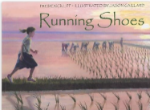  Setting Description |  |  |  |  |  | Retell |  |  | 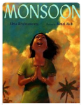  Diary |  |  | Rhythm of the rain  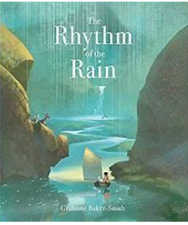  Explanation of the water cycle
Year 3 Genre Progression | title to make the reader want to read the story  Include simple speech with inverted commas. Limited speech  Detailed description of character OR setting | Include the sender’s address  Use an appropriate greeting  Past tense, include future  tense in the conclusion  Present perfect tense. Write an introduction. Accurate use of tenses (explore future tense)  Paragraphs for time / order  Informal chatty language  Questions sentences. Wider range of contractions. Greeting and signing off (own choice). Consider the audience |  |  | Similes and metaphors  Fronted adverbials for place and manner  Adjective, adjective  Powerful verbs |  |  |  |  |  | title to make the reader want to read the story  Using paragraphs to organise my writing  Include simple speech with inverted commas. Limited speech  Detailed description of character OR setting |  |  | Experiment with future tense. Informal voice. Paragraphs for events. Varied language to convey thoughts and feelings. Adverbs as openers. Addresses the diary directly. Includes opinions and facts. Informal, chatty language  Ambitious words to describe people and settings. Talks about secret / private feelings and opinions. Includes events that are important to the writer. Use paragraphs to organise events |  |  | Use how or why in the title  Persuasive question in the introduction  More detailed introduction  Closing statement  Facts given by the teacher  Very directed research  Given subheadings  Conjunctions for cause  because / as / so /since
Year 4 Genre Progression | Including build-up, problem, resolution (Story-map)  Independently structuring paragraphs around an idea  Show not tell for character’s emotions  Detailed description of character and setting  Direct speech to move the action on  3 part speech – what they said, who said it and how they said it (adverb)  Still limit speech | Paragraphs around a theme  Address the reader directly  Present perfect tense  Thoughts and feelings  Show don’t tell  Rhetorical questions |  |  | What did they see?  Simile as a sentence opener  Show don’t tell to convey a character’s emotion  Beginning to use personification to describe things in my writing |  |  |  |  |  | Including build-up, problem, resolution (Story-map)  Independently structuring paragraphs around an idea  Show not tell for character’s emotions  Detailed description of character and setting  Direct speech to move the action on  3 part speech – what they said, who said it and how they said it (adverb)  Still limit speech |  |  | Introduction to set the scene and create atmosphere. Events described from the author’s perspective. Talks about feelings, reactions an opinion. Author explains reason for their actions. Ends with the authors present situation, wondering what they will do next. Select events thinking about the audience. Varied language to convey thoughts and feelings and opinions (Show don’t tell). Justify why things happened. Select and maintain the appropriate tense (within given paragraphs). Use a rhetorical question with a subordinating conjunction. |  |  | Title to intrigue  Start to choose own subheadings  Subheading as a question  Compare vocabulary  Use a wider variety of conjunctions for cause  Consequently / therefore / as a result  These can be used at the beginning or the middle of a sentence.
Year 3  Grammar and Punctuation | Use openers (fronted adverbials) as sentence openers: How (Manner), When (Time) and Where (Place) | Change the place of the adverb in the sentence. |  |  | Use openers (fronted adverbials) as sentence openers: How (Manner), When (Time) and Where (Place) |  |  |  |  |  | Start a new paragraph to show a change in time in narrative writing.  Use ellipses to build suspense. |  |  | Use a variety of subordinating conjunctions in the middle of a sentence to write a complex sentence. |  |  | Use a question in a non-fiction introduction.  Use conjunctions for cause (because, as, so) (non- fiction)
Year 4  Grammar and Punctuation | Adverbs to show how (manner) root word spelling change | Write a complex question sentence to emphasis my point in fiction. |  |  | Consolidation of fronted adverbials. |  |  |  |  |  | Start a new paragraph when the setting, action or time change in narrative writing. |  |  | Extend sentences to add more detail by using a variety of subordinating conjunctions (All of Year 3 + during, since) in the middle of a sentence. |  |  | Write a complex question sentence to emphasis my point in non-fiction writing.  Use a wider a range of conjunctions for cause (non-fiction)
Handwriting Year 3 - Ascenders and descenders do not interfere with writing on the line above and below.
Handwriting Year 4 - Use a consistent and efficient style of handwriting
Year 3 Spelling
Year 4
Spelling
Spring 2
Science – Can you explain the function of different parts of a plant? |  |  |  |  |  |  |  |  |  | Geography – Where are the world’s rainforests and what are their specific physical and climate characteristics?
Text and Genre | 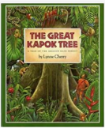  Setting | 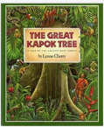  Retell |  |  | Retell- Up to the sign going up  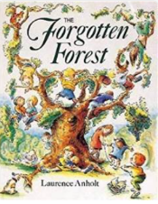 |  |  |  |  |  | Write the end of the story  What will the builders do?  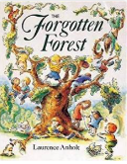 |  |  | Non- Chron- layers of the Rainforest  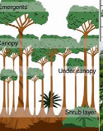
Year 3 Genre Progression | Similes and metaphors  Fronted adverbials for place and manner  Adjective, adjective  Powerful verbs | title to make the reader want to read the story  Using paragraphs to organise my writing  Include simple speech with inverted commas. Limited speech  Detailed description of character OR setting |  |  | title to make the reader want to read the story  Using paragraphs to organise my writing  Include simple speech with inverted commas. Limited speech  Detailed description of character OR setting |  |  |  |  |  | Stick to the theme given, Use a story map (template given). Select own appropriate language Add my own title. Simple speech using inverted commas Paragraphs for time. Develop character through action and description. A beginning to introduce the characters and setting. A build up to give hints and clues about what is going to happen. A dilemma when something goes wrong. A resolution where the characters solve the problem. An ending to say what happens next. |  |  | Teacher led research (content provided by teacher)  Use given sub-headings but arrange information independently  Generate captions for given images  Begin to use the 5w’s in the introduction  Provided reason for processes
Year 4 Genre Progression | What did they see?  Simile as a sentence opener  Show don’t tell to convey a character’s emotion  Beginning to use personification to describe things in my writing | Including build-up, problem, resolution (Story-map)  Independently structuring paragraphs around an idea  Show not tell for character’s emotions. Detailed description of character and setting. Direct speech to move the action on. 3 part speech – what they said, who said it and how they said it (adverb). Still limit speech |  |  | Including build-up, problem, resolution (Story-map)  Independently structuring paragraphs around an idea  Show not tell for character’s emotions. Detailed description of character and setting. Direct speech to move the action on. 3 part speech – what they said, who said it and how they said it (adverb). Still limit speech |  |  |  |  |  | 3rd and 1st person  Use rich and varied vocabulary Paragraphs for time and/or events Show don’t tell  Speech with varied reporting clauses |  |  | Select from a choice of sub-headings  Include multiple paragraphs for each sub-heading  Use 5w’s independently  Follow given structure  Technical vocabulary  Factual language  Conjunctions for cause  These can be used at the beginning or the middle of a sentence
Year 3  Grammar and Punctuation | Use prepositions as fronted adverbials and include an adjective to give the reader more information. | Use short sentences to make key points. |  |  | Use conjunctions for cause (because, as, so) (fiction) |  |  |  |  |  | Beginning to vary the range of verbs used in the reporting clause to avoid repeating, ‘said’. |  |  | Organise similar ideas into paragraphs in non-fiction writing.  Use a subheading to guide the reader.  Appropriate non-fiction openers.
Year 4  Grammar and Punctuation | Use a simile as a sentence opener.  Use more sophisticated metaphors to describe things in my writing. | Short sentences to move events on quickly in a story. |  |  | Use a wider a range of conjunctions for cause (fiction) |  |  |  |  |  | Beginning to vary the range of verbs used in the reporting clause to avoid repeating, ‘said’.  Include direct speech in stories but change where the reporting clause is in the sentence (beginning and end). |  |  | Write a complex question sentence to emphasis my point in both fiction and non-fiction writing.  Appropriate non-fiction openers.
Handwriting Year 3- Ascenders and descenders do not interfere with writing on the line above and below.
Handwriting Year 4 - Use a consistent and efficient style of handwriting
Year 3
Spelling
Year 4
Spelling
Summer 1
History – How have the Ancient Egyptians influenced our life today? |  |  |  |  |  |  |  |  | Science- Can you categorise and describe different rocks and soils?
Text and Genre | Retell  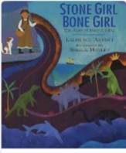 | 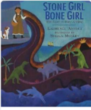  Informal Letter about her discovery. |  |  | 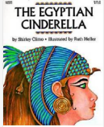  Setting- The Banks of the Nile |  |  |  |  |  | Instructions mummification  horrible histories mummification - Search (bing.com)  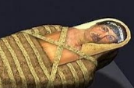 |  |  | Non- Chronological Report on Tutankhamun  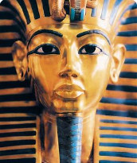 |  |  | The Sound Collector- Roger Mc Gough-Own version of the poem  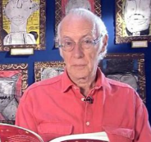
Year 3 Genre Progression | title to make the reader want to read the story  Using paragraphs to organise my writing  Include simple speech with inverted commas. Limited speech  Detailed description of character OR setting | Include the sender’s address  Use an appropriate greeting  Past tense, include future  tense in the conclusion  Present perfect tense. Write an introduction. Accurate use of tenses (explore future tense)  Paragraphs for time / order  Informal chatty language  Questions sentences. Wider range of contractions. Greeting and signing off (own choice). Consider the audience |  |  | Similes and metaphors  Fronted adverbials for place and manner  Adjective, adjective  Powerful verbs |  |  |  |  |  | Persuasive introduction.  Subheadings – Equipment and method. Openers (time adverbials, imperative verbs, -ly adverbs +subordinating conjunctions).  use a range of openers.  Equipment subheading will be followed by a colon and bullet points. Technical vocabulary / scientific vocabulary. Prepositional phrases Top tips / safety tips / handy hints at the end. |  |  | Teacher led research (content provided by teacher)  Use given sub-headings but arrange information independently  Generate captions for given images  Begin to use the 5w’s in the introduction  Provided reason for processes |  |  | ABAB rhyme scheme  Lines that end with a rhyme are labelled with the same letter.  In an ABAB rhyme scheme, the first and third line end with the rhyming words (A) and the second and fourth lines end with different rhyming words (B). The rhyme scheme is determined by the last word of each line.
Year 4 Genre Progression | Including build-up, problem, resolution (Story-map)  Independently structuring paragraphs around an idea  Show not tell for character’s emotions. Detailed description of character and setting  Direct speech to move the action on. 3 part speech – what they said, who said it and how they said it (adverb). Still limit speech | Paragraphs around a theme  Address the reader directly  Present perfect tense  Thoughts and feelings  Show don’t tell  Rhetorical questions |  |  | What did they see?  Simile as a sentence opener  Show don’t tell to convey a character’s emotion  Beginning to use personification to describe things in my writing |  |  |  |  |  | Rhetorical question in the introduction  Closing statement  More than one sentence for some steps |  |  | Select from a choice of sub-headings. Include multiple paragraphs for each sub-heading  Use 5w’s independently  Follow given structure. Technical vocabulary. Factual language  Conjunctions for cause  (beginning or the middle of a sentence).
Year 3  Grammar and Punctuation | Use adverbs to show when something happened (Time)  Begin to use a comma after a fronted adverbial  Use adverbs to show where something happened. (Place) | Consolidation of previous skills AFL |  |  | Use two –ly adverbs in a sentence. |  |  |  |  |  | Consolidation of previous skills AFL |  |  | Consolidation of previous skills AFL |  |  | Consolidation of previous skills AFL
Year 4  Grammar and Punctuation | Use fronted adverbials followed by a comma. When (Frequency) and How (Degree).  Add an ‘s’ to show plural and use irregular plural noun forms of plural (children, women)  Add an ‘s’ to show plural and use irregular plural noun forms of plural. -es words (foxes, boxes). | Include complex sentences in my writing which start with a subordinating conjunction and marking the subordinating clause with a comma. |  |  | Beginning to use personification to describe things in my writing.  Choose the most appropriate nouns. |  |  |  |  |  | Consolidation of previous skills AFL |  |  | Consolidation of previous skills AFL |  |  | Consolidation of previous skills AFL
Handwriting Year 3 - My handwriting style is consistent throughout my work.
Handwriting Year 4 - Use a fluent, consistent style and write at speed
Year 3
Spelling
Year 4
Spelling
Summer 2
DT- How can we combine food groups to make a healthy sandwich.
Text and Genre | 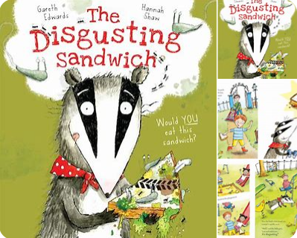  Retell | Instructions- A Healthy Sandwich   |  |  | 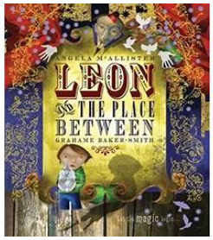  Setting Description |  |  |  |  |  | Diary Entry |  |  | Non -Chronological Report- Healthy Eating/Food Groups  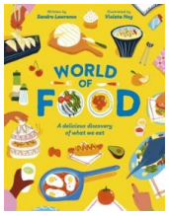
Year 3 Genre Progression | Title to make the reader want to read the story  Using paragraphs to organise my writing  Include simple speech with inverted commas. Limited speech  Detailed description of character OR setting | Persuasive introduction.  Subheadings – Equipment and method. Openers (time adverbials, imperative verbs, -ly adverbs +subordinating conjunctions).  use a range of openers.  Equipment subheading will be followed by a colon and bullet points. Technical vocabulary / scientific vocabulary. Prepositional phrases Top tips / safety tips / handy hints at the end. |  |  | Similes and metaphors  Fronted adverbials for place and manner  Adjective, adjective  Powerful verbs |  |  |  |  |  | Past perfect and present progressive tenses. Experiment with future tense. Informal voice. Paragraphs for events. Varied language to convey thoughts and feelings. Adverbs as openers. Addresses the diary directly. Includes opinions and facts  Informal, chatty language  Ambitious words to describe people and settings. Talks about secret / private feelings and opinions  Includes events that are important to the writer. Use paragraphs to organise events |  |  | Teacher led research (content provided by teacher)  Use given sub-headings but arrange information independently  Generate captions for given images  Begin to use the 5w’s in the introduction  Provided reason for processes
Year 4 Genre Progression | Including build-up, problem, resolution (Story-map)  Independently structuring paragraphs around an idea  Show not tell for character’s emotions. Detailed description of character and setting  Direct speech to move the action on. 3 part speech – what they said, who said it and how they said it (adverb). Still limit speech | Rhetorical question in the introduction  Closing statement  More than one sentence for some steps |  |  | What did they see?  Simile as a sentence opener  Show don’t tell to convey a character’s emotion  Beginning to use personification to describe things in my writing |  |  |  |  |  | Introduction to set the scene and create atmosphere. Events described from the author’s perspective. Talks about feelings, reactions an opinion. Author explains reason for their actions. Ends with the authors present situation, wondering what they will do next. Select events thinking about the audience. Varied language to convey thoughts and feelings and opinions (Show don’t tell). Justify why things happened. Select and maintain the appropriate tense (within given paragraphs)  Use a rhetorical question with a subordinating conjunction. |  |  | Select from a choice of sub-headings  Include multiple paragraphs for each sub-heading  Use 5w’s independently  Follow given structure  Technical vocabulary  Factual language  Conjunctions for cause  These can be used at the beginning or the middle of a sentence
Year 3  Grammar and Punctuation | Start a new paragraph when the setting changes in narrative writing. | Use prepositions to express place.  Use a colon before a list in instructional writing (what you need:) |  |  | Consolidation of previously taught skills. |  |  |  |  |  | Use the Present Perfect Tense. |  |  | Use prepositions to express time.  Use conjunctions for place (Where and Wherever).
Year 4  Grammar and Punctuation | Use a mixture of short sentences, simple sentences, compound and complex sentences. | Identify the difference between simple past and simple present tense. |  |  | Consolidation of previously taught skills. |  |  |  |  |  | I can explain how to use Present Perfect Tense and use irregular verbs. |  |  | Understand the difference between the use of conjunctions, adverbs and prepositions and can explain this.
Handwriting Year 3 - My handwriting style is consistent throughout my work.
Handwriting Year 4 - Use a fluent, consistent style and write at speed
Year 3
Spelling
Year 4
Spelling

