- All new vocabulary will be displayed on Working Walls in the classroom environment.  - WAGOLL to use for whole class teaching demonstrating the skills and vocabulary expectations.  - Learning is progressive and therefore texts and skills need to be taught in chronological order.  - New ambitious vocabulary will be introduced and pre taught by staff weekly using a range of adjectives, verbs, nouns, adverbs. |  |  |  |  |  |  |  |  | “Dictation gives children opportunities to practise and apply their spelling knowledge and segmenting skills, without having to compose sentences by themselves. It requires them to distinguish between the sounds they hear in order to choose the correct graphemes to represent the sounds and to form the letters correctly.” Research and Review, May 2023
Autumn 1
Geography – Where is Glossop and what is it like? |  |  |  |  |  |  |  |  |  |  | Science - Where do different animals live and what do they need to survive?
Text and Genre | Whose habitat is that?  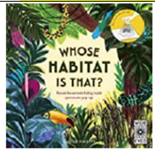 |  | 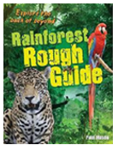  Rainforest Rough Guidebook. |  |  |  | 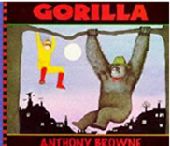  Retell |  |  |  |  |  | 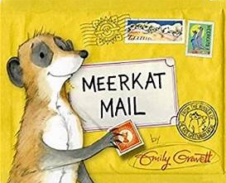  Retell |  |  |  | 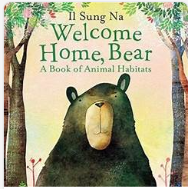  Retell |  |  | 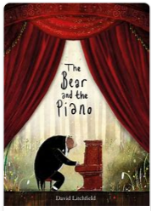  Retell
Year 1 Genre Progression | Use past tense  Title  Include beginning, middle end  Chronological order  Story language; Once upon a time, one sunny day etc  Simple sentences  Structure needs to be correct  (Not to rewrite word for word / use said.) |  | Use past tense  Title  Include beginning, middle end  Chronological order  Story language; Once upon a time, one sunny day etc  Simple sentences  Structure needs to be correct  (Not to rewrite word for word / use said.) |  |  |  | Use past tense  Title  Include beginning, middle end  Chronological order  Story language; Once upon a time, one sunny day etc  Simple sentences  Structure needs to be correct  (Not to rewrite word for word / use said.) |  |  |  |  |  | Use past tense  Title  Include beginning, middle end  Chronological order  Story language; Once upon a time, one sunny day etc  Simple sentences  Structure needs to be correct  (Not to rewrite word for word / use said.) |  |  |  | Use past tense  Title  Include beginning, middle end  Chronological order  Story language; Once upon a time, one sunny day etc  Simple sentences  Structure needs to be correct  (Not to rewrite word for word / use said.) |  |  | Use past tense  Title  Include beginning, middle end  Chronological order  Story language; Once upon a time, one sunny day etc  Simple sentences  Structure needs to be correct  (Not to rewrite word for word / use said.)
Year 2 Genre Progression | May create a story map or use pictures as prompts  Description of the character and setting  No comma would be used after the fronted adverbial opener until Year 3. |  | May create a story map or use pictures as prompts  Description of the character and setting  No comma would be used after the fronted adverbial opener until Year 3. |  |  |  | May create a story map or use pictures as prompts  Description of the character and setting  No comma would be used after the fronted adverbial opener until Year 3. |  |  |  |  |  | May create a story map or use pictures as prompts  Description of the character and setting  No comma would be used after the fronted adverbial opener until Year 3. |  |  |  | May create a story map or use pictures as prompts  Description of the character and setting  No comma would be used after the fronted adverbial opener until Year 3. |  |  | May create a story map or use pictures as prompts  Description of the character and setting  No comma would be used after the fronted adverbial opener until Year 3..
Year 1  Grammar and Punctuation | Sit at a table properly and hold my pencil correctly.  I form lower case letters correctly, starting and finishing in the right place.  All letters sit on the line.  Tall letters (ascenders) touch the line above.  Use short letters.  a, c, o, d, g, q, e, s, f, l, i, t, j, y, u, |  | Sit at a table properly and hold my pencil correctly.  I form lower case letters correctly, starting and finishing in the right place.  All letters sit on the line.  Tall letters (ascenders) touch the line above.  Use short letters.  r, b, n, h, m, k, p, v, w, x, z |  |  |  | Think, say and remember a sentence that starts with a time adverbial.  (First, Next, Finally).  Write a sentence starting with a time adverbial and ending with a full stop (fiction)  Write in the past tense. |  |  |  |  |  | Think, say and remember a sentence that starts with a time adverbial.  (First, Next, Then, After that, Finally). |  |  |  | Think, say and remember a sentence that starts with a time adverbial.  (First, Next, Then, After that, Finally). |  |  | Think, say and remember a sentence that starts with a time adverbial.  (First, Next, Then, After that, Finally).
Year 2  Grammar and Punctuation | My letters are close together when I write a word (snuggle my letters).  I fill the line with my writing.  Lower case letters are the same height. |  | My letters are close together when I write a word (snuggle my letters).  I fill the line with my writing.  Lower case letters are the same height. I am able to form all my capital letters correctly. I am able to write all of the Year 1 CEW correctly. |  |  |  | Use a wider range of time adverbs at the start of my sentences.  Eg. Later that cold day, A few minutes later.  Use the past tense correctly. |  |  |  |  |  | Use a wider range of openers at the start of my sentences.  Eg. Everyone, Far away… |  |  |  | Use a wider range of question openers and end with a question mark.  Eg. Where, Who |  |  | Use a wider range of exciting openers and use an exclamation mark at the end of an exciting sentence.  Eg. Unexpectedly,  Use an expanded noun phrase (noun phrase) using one or more adjectives.
Handwriting Year 1 -Sit at a table properly and hold my pencil correctly. I form lower case letters correctly, starting and finishing in the right place. All letters sit on the line. Tall letters (ascenders) touch the line above. Use short letters. Use finger spaces between words.
Handwriting Year 2 - Lower case letters are the same height.
Year 1
Spelling
Year 2
Spelling
Autumn 2
Science – How can living creatures be classified? |  |  |  |  | History - How has Glossop changed throughout my life and my grandparents’ lives? |  |  |  |  |  |  |  |  |  | Geography-
Text and Genre | Retell  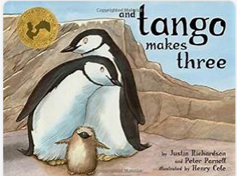 |  | 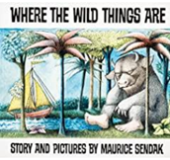  Retell |  |  |  | 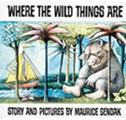  Diary |  |  |  |  |  | 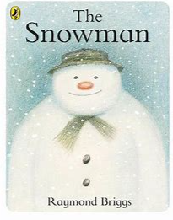  Retell-The snowman |  |  |  | Retell- The snowman |  |  | 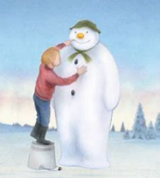  Instructions How to build a snowman.
Year 1 Genre Progression | Use past tense  Title  Include beginning, middle end  Chronological order  Story language; Once upon a time, one sunny day etc  Simple sentences  Structure needs to be correct  (Not to rewrite word for word / use said.) |  | Use past tense  Title  Include beginning, middle end  Chronological order  Story language; Once upon a time, one sunny day etc  Simple sentences  Structure needs to be correct  (Not to rewrite word for word / use said.) |  |  |  | Simple recount of a day  First person  Past tense  Dear Diary |  |  |  |  |  | Use past tense  Title  Include beginning, middle end  Chronological order  Story language; Once upon a time, one sunny day etc  Simple sentences  Structure needs to be correct  (Not to rewrite word for word / use said.) |  |  |  | Use past tense  Title  Include beginning, middle end  Chronological order  Story language; Once upon a time, one sunny day etc  Simple sentences  Structure needs to be correct  (Not to rewrite word for word / use said.) |  |  | Title  Numbered steps  Each step on a new line  What you need with bullet points  Time adverbial as an opener  Linked to personal experience  Present tense  Linked to oral instructions when playing
Year 2 Genre Progression | May create a story map or use pictures as prompts  Description of the character and setting  No comma would be used after the fronted adverbial opener until Year 3. |  | May create a story map or use pictures as prompts  Description of the character and setting  No comma would be used after the fronted adverbial opener until Year 3. |  |  |  | Dear Diary and date  Add in private / secret thoughts and feelings  First person (I, We, My)  Openers –  Past tense  Use time adverbials to show when things happened  Chronological order  Simple conclusion looks ahead to the future (future tense using the conjunction ‘If’) and includes a rhetorical question  Informal language (contractions) |  |  |  |  |  | May create a story map or use pictures as prompts  Description of the character and setting  No comma would be used after the fronted adverbial opener until Year 3. |  |  |  | May create a story map or use pictures as prompts  Description of the character and setting  No comma would be used after the fronted adverbial opener until Year 3. |  |  | Title with question  What you need  Introduction with a question  Command sentence / Imperative verbs as openers  -ly adverb at the start of the sentence  Top tip / warning  Link to fictional writing
Year 1  Grammar and Punctuation | Write a sentence starting with an opener and ending with a full stop.  Use adjectives to describe a noun (size and colour). |  | Think, say and remember a sentence that starts with a time adverbial or an opener.  Time adverbial / opener always starts with a capital letter. |  |  |  | Use the personal pronoun ‘I’ (when writing a personal recount).  To write in the first person, I, My, We, They, me). |  |  |  |  |  | Use a capital letter for names of people.  Use the conjunction ‘and’ to join two words. (The tree was tall and green). |  |  |  | Include an exclamation mark to demarcate exciting sentences (Suddenly, Quickly, As quick as a flash). |  |  | Write in the present tense (instructions).  Write a sentence starting with a time adverbial and ending with a full stop (non-fiction)
Year 2  Grammar and Punctuation | Use the conjunction ‘but’.  Recognise and write an exclamative sentence using What or How. |  | Use ‘when’ as an opener/at the start of a sentence. |  |  |  | Use ‘when’ as a sentence opener  I can use an apostrophe to show contraction in my written work. |  |  |  |  |  | Consolidate all skills in a retell |  |  |  | Use the conjunctions ‘because’ in fiction writing. |  |  | Recognise and write a command sentence with a imperative (bossy) verb and punctuate it with an exclamation mark or a full stop.  Use commas in a list (to list nouns in a sentence).
Handwriting Year 1 - Form uppercase letters correctly, starting and finishing in the right place.
Handwriting Year 2 - Leave equal spaces between words.
Year 1
Spelling
Year 2
Spelling
Spring 1
Geography – What is the weather like where we live?
Text and Genre | Retell  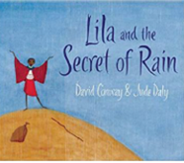 | Diary  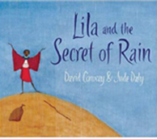 |  |  |  | 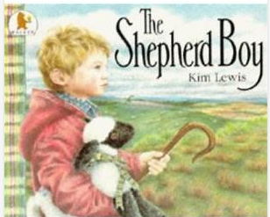  Retell |  |  |  |  |  | Season Non-chronological Report  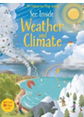 |  |  |  | Riddle Food  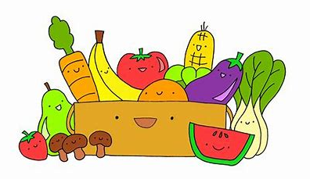 |  |  | Riddle (weather and seasons)  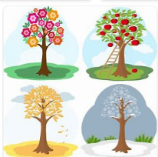
Year 1 Genre Progression | Use past tense  Title  Include beginning, middle end  Chronological order  Story language; Once upon a time, one sunny day etc  Simple sentences  Structure needs to be correct  (Not to rewrite word for word / use said.) | Simple recount of a day  First person  Past tense  Dear Diary |  |  |  | Use past tense  Title  Include beginning, middle end  Chronological order  Story language; Once upon a time, one sunny day etc  Simple sentences  Structure needs to be correct  (Not to rewrite word for word / use said.) |  |  |  |  |  | Facts gathered as a class  Topic related vocabulary  Given title  Labelled pictures  Present tense |  |  |  | Riddle  What am I?  Openers  New clue, new line.  Present tense.  Conjunctions – and  Tease the reader.  Adjectives |  |  | Riddle  What am I?  Openers  New clue, new line.  Present tense.  Conjunctions – and  Tease the reader.  Adjectives
Year 2 Genre Progression | May create a story map or use pictures as prompts  Description of the character and setting  No comma would be used after the fronted adverbial opener until Year 3. | Dear Diary and date  Add in private / secret thoughts and feelings  First person (I, We, My)  Openers –  Past tense  Use time adverbials to show when things happened  Chronological order  Simple conclusion looks ahead to the future (future tense using the conjunction ‘If’) and includes a rhetorical question  Informal language (contractions) |  |  |  | May create a story map or use pictures as prompts  Description of the character and setting  No comma would be used after the fronted adverbial opener until Year 3. |  |  |  |  |  | Title  Introduction  Include question  Subheadings (given)  Paragraphs (from given structure)  Ending/closing sentence  Scientific/technical language |  |  |  | Riddle  What am I?  Openers  New clue, new line.  Present tense.  , but  Conjunctions – and, that, When, If, or, because.  Tease the reader.  Commas in a list.  Adjectives |  |  | Riddle  What am I?  Openers  New clue, new line.  Present tense.  , but  Conjunctions – and, that, When, If, or, because.  Tease the reader.  Commas in a list.  Adjectives
Year 1  Grammar and Punctuation | Use a wider variety of openers (Once upon a time…)  Increase use of a variety of time adverbials (Later, Soon, At last….) | Use adjectives to describe thoughts and feelings (diary entry). |  |  |  | Use a question mark to demarcate a question sentence starting with Will and What. |  |  |  |  |  | Use the conjunction ‘and’ in non-fiction writing.  Use non-fiction openers |  |  |  | Use new sentence openers - I have, I am, You (riddles). |  |  | Use the conjunction ‘and’ when writing a riddle.  AFL *
Year 2  Grammar and Punctuation | Use the conjunction ‘but’.  Recognise and write an exclamative sentence using What or How. | Use ‘If’’ as an opener/at the start of a sentence. |  |  |  | Consolidate all skills in a retell |  |  |  |  |  | Use a question in non-fiction writing.  Use the conjunctions ‘because’, and ‘and’ in non-fiction writing.  Use a wider range of non-fiction openers |  |  |  | Use commas in a list (to list adjectives in a sentence).  Use a wider variety of sentence openers.  E.g., Often, Sometimes, Usaully… |  |  | Use the conjunction ‘or’.  I can use an apostrophe to show contraction in my written work.  .
Handwriting Year 1 - My letters are close together when I write a word (snuggle my letters).
Handwriting Year 2 - Start using some of the horizontal strokes to join letters.
Year 1 Spelling
Year 2
Spelling
Spring 2
Science – what makes objects move, change speed, or change direction? |  |  |  |  |  |  |  |  |  |  | History - How have Neil Armstrong and Amelia Earhart contributed to exploration?
Text and Genre | 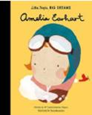  Recount- Amelia Earhart | 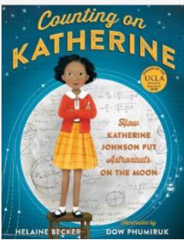  Recount – Katherine Johnson |  |  |  |   Man on the moon – Instructions for a timetable of Bob’s Day. |  |  |  |  |  | 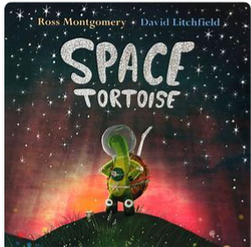  Retell |  |  |  | 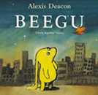  Retell |  |  | 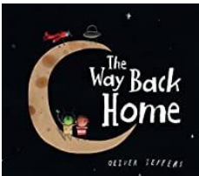  Retell
Year 1 Genre Progression | Use first person.  Use time words. Chronological.  Use information based on a real event/experience. | Use first person.  Use time words. Chronological.  Use information based on a real event/experience. |  |  |  | Title with question  What you need  Introduction with a question  Command sentence / Imperative verbs as openers  -ly adverb at the start of the sentence  Top tip / warning  Link to fictional writing |  |  |  |  |  | Use past tense  Title  Include beginning, middle end  Chronological order  Story language; Once upon a time, one sunny day etc  Simple sentences  Structure needs to be correct  (Not to rewrite word for word / use said.) |  |  |  | Use past tense  Title  Include beginning, middle end  Chronological order  Story language; Once upon a time, one sunny day etc  Simple sentences  Structure needs to be correct  (Not to rewrite word for word / use said.) |  |  | Use past tense  Title  Include beginning, middle end  Chronological order  Story language; Once upon a time, one sunny day etc  Simple sentences  Structure needs to be correct  (Not to rewrite word for word / use said.)
Year 2 Genre Progression | Chronological events  5w’s to introduce  Use proper nouns  Emotions to describe feelings (I was excited when….)  Final statement (My favourite part was…)  Details to interest the reader  Exclamative sentence to close | Chronological events  5w’s to introduce  Use proper nouns  Emotions to describe feelings (I was excited when….)  Final statement (My favourite part was…)  Details to interest the reader  Exclamative sentence to close |  |  |  | Title with question  What you need  Introduction with a question  Command sentence / Imperative verbs as openers  -ly adverb at the start of the sentence  Top tip / warning  Link to fictional writing |  |  |  |  |  | May create a story map or use pictures as prompts  Description of the character and setting  No comma would be used after the fronted adverbial opener until Year 3. |  |  |  | May create a story map or use pictures as prompts  Description of the character and setting  No comma would be used after the fronted adverbial opener until Year 3. |  |  | May create a story map or use pictures as prompts  Description of the character and setting  No comma would be used after the fronted adverbial opener until Year 3.
Year 1  Grammar and Punctuation | Consolidation of capital letters for the names of people and places. | Consolidation of capital letters for the names of people and places. |  |  |  | Consolidation of previously taught skills. |  |  |  |  |  | Increase use of a variety of time adverbials (Later, Soon, At last….) |  |  |  | Use ‘and’ to join words and to join clauses in sentences. |  |  | Consolidation of using ‘and’ to join words and to join clauses in sentences.
Year 2  Grammar and Punctuation | Use an -ly adverb as an opener Interestingly, Amazingly,… | Use an -ly adverb as an opener Interestingly, Amazingly,… |  |  |  | Use commas in a list to list three actions. |  |  |  |  |  | adding the suffix -ful (careful, fearful, powerful, dreadful, wonderful, playful, beautiful). |  |  |  | Wider range of openers  E.g., In the street..  Add the suffix -ly to change a word from an adjective to an adverb and use as a sentence openers. |  |  | Use the conjunction ‘or’.  Linked to a question. Will the boy get home or will he be stranded on the moon?
Handwriting Year 1 - I fill the line with my writing.
Handwriting Year 2 - Start using some of the horizontal strokes to join letters.
Year 1
Spelling
Year 2
Spelling
Summer 1
Science- What do plants need to live and grow? |  |  |  |  |  |  |  |  |  | Geography – What is a rainforest and what are its physical features?
Text and Genre | 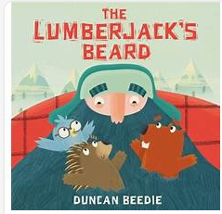  The Lumberjacks Beard- Character Description | Retell |  |  |  | 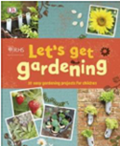  Instructions to plant seeds |  |  |  |  |  | 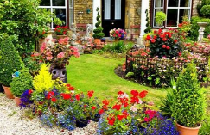  Setting Description of a beautiful garden or park. |  |  |  | 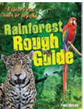  Non-chronological report the layers of the rainforest |  |  | 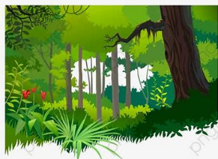  List Poem for the Rainforest
Year 1 Genre Progression | Wanted poster  Picture annotated  Name of character  What they look like  Simple adjectives (colour and size)  Appearance and personality (appropriate words)  Actions – what does your character do in the story?  Present tense | Use past tense  Title  Include beginning, middle end  Chronological order  Story language; Once upon a time, one sunny day etc  Simple sentences  Structure needs to be correct  (Not to rewrite word for word / use said.) |  |  |  | Title  Numbered steps  Each step on a new line  What you need with bullet points  Time adverbial as an opener  Linked to personal experience  Present tense  Linked to oral instructions when playing |  |  |  |  |  | Use senses (see and hear) to compile a word bank of adjectives to describe setting through visual stimulus  First person  Present tense |  |  |  | Facts gathered as a class  Topic related vocabulary  Given title  Labelled pictures  Present tense |  |  | A ‘list poem’ gets its name from the fact that most of the poem is made up of a long list of things. A list poem usually has a few lines at the beginning, a list in the middle and a few lines at the end.  Rainforest List poem.  Under the enormous canopy many creatures hide.  There might be...  Colourful parrots squawking,  chattering monkeys swinging,  sleeping sloths slouching,  tiny millipedes marching,  sneaky snakes slithering,  Their magical world is a mystery to us all!
Year 2 Genre Progression | Present tense  Describe how the character looks using adjectives and simple similes  Use because / when to describe their personality and actions  Use an ! in an exciting sentence  Include how other characters feel about the character I am describing  Say what I like / dislike about the character. Identify where – using prepositions Select effective vocabulary and up level. Begin to experiment with word order in sentence structure, -ly adverbs to describe how an action was performed | May create a story map or use pictures as prompts  Description of the character and setting  No comma would be used after the fronted adverbial opener until Year 3. |  |  |  | Title with question  What you need  Introduction with a question  Command sentence / Imperative verbs as openers  -ly adverb at the start of the sentence  Top tip / warning  Link to fictional writing |  |  |  |  |  | Describe using the senses – what the character can see, hear, smell, touch and how they feel  Identify where – using prepositions  Similes  Expanded Noun Phrase  Range of openers (Far away, In the distance)  Past tense  If the setting writing is part of a story, rhetorical questions relating to the characters may be asked. |  |  |  | Title  Introduction  Include question  Subheadings (given)  Paragraphs (from given structure)  Ending/closing sentence  Scientific/technical language
Year 1  Grammar and Punctuation | Addition of adjective to improve a sentence. | Focus on using the question words – Where and Who to begin a question sentence. |  |  |  | Revision of writing in the present tense (instructions). |  |  |  |  |  | Addition of adjective to improve a sentence. |  |  |  | Revision of using capital letter for names of places and the days of the week. |  |  | Correct any misspelt Year 1 Common Exception Words and many Year 1 Spelling rules.
Year 2  Grammar and Punctuation | To use effective word choices and create a list of adjectives to describe a noun. | Consolidation of using ? and ! |  |  |  | Add the suffix -ly to change a word from an adjective to an adverb and use as a sentence openers. |  |  |  |  |  | Use a comma to separate adjectives when describing a noun. |  |  |  | Use an apostrophe to show singular possession. |  |  | Consolidation of previously taught skills.
Handwriting Year 1 - Fill the line with writing and start a new line when there is not enough space to write the complete word.
Handwriting Year 2 -- Start to join handwriting.
Year 1
Spelling
Year 2
Spelling
Summer 2
History - Who is Queen Elizabeth II and what is her job?

Text and Genre | 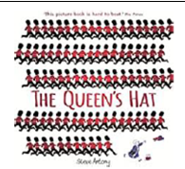  Retell – The Queen’s Hat | Instructions for afternoon tea.  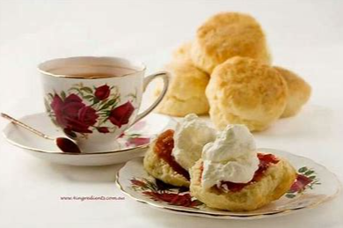 |  |  |  | 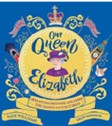  Recount of her life |  |  |  |  |  |  |  |  |  | 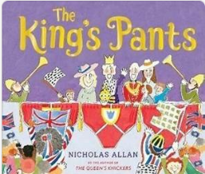  Retell- The King’s Pants |  |  | Letter to New Teacher  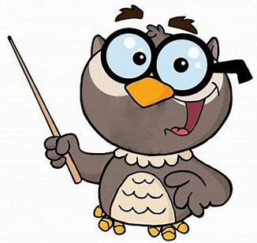
Year 1 Genre Progression | Use past tense  Title  Include beginning, middle end  Chronological order  Story language; Once upon a time, one sunny day etc  Simple sentences  Structure needs to be correct  (Not to rewrite word for word / use said.) | Title  Numbered steps  Each step on a new line  What you need with bullet points  Time adverbial as an opener  Linked to personal experience  Present tense  Linked to oral instructions when playing |  |  |  | Use first person.  Use time words. Chronological.  Use information based on a real event/experience. |  |  |  |  |  |  |  |  |  | Use past tense  Title  Include beginning, middle end  Chronological order  Story language; Once upon a time, one sunny day etc  Simple sentences  Structure needs to be correct  (Not to rewrite word for word / use said.) |  |  | Simple format (To, From)  First person  An informal greeting (Hi)  Add a few sentences  First sentence starts on a new line  From on a new line and add my name  Date
Year 2 Genre Progression | May create a story map or use pictures as prompts  Description of the character and setting  No comma would be used after the fronted adverbial opener until Year 3. | Title with question  What you need  Introduction with a question  Command sentence / Imperative verbs as openers  -ly adverb at the start of the sentence  Top tip / warning  Link to fictional writing |  |  |  | Chronological events  5w’s to introduce  Use proper nouns  Emotions to describe feelings (I was excited when….)  Final statement (My favourite part was…)  Details to interest the reader  Exclamative sentence to close |  |  |  |  |  |  |  |  |  | May create a story map or use pictures as prompts  Description of the character and setting  No comma would be used after the fronted adverbial opener until Year 3. |  |  | Address and date (Given)  Greeting (From a choice)  Past tense  Introduction (why you are writing)  More details  Final sentence written in the present tense (what the sender wants the recipient to do next)  Signing off (given)  Personal thoughts and feelings  Informal (use contractions)
Year 1  Grammar and Punctuation | Consolidation of previously taught skills. | Consolidation of previously taught skills. |  |  |  | Consolidation of previously taught skills. |  |  |  |  |  |  |  |  |  | Consolidation of previously taught skills. |  |  | Consolidation of previously taught skills.
Year 2  Grammar and Punctuation | Consolidation of previously taught skills. | Consolidation of previously taught skills. |  |  |  | Consolidation of previously taught skills. |  |  |  |  |  | Consolidation of previously taught skills. |  |  |  | Consolidation of previously taught skills. |  |  | Consolidation of previously taught skills.
Handwriting Year 1 - Fill the line with writing and start a new line when there is not enough space to write the complete word.
Handwriting Year 2 -- Start to join handwriting.
Year 1
Spelling
Year 2
Spelling

