- All new vocabulary will be displayed on Working Walls in the classroom environment.  - WAGOLL to use for whole class teaching demonstrating the skills and vocabulary expectations.  - Learning is progressive and therefore texts and skills need to be taught in chronological order.  - New ambitious vocabulary will be introduced and pre taught by staff weekly using a range of adjectives, verbs, nouns, adverbs. |  |  |  | “Dictation gives children opportunities to practise and apply their spelling knowledge and segmenting skills, without having to compose sentences by themselves. It requires them to distinguish between the sounds they hear in order to choose the correct graphemes to represent the sounds and to form the letters correctly.” Research and Review, May 2022
Autumn 1
Science How do humans see? |  |  |  |  | History – What impact did the Industrial Revolution have on our area?
Text and Genre | Retell- Leather Shoe Charlie  1 week  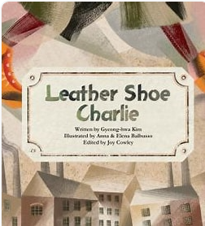 | Diary Entry for various parts of the story  2 weeks | Own story- Eye of the Storm- Literacy shed (Alternative ending)  2 weeks  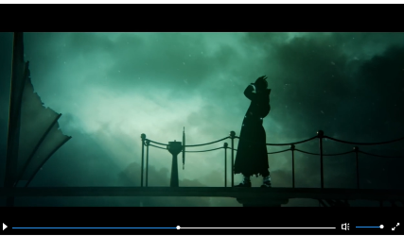 |  |  | Non- Chronological Report- Impact of the Industrial Revolution  2 weeks  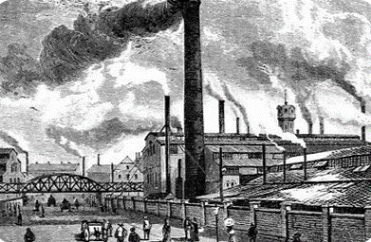
Year 5 Genre Progression | Describe setting, characters and atmosphere.  Describe the character and include their feelings using show don’t tell. Use show don’t tell to build suspense. Use short sentences for tension. Cliff hanger questions.  Use dialogue to convey a character and advance the action.  Use organisational and presentational devices that are relevant to the text type, for example, underlining / uppercase. | Past perfect tense.  Organised into paragraphs, with the day’s events developed and expanded through descriptive detail.The opening locates the events precisely in time and the piece concludes by looking ahead to the following day.  Language choices to reflect the theme (historical etc.).  Include a quote.  Move between tenses within paragraphs – own choice. | Choose a planning frame/format  Write for the given audience  Use rich and varied vocabulary thinking  about the intensity of words |  |  | Independent research.  Select own sub-headings.  Use examples for presentation/structure.  Include a glossary.  Consider audience (fun, factual etc).
Year 6 Genre Progression | Author’s style of writing and use appropriate author’s voice  Consider purpose and audience  Changing tenses – flashback | Multiple entries  Include suspense  Changing moods and emotions  Maintaining tense and writer’s voice  Subjunctive form  Active and passive voice  Formality for effect  Consider the audience, purpose and write using the appropriate author’s voice | There may be a quest and the main  character may be confronted with a  number of dilemmas that are overcome /  or not by the end of the story  May include a sequence of fast-moving  events  Dialogue is used to introduces the  characters and may establish reason for  the journey, advancing the action in the  story from the very beginning  Consider the audience, purpose and  write appropriately.  Include emotive language  Author’s style of writing and use  appropriate author’s voice.  Changing tenses – flashback |  |  | Presentation/structure to be independently planned  References sources of data  Independent research  Use a range of presentational devices (table, diagram)  Include questions for intrigue/to entice the reader  Author’s style of writing and use appropriate author’s voice  Consider purpose and audience
Year 5  Grammar and Punctuation | Insert whole sentences to describe setting and characters.  Use show don’t tell to build suspense, to introduce a dilemma in a story and convey a character’s emotions.  Include direct speech in my stories but changing where the reporting clause is in the sentence (beginning, middle, end). | Link sentences and paragraphs using coordinating and subordinating conjunction.  Use noun phrases with a modifier, choosing words carefully to really ‘show’ the reader what I am describing. | Use relative clauses beginning with who, which, where, when, whose, that or with an implied (i.e. omitted) relative pronoun. |  |  |  | Use a colon to introduce a list within a sentence.  Punctuate bullet points consistently in non-fiction.
Year 6  Grammar and Punctuation | In narratives, describe settings, characters and atmosphere.  Inverted commas and other punctuation to indicate direct speech. | Use commas to demarcate relative clauses, reporting clauses, embedded clauses and to separate the subordinate clause from the main clause where the subordinate clause comes first.  Make purposeful choices with adverbs, adjectives, ENPs and adverbials to make writing more descriptive. | Use dialogue to suggest a character’s feelings  My heart’s pounding like a drum and I can’t catch my breath,”  muttered Dominique. |  |  |  | Use colons to introduce a list and punctuate bullet points consistently.  Use sentences with lists to give a number of pieces of information succinctly (e.g., component parts, features of locations…)
Handwriting Year 5 - Adapt handwriting style according to the purpose of the writing.
Handwriting Year 6 - Maintain legibility and consistency in joined handwriting when writing at speed.

Autumn 2
Science – How important is our heart and circulatory system? |  |  |  | Geography- How have mountains and rivers shaped the landscape of the UK?
Text and Genre | Character Description  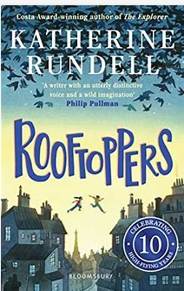 | Setting Description | Diary Entry -choose character |  | Instructions for preparing for a possible flood  2 weeks  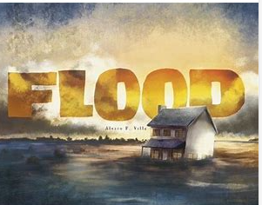 | Free Verse Poetry inspired by the pictures of the book.  2 weeks  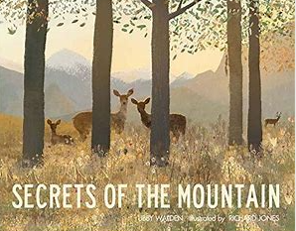
Year 5 Genre Progression | Written in the past / past tense.  Describe the character and included their feelings by using show don’t tell.  Including speech and moving the action on. | Include two adjectives in my fronted adverbial of place.  “Under the ancient, crumbling bridge,”  Using rich description to interest the reader such as metaphors, personification, and onomatopoeia. | Past perfect tense.  Organised into paragraphs, with the day’s events developed and expanded through descriptive detail.The opening locates the events precisely in time and the piece concludes by looking ahead to the following day.  Language choices to reflect the theme (historical etc.).  Include a quote.  Move between tenses within paragraphs – own choice. |  | Informal / formal instructions could be humorous or formal.  Hook the reader in the introduction  Sophisticated / appropriate use of adverbs / adjectives  Awareness of the audience  Add a recommendation.  You may want to close your eyes for this next step. | Free Verse poems  Tell a story, describe something or explain an emotion.  These poems do not need to rhyme or use a structure.  Figurative language.  language linked to the topic.  Capital letters at the beginning of each line.  Free verse poems do not have a certain number of syllables per line.  They do not rhyme, and other language devices may be used.  Lines can be single words, phrases, or sentences.  Own vocabulary choices.  .
Year 6 Genre Progression | Written in the past / past tense.  Describe the character and included their feelings by using show don’t tell.  Including speech and moving the action on. | Power of three fronted adverbials  Personification of the weather  Evocative language to create a mood, strong feelings, memories, or emotions back  Consider the audience, purpose and write using the appropriate author’s voice | Multiple entries  Include suspense  Changing moods and emotions  Maintaining tense and writer’s voice  Subjunctive form  Active and passive voice  Formality for effect  Consider the audience, purpose and write using the appropriate author’s voice |  | Develop an introduction – add background.  If appropriate add personal advice using parentheses  Select own title, headings and presentational devices  Use pictures, diagrams, flow charts and symbols (if appropriate) to present information independently  Use brackets to add asides  Author’s style of writing and use appropriate author’s voice.  Consider purpose and audience.
Year 5  Grammar and Punctuation | Use a range of figurative language (metaphors, onomatopoeia, personification). | Use more sophisticated metaphors to describe things in my writing.  Use a metaphor as an opener.  Use personification.  In narratives describing settings, characters and atmosphere and integrating dialogue to advance the action.  Use ISPACED (ing word, simile, preposition, adverb, conjunction, -ed word, dialogue) to open a sentence. | Confidently use the correct tense throughout a piece of writing (even if it means a change of tense). |  | Include complex sentences, which start with a subordinating conjunction followed by a comma. | Use parenthesis to add detail and description.
Year 6  Grammar and Punctuation | Use a range of figurative language (metaphors, onomatopoeia, personification). | Use a range of figurative language (metaphors, onomatopoeia, personification).  Use simple sentences to build tension. | Use hyphens and ellipses. |  | Use sentences with lists to give a number of pieces of information succinctly (e.g., component parts, features of locations…)  Add a comma to avoid ambiguity and change the meaning of a single clause sentence with adverbials. | Use semi-colons to mark boundaries between independent clauses.
Handwriting Year 5 - Adapt handwriting style according to the purpose of the writing.
Handwriting Year 6 - Maintain legibility and consistency in joined handwriting when writing at speed.

Spring 1
Science – |  |  | Geography – What do we know about the Victorians and the way they lived in Glossop?
Text and Genre | Explanation Text- Circulatory System  (Sticky knowledge from previous half term’s Science) (2 weeks)  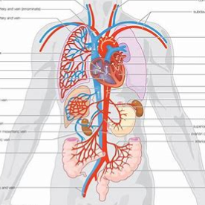 | Letter to the Secretary of the Duke (1 week)  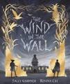 |  | The Shark Caller Balanced Argument- For and against being a Shark Caller  (2 weeks)  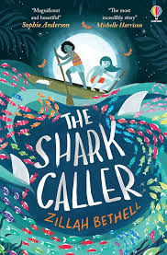 | Limerick Poem based on the moth.  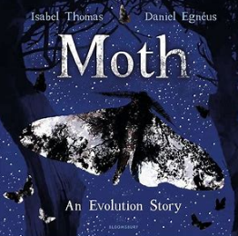  ( 1 week)
Year 5 Genre Progression | Passive voice.  Wider range of cause-and-effect conjunctions.  Effect and cause conjunctions because / as / since / for  They cannot be made quickly because of the intricate designs.  Put into context.  Compare and contrast vocabulary.  The sun is an amazing 864, 000 miles in diameter, unbelievably stars have been found which are 100 times bigger.  Glossary.  Draw the reader in.  Independently start to consider presentation. | Include a range of tenses – own choice.  Include colloquialism  Cohesion; referring back, pronouns  Consider the audience, purpose and write using the appropriate author’s voice |  | Include facts and opinions  Use modal verbs and degrees of possibility.  Facts and statistics.  Persuasive openers.  Rule of three.  Conjunctions of cause | Limerick Poem  They are five lines long  They all follow the following rhyme scheme: AABBA rhyme scheme  – the first line must rhyme with the 2nd and 5th line. And lines 3 and  4 must rhyme. They usually include humour  Stanza of 5 lines  The first, second and fifth line are rhyme with each other  The third and fourth line rhyme with each other. Consider the  syllables on each line. The first, second and fifth line all have  between 8 to 9 syllables  The third and fourth line have between 5 to 6 syllables
Year 6 Genre Progression | More ownership  Independent research and presentation  Decide where diagrams, illustrations, or a flow chart would help explain.  Author’s style of writing and use appropriate author’s voice.  Consider purpose and audience. | Include a range of tenses – own choice.  Include colloquialism  Cohesion; referring back, pronouns  Consider the audience, purpose and write using the appropriate author’s voice |  | Introduce the debate with background information.  Argument for the issue with supporting evidence.  Phrases of debate.  Facts and statistics.  Technical vocabulary.  Passive voice.
Year 5  Grammar and Punctuation | Use the past perfect form to mark relationship of time and cause. | Use modal verbs to indicate probability and/or obligation. |  | Use persuasive openers in my writing. | Use a thesaurus to find synonyms to improve my writing.
Year 6  Grammar and Punctuation | Use colons, semi-colons and dashes deliberately, according to formality, context and the effect that is trying to be created. | Use the subjunctive form in formal writing and speech. |  | Select ambitious vocabulary to engage and enhance my writing. | Use a thesaurus to find synonyms to improve my writing.
Handwriting Year 5 - Choose the writing implement that best suits the task.
Handwriting Year 6 - Maintain legibility and consistency in joined handwriting when writing at speed.

Spring 2
Science – |  |  |  | Geography – How does the Caribbean compare with the UK?
Text and Genre | Retell  The Lighthouse  Short animation from the Literacy Shed  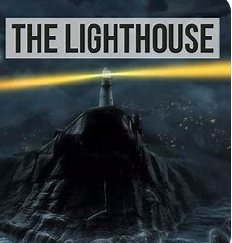  (1 week) | Setting-(Arriving at Southampton.)  (1 week)  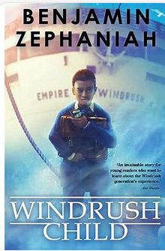 | Informal Letter  (2 weeks) |  | Balanced Argument -Pros and Cons of moving to England.  (2 weeks)
Year 5 Genre Progression | Describe setting, characters and atmosphere.  Describe the character and include their feelings using show don’t tell. Use show don’t tell to build suspense. Use short sentences for tension. Cliff hanger questions.  Use dialogue to convey a character and advance the action.  Use organisational and presentational devices that are relevant to the text type, for example, underlining / uppercase. | Include two adjectives in my fronted adverbial of place.  “Under the ancient, crumbling bridge,”  Using rich description to interest the reader such as metaphors, personification, and onomatopoeia | Include a range of tenses – own choice.  Include colloquialism  Cohesion; referring back, pronouns  Consider the audience, purpose and write using the appropriate author’s voice |  | Include facts and opinions  Use modal verbs and degrees of possibility.  Facts and statistics.  Persuasive openers.  Rule of three.  Conjunctions of cause
Year 6 Genre Progression | Author’s style of writing and use appropriate author’s voice  Consider purpose and audience  Changing tenses – flashback | Power of three fronted adverbials  Personification of the weather  Evocative language to create a mood, strong feelings, memories, or emotions back  Consider the audience, purpose and write using the appropriate author’s voice | Include a range of tenses – own choice.  Include colloquialism  Cohesion; referring back, pronouns  Consider the audience, purpose and write using the appropriate author’s voice |  | Introduce the debate with background information.  Argument for the issue with supporting evidence.  Phrases of debate.  Facts and statistics.  Technical vocabulary.  Passive voice.
Year 5  Grammar and Punctuation | Understand the importance of cohesion in my writing in fiction writing. I use place, time or manner adverbials to ensure cohesion in and across paragraphs. | Use ISPACED (ing word, simile, preposition, adverb, conjunction, -ed word, dialogue) to open a sentence. | Use show don’t tell to build suspense, to introduce a dilemma in a story and convey a character’s emotions. |  | Ask a rhetorical question to appeal directly to the reader.  Use modal verbs and adverbs to show the possibility of something happening.
Year 6  Grammar and Punctuation | Integrate dialogue in narratives to convey character and advance the action. | To use semi- colons in descriptive writing. | Understand the between vocabulary typical of informal speech and  vocabulary appropriate for formal speech and writing. |  | Use adverbials to introduce an argument (Firstly).  Use adverbials to form links between arguments and develop arguments, to signal an illustration of a proceeding point.  Use linking adverbials (adverbials of cause) in an explanation text to show reasons or results.  Use adverbials to introduce a concluding paragraph (Having considered all of the arguments… In Summary, To conclude,).  Use adverbials in different places in a sentence (On one hand…. whereas/yet/however…).
Handwriting Year 5 - Choose the writing implement that best suits the task.
Handwriting Year 6 - Maintain legibility and consistency in joined handwriting when writing at speed.

Summer 1
History – Who were the suffragettes and what did they achieve? |  |  |  | Science- Circuits
Text and Genre | Retell the opening section  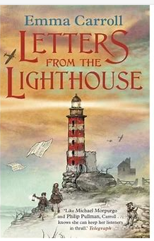 | Character description of Sukie | Formal Missing Person’s Report |  | Balanced Argument- Should children be Evacuated | Letter home to mum
Year 5 Genre Progression | Describe setting, characters and atmosphere.  Describe the character and include their feelings using show don’t tell. Use show don’t tell to build suspense. Use short sentences for tension. Cliff hanger questions.  Use dialogue to convey a character and advance the action.  Use organisational and presentational devices that are relevant to the text type, for example, underlining / uppercase. | Written in the past / past tense.  Describe the character and included their feelings by using show don’t tell.  Including speech and moving the action on. | Indirect speech.  Main body.  Verbs selected for meaning and effect.  Precise vocabulary choices. Paragraphs and caption.  Journalistic words and phrases.  By-line (who wrote it).  Conclusion (plan for the future). |  | Can take the form of a balanced argument  Introduce the debate with background information.  Argument for the issue with supporting evidence.  Argument against the issue with supporting evidence.  Phrases of debate.  Facts and statistics.  Technical vocabulary.  Passive voice. | Include a range of tenses – own choice.  Include colloquialism  Cohesion; referring back, pronouns  Consider the audience, purpose and write using the appropriate author’s voice
Year 6 Genre Progression | Author’s style of writing and use appropriate author’s voice  Consider purpose and audience | Written in the past / past tense.  Describe the character and included their feelings by using show don’t tell.  Including speech and moving the action on. | Précis key events Lead the reader to reflect on the events Skilfully manages of shits in time (past, present and future)  Appropriate presentation Reconstruct, interpret and communicate events  Passive voice First-hand accounts Paints a vivid and dramatic picture Distinctive voices of individuals  Thoughtful ending  Closing editorial comment adapts a more personal stance |  |  | Include a range of tenses – own choice.  Include colloquialism  Cohesion; referring back, pronouns  Consider the audience, purpose and write using the appropriate author’s voice
Year 5  Grammar and Punctuation | Use relative clauses that are a type of subordinate clause which gives more information about the noun. They contain a verb and usually a relative pronoun. (e.g. The boy, who worked extremely hard, achieved high marks in the test.) | Use rich description for interest, (metaphors, personification, onomatopoeia)  Use a metaphor as an opener. | Use a rhetorical question to make the reader think.  Use an embedded relative clause, marked with commas for parenthesis.  Know the difference between direct speech and reported speech. |  | Use brackets to add parenthesis.  Use a comma before the relative clause if it is providing extra, non-essential information and is after the main clause. | Use dashes to add parenthesis.  Use short sentences to build suspense.
Year 6  Grammar and Punctuation | Use varied sentence structure in my writing (e.g. fronted adverbials,  subordinate clauses and short sentences for effect). | Make purposeful choices with adverbs, adjectives, ENPs and adverbials to make writing more descriptive. | Use quotes for effective purpose in newspaper reports – to add authenticity and make them more memorable.  Use the passive voice to make the object more important in the sentence than the subject.  Exercise a conscious control over levels of formality (particularly through manipulating grammar and vocabulary). |  | Exercise a conscious control over levels of formality (particularly through manipulating grammar and vocabulary).  Use the perfect form of verbs to mark relationships of time and cause. | Consolidation of previously taught skills.
Handwriting Year 5 - Maintain legibility in joined handwriting when writing at speed.
Handwriting Year 6 -- Maintain legibility and consistency in joined handwriting when writing at speed.

Summer 2
Science –Materials |  |  | Geography – What is global trade and how does it impact the World?
Text and Genre | Instructions  Instructions on how to save your pocket money.  (2 weeks)  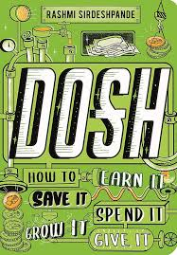 | Diary Entry  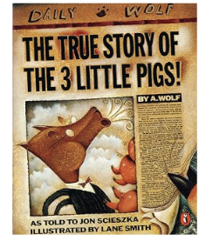  The true story of the Three Little Pigs (2 weeks) |  | Own Little People Big Dreams Book- Aspiration Life!  Biography (2 weeks)  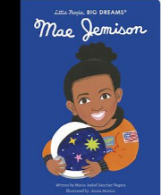  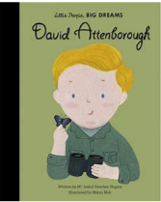 | The Lost Words- Poetry (1 week)  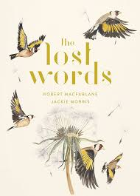
Year 5 Genre Progression | Informal / formal instructions could be  Humorous or formal.  Hook the reader in the introduction  Sophisticated / appropriate use of  adverbs / adjectives  Awareness of the audience  Add a recommendation  You may want to close your eyes for  This next step. | Past perfect tense.  Organised into paragraphs, with the day’s events developed and expanded through descriptive detail.The opening locates the events precisely in time and the piece concludes by looking ahead to the following day.  Language choices to reflect the theme (historical etc.).  Include a quote.  Move between tenses within paragraphs – own choice. |  | Key influences in the person’s life, their relationship with other. people and who  inspired them  Own inspirational character  Own research / link to interviews  Includes links to inferences of the time  Children could choose someone who inspired them.  Examples of books above- there are more in the library and in other year groups. | Narrative poems  Narrative poems tell a story  They include rhythm and rhyme  Rhythm and rhyme give the narrative dynamics  They can include repetition to add rhythm and make it more  predictable  They can be short narrative poem and describes something that  has happened  There are some similarities between Free verse and Narrative  poems, but they are not the same
Year 6 Genre Progression | Develop an introduction – add  background  If appropriate add personal advice using  parentheses  Select own title, headings and  presentational devices  Use pictures, diagrams, flow charts  and symbols (if appropriate) to present  information independently  Use brackets to add asides | Multiple entries  Include suspense  Changing moods and emotions  Maintaining tense and writer’s voice  Subjunctive form  Active and passive voice  Formality for effect  Consider the audience, purpose and write using the appropriate author’s voice
Year 5  Grammar and Punctuation | Use informal and humorous language to have an effect on the reader.  Use informal and humorous language to have an effect on the reader. | Use expanded noun phrases. |  | Use brackets to add parenthesis. | Consolidation of previously taught skills.
Year 6  Grammar and Punctuation |  | Write in the subjunctive form, use the verb ‘were’ instead of ‘was’ to create a more formal sentence. |  | Add a comma to avoid ambiguity and change the meaning of a single clause sentence with adverbials. |  | Consolidation of previously taught skills.
Handwriting Year 5 - Maintain legibility in joined handwriting when writing at speed.
Handwriting Year 6 - Maintain legibility and consistency in joined handwriting when writing at speed.

