- All new vocabulary will be displayed on Working Walls in the classroom environment.  - WAGOLL to use for whole class teaching demonstrating the skills and vocabulary expectations. |  |  |  | - Learning is progressive and therefore texts and skills need to be taught in chronological order.  - New ambitious vocabulary will be introduced and pre taught by staff weekly using a range of adjectives, verbs, nouns, adverbs.
Autumn 1
History -How did life in Derbyshire change from the Stone Age to the Iron Age? |  |  |  |  | Science-Sound
Text and Genre | Retell- Camille and the Sunflowers  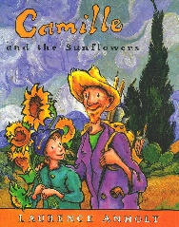 | 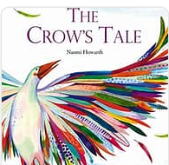  Retell- The Crows Tale | Diary- Stone Age Boy  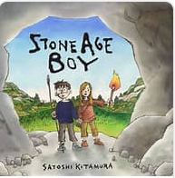  Opening Section of the book |  |  | Retell- The Hunt | 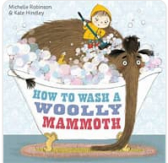  Instructions- How to Wash a Woolly Mammoth | Retell- The Cave Baby  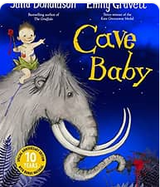
Year 3 Genre Progression | Title to make the reader want to read the story  Description of character OR setting | Title to make the reader want to read the story  Description of character OR setting | Varied language to convey thoughts and feelings. Adverbs as openers. Addresses the diary directly. Includes opinions and facts. Informal, chatty language  Ambitious words to describe people and settings. Talks about secret / private feelings and opinions. includes events that are important to the writer. |  |  | Title to make the reader want to read the story  Description of character OR setting | Persuasive introduction.  Subheadings – Equipment and method. Openers (time adverbials, imperative verbs, -ly adverbs +subordinating conjunctions).  use a range of openers.  Equipment subheading will be followed by a colon and bullet points. Technical vocabulary / scientific vocabulary. Prepositional phrases Top tips / safety tips / handy hints at the end. | Title to make the reader want to read the story. Using paragraphs to organise my writing  Include one piece of simple speech with inverted commas.  Detailed description of character OR setting
Year 4 Genre Progression | Independently structuring paragraphs around an idea  Show not tell for character’s emotions  Detailed description of character and setting  Still limit speech | Independently structuring paragraphs around an idea  Show not tell for character’s emotions  Detailed description of character and setting  Still limit speech | Talks about feelings, reactions an opinion. Author explains reason for their actions. Ends with the authors present situation, wondering what they will do next. Varied language to convey thoughts and feelings and opinions (Show don’t tell). Justify why things happened. Select and maintain the appropriate tense (within given paragraphs). Use a rhetorical question with a subordinating conjunction. |  |  | Independently structuring paragraphs around an idea  Show not tell for character’s emotions  Detailed description of character and setting  Still limit speech | Rhetorical question in the introduction  Closing statement  More than one sentence for some steps | Independently structuring paragraphs around an idea  Show not tell for character’s emotions  Detailed description of character and setting  Still limit speech
Year 3  Grammar and Punctuation | Use a comma to separate adjectives when describing a noun.  Revision of Year 2 commas in a list. | Use powerful verbs to make my writing more interesting.  Revision of Year 2 coordinating conjunctions (and, or, but) | Begin to extend sentences to add more detail by using a variety of subordinating conjunctions at the start of a sentence to write a complex sentence. Before, After, While, As (+ Year 2)  Revision of Year 2 contractions.  . |  |  | Use more exciting adjectives and expanded noun phrases to help the reader clearly see what I am describing. | Use prepositions to express place.  Use a colon before a list in instructional writing (what you need:)Use adverbs of manner as openers (fronted adverbials)  Use prepositions as fronted adverbials | Write compound sentences by including co-ordinating conjunctions (or, and, but, so, yet).  Use inverted commas at the start and end of speech. Put the reporting clauses at the end of speech. Use an exclamation mark or a question mark before the closing inverted commas when the reporting clause is at the end of the speech.
Year 4  Grammar and Punctuation | Modify a noun phrase with an adjective.  Use ambitious adjectives to enhance the nouns in the writing.  Use the Standard Form of English, drawing on my knowledge of Subject Verb Agreement. | Choose the most appropriate verbs to accurately describe to the reader what is being described.  Revision of Year 3 coordinating conjucntions. (Year 2 + so, yet) | Extend sentences to add more detail by using a variety of subordinating conjunctions (All of Year 3 + during, since) at the start of a sentence.  Revision of contractions. |  |  | Modify a noun phrase with a noun or preposition | Use a comma after a fronted adverbial.  Choose the most appropriate nouns and pronouns. | Use the acronym FANBOYS to help me remember coordinating conjunctions  (All of Year 3 + for, nor).  Revision of Year 3 speech  Use a comma, an exclamation mark or a question mark before the closing inverted commas when the reporting clause is at the end of the speech.
Handwriting Year 3 - Use the diagonally and horizontal strokes that are needed to join letters.
Handwriting Year 4 - Understand which letters, when adjacent to one another, are best left unjoined.

Autumn 2
Geography- How does life in a polar region impact or influence people’s lives?
Text and Genre | Free Verse Poem  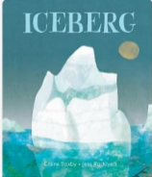 | Retell – Leaf   | Own Ending to the Story | Setting Description | Retell- Sky  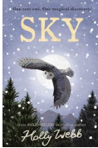 |  | Character Description
Year 3 Genre Progression | Free Verse  Free Verse poems tell a story, describe something or explain an emotion  These poems do not need to rhyme or use a structure  Figurative language linked to the topic  Capital letters at the beginning of each line  Free verse poems do not have a certain number of syllables per line  They do not rhyme, and other language devices may be used  Lines can be single words, phrases or sentences Own vocabulary choices | title to make the reader want to read the story  Include simple speech with inverted commas. Limited speech  Detailed description of character OR setting | Stick to the theme given, Use a story map (template given). Select own appropriate language Add my own title. Simple speech using inverted commas Paragraphs for time. Develop character through action and description. A beginning to introduce the characters and setting. A build up to give hints and clues about what is going to happen. A dilemma when something goes wrong. A resolution where the characters solve the problem. An ending to say what happens next. | Similes and metaphors  Fronted adverbials for place and manner  Adjective, adjective  Powerful verbs | title to make the reader want to read the story  Include simple speech with inverted commas. Limited speech  Detailed description of character OR setting |  | Past tense  More ambitious vocabulary choices  Range of prepositional phrases as openers  Similies and Metaphors  Include speech to show personality
Year 4 Genre Progression |  | Including build-up, problem, resolution (Story-map)  Independently structuring paragraphs around an idea  Show not tell for character’s emotions. Detailed description of character and setting  Direct speech to move the action on. 3 part speech – what they said, who said it and how they said it (adverb). Still limit speech | 3rd or 1st person  Use rich and varied vocabulary Paragraphs for time and/or events Show don’t tell  Speech with varied reporting clauses | What did they see?  Simile as a sentence opener  Show don’t tell to convey a character’s emotion  Beginning to use personification to describe things in my writing | Including build-up, problem, resolution (Story-map)  Independently structuring paragraphs around an idea  Show not tell for character’s emotions. Detailed description of character and setting  Direct speech to move the action on. 3 part speech – what they said, who said it and how they said it (adverb). Still limit speech |  | Y3 Skills  As part of a story
Year 3  Grammar and Punctuation | Use similes to add description to my writing. | Consistently use an apostrophe to show possession and use apostrophes in my writing to show singular possession.  Use a comma, an exclamation mark or a question mark before the closing inverted commas when the reporting clause is at the end of the speech. | Use show don’t tell to convey a character’s emotions  Consolidate speech  Use a comma before some co-ordinating conjunctions (or, but, so) | Use of a comma to list expanded noun phrases.  Use tense accurately most of the time.  Understanding what a noun, adjective, verb, adverb means. | Use verb tenses correctly most of the time (was/were) (is/are).  Begin to build cohesion by choosing the right nouns and pronouns to avoid repeating myself. | Select a skill from Autumn Term that needs further work on.
Year 4  Grammar and Punctuation | Use more sophisticated similes to describe things in my writing.  Use prepositions as fronted adverbials and include an adjective to give the reader more information. | Know the difference between the plural and possessive ‘s’.  Use an apostrophe for plural possession with regular plurals.  Include direct speech in stories but change where the reporting clause is in the sentence (beginning).  Mark the reporting clause (who said it) with a comma when it is not at the end of the sentence. | Consolidate speech | Revision - Understanding what a noun, adjective, verb, adverb means.  Revision - Use of a comma to list expanded noun phrases.  Use commas to list actions (power of three). | .Recap commas to mark fronted adverbials. | Select a skill from Autumn Term that needs further work on.
Handwriting Year 3 - Use the diagonally and horizontal strokes that are needed to join letters.
Handwriting Year 4 - Understand which letters, when adjacent to one another, are best left unjoined.

Spring 1
Science- Electricity |  |  |  | History- What impact did the Romans have on Glossop?
Text and Genre | Retell (Opening Section)- The Wild Robot.  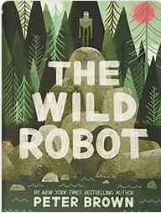 | Character Description of Roz | Setting Description (Chapter 7/8) |  | 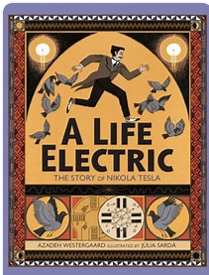  Recount | Diary | Non- Chronological Report on the impact of the Romans on Glossop.  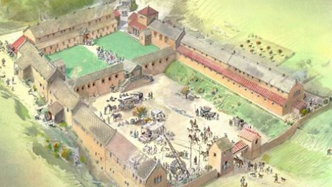
Year 3 Genre Progression | title to make the reader want to read the story  Include simple speech with inverted commas. Limited speech  Detailed description of character OR setting | Past tense.  More ambitious vocabulary choices.  Range of prepositional phrases as openers.  Similes and metaphors.  Include speech to show personality. | Similes and metaphors  Fronted adverbials for place and manner  Adjective, adjective  Powerful verbs |  | Present/past perfect tense.  Range of emotions to describe feelings.  Paragraphs for time order of events.  Concluding paragraph. | Experiment with future tense. Informal voice. Paragraphs for events. Varied language to convey thoughts and feelings. Adverbs as openers. Addresses the diary directly. Includes opinions and facts. Informal, chatty language  Ambitious words to describe people and settings. Talks about secret / private feelings and opinions. Includes events that are important to the writer. Use paragraphs to organise events | Teacher led research (content provided by teacher)  Use given sub-headings but arrange information independently  Generate captions for given images  Begin to use the 5w’s in the introduction  Provided reason for processes
Year 4 Genre Progression | Including build-up, problem, resolution (Story-map)  Independently structuring paragraphs around an idea  Show not tell for character’s emotions  Detailed description of character and setting  Direct speech to move the action on  3 part speech – what they said, who said it and how they said it (adverb)  Still limit speech | Written in the past tense.  Describe the character and include their feelings by using show don’t tell.  Include speech. | What did they see?  Simile as a sentence opener  Show don’t tell to convey a character’s emotion  Beginning to use personification to describe things in my writing |  | Engage the reader- why was the event significant?  Include thoughts, opinions and feelings.  Select important elements. | Introduction to set the scene and create atmosphere. Events described from the author’s perspective. Talks about feelings, reactions an opinion. Author explains reason for their actions. Ends with the authors present situation, wondering what they will do next. Select events thinking about the audience. Varied language to convey thoughts and feelings and opinions (Show don’t tell). Justify why things happened. Select and maintain the appropriate tense (within given paragraphs). Use a rhetorical question with a subordinating conjunction. | Select from a choice of sub-headings  Include multiple paragraphs for each sub-heading  Use 5w’s independently  Follow given structure  Technical vocabulary  Factual language  Conjunctions for cause  These can be used at the beginning or the middle of a sentence
Year 3  Grammar and Punctuation | Use openers (fronted adverbials) as sentence openers: How (Manner), When (Time) and Where (Place) | Change the place of the adverb in the sentence. | Use openers (fronted adverbials) as sentence openers: How (Manner), When (Time) and Where (Place) |  | Start a new paragraph to show a change in time in narrative writing.  Use ellipses to build suspense. | Use a variety of subordinating conjunctions in the middle of a sentence to write a complex sentence. | Use a question in a non-fiction introduction.  Use conjunctions for cause (because, as, so) (non- fiction)
Year 4  Grammar and Punctuation | Adverbs to show how (manner) root word spelling change | Consolidation of using more sophisticated similes to describe things in my writing. | Consolidation of fronted adverbials. |  | Start a new paragraph when the setting, action or time change in narrative writing. | Extend sentences to add more detail by using a variety of subordinating conjunctions (All of Year 3 + during, since) in the middle of a sentence. | Write a complex question sentence to emphasis my point in non-fiction writing.  Use a wider a range of conjunctions for cause (non-fiction)
Handwriting Year 3 - Ascenders and descenders do not interfere with writing on the line above and below.
Handwriting Year 4 - Use a consistent and efficient style of handwriting

Spring 2
Science – Skeletons and Muscles |  |  |  | Geography –How is Italy similar and different to the U.K.?
Text and Genre | 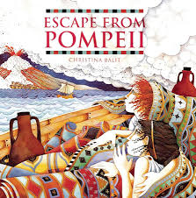  Setting description of Pompeii | Retell- Escape from Pompeii | Retell- The Pea and the Princess  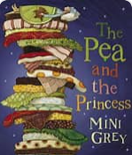 |  | Write an alternative end to the story | Non-Chronological Report on Italy  (2 weeks)  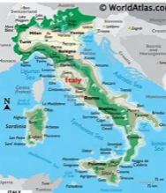  
Year 3 Genre Progression | Similes and metaphors  Fronted adverbials for place and manner  Adjective, adjective  Powerful verbs | title to make the reader want to read the story  Using paragraphs to organise my writing  Include simple speech with inverted commas. Limited speech  Detailed description of character OR setting | title to make the reader want to read the story  Using paragraphs to organise my writing  Include simple speech with inverted commas. Limited speech  Detailed description of character OR setting |  | Stick to the theme given, Use a story map (template given). Select own appropriate language Add my own title. Simple speech using inverted commas Paragraphs for time. Develop character through action and description. A beginning to introduce the characters and setting. A build up to give hints and clues about what is going to happen. A dilemma when something goes wrong. A resolution where the characters solve the problem. An ending to say what happens next. | Teacher led research (content provided by teacher)  Use given sub-headings but arrange information independently  Generate captions for given images  Begin to use the 5w’s in the introduction  Provided reason for processes
Year 4 Genre Progression | What did they see?  Simile as a sentence opener  Show don’t tell to convey a character’s emotion  Beginning to use personification to describe things in my writing | Including build-up, problem, resolution (Story-map)  Independently structuring paragraphs around an idea  Show not tell for character’s emotions. Detailed description of character and setting. Direct speech to move the action on. 3 part speech – what they said, who said it and how they said it (adverb). Still limit speech | Including build-up, problem, resolution (Story-map)  Independently structuring paragraphs around an idea  Show not tell for character’s emotions. Detailed description of character and setting. Direct speech to move the action on. 3 part speech – what they said, who said it and how they said it (adverb). Still limit speech |  | 3rd and 1st person  Use rich and varied vocabulary Paragraphs for time and/or events Show don’t tell  Speech with varied reporting clauses | Select from a choice of sub-headings  Include multiple paragraphs for each sub-heading  Use 5w’s independently  Follow given structure  Technical vocabulary  Factual language  Conjunctions for cause  These can be used at the beginning or the middle of a sentence
Year 3  Grammar and Punctuation | Use prepositions as fronted adverbials and include an adjective to give the reader more information. | Use short sentences to make key points. | Use conjunctions for cause (because, as, so) (fiction) |  | Beginning to vary the range of verbs used in the reporting clause to avoid repeating, ‘said’. | Organise similar ideas into paragraphs in non-fiction writing.  Use a subheading to guide the reader.  Appropriate non-fiction openers.
Year 4  Grammar and Punctuation | Use a simile as a sentence opener.  Use more sophisticated metaphors to describe things in my writing. | Short sentences to move events on quickly in a story. | Use a wider a range of conjunctions for cause (fiction) |  | Beginning to vary the range of verbs used in the reporting clause to avoid repeating, ‘said’.  Include direct speech in stories but change where the reporting clause is in the sentence (beginning and end). | Write a complex question sentence to emphasis my point in both fiction and non-fiction writing.  Appropriate non-fiction openers.
Handwriting Year 3- Ascenders and descenders do not interfere with writing on the line above and below.
Handwriting Year 4 - Use a consistent and efficient style of handwriting

Summer 1
History – Did Nelson Mandela, Rosa Parks and Paul Stephenson help to make the world a better place? |  |  |  | Science- Can you use keys to classify living things and explore their environmental needs?
Text and Genre | Recount  (Doesn’t need to be complete life story.)  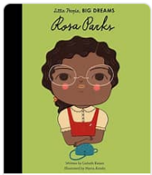 | Informal Letter Home to parents whilst in the cell. | Retell- Hummingbird  (Doesn’t need to be the entire story)  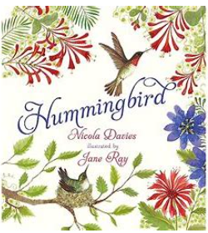 |  | Non- Chronological Report on Nelson Madela/Rosa Parks/Paul Stephenson  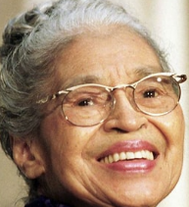     | Free Verse Poetry- using Hummingbird and the beginning section of the poem ‘Hummingbirds’ by Mary Oliver
Year 3 Genre Progression | Present/past perfect tense.  Range of emotions to describe feelings.  Paragraphs for time order of events.  Concluding paragraph. | Include the sender’s address  Use an appropriate greeting  Past tense, include future  tense in the conclusion  Present perfect tense. Write an introduction. Accurate use of tenses (explore future tense)  Paragraphs for time / order  Informal chatty language  Questions sentences. Wider range of contractions. Greeting and signing off (own choice). Consider the audience | title to make the reader want to read the story  Using paragraphs to organise my writing  Include simple speech with inverted commas. Limited speech  Detailed description of character OR setting |  | Teacher led research (content provided by teacher)  Use given sub-headings but arrange information independently  Generate captions for given images  Begin to use the 5w’s in the introduction  Provided reason for processes | Free Verse poems tell a story, describe something or explain an emotion.  These poems do not need to rhyme or use a structure.  Figurative language.  language linked to the topic.  Capital letters at the beginning of each line.  Free verse poems do not have a certain number of syllables per line.  They do not rhyme, and other language devices may be used.  Lines can be single words, phrases, or sentences.  Own vocabulary choices.
Year 4 Genre Progression | Engage the reader- why was the event significant?  Include thoughts, opinions and feelings.  Select important elements. | Paragraphs around a theme  Address the reader directly  Present perfect tense  Thoughts and feelings  Show don’t tell  Rhetorical questions | Including build-up, problem, resolution (Story-map)  Independently structuring paragraphs around an idea  Show not tell for character’s emotions. Detailed description of character and setting  Direct speech to move the action on. 3 part speech – what they said, who said it and how they said it (adverb). Still limit speech |  | Select from a choice of sub-headings. Include multiple paragraphs for each sub-heading  Use 5w’s independently  Follow given structure. Technical vocabulary. Factual language  Conjunctions for cause  (beginning or the middle of a sentence).
Year 3  Grammar and Punctuation | Use adverbs to show when something happened (Time)  Begin to use a comma after a fronted adverbial  Use adverbs to show where something happened. (Place) | Recap contractions | Use two –ly adverbs in a sentence. |  | Choose nouns and pronouns carefully to reduce repetition. | Consolidation of previous skills AFL
Year 4  Grammar and Punctuation | Use fronted adverbials followed by a comma. When (Frequency) and How (Degree).  The highlighted skills (below) may need to be taught in stand-alone spag lessons at some point in the term.  Add an ‘s’ to show plural and use irregular plural noun forms of plural (children, women)  Add an ‘s’ to show plural and use irregular plural noun forms of plural. -es words (foxes, boxes). | Include complex sentences in my writing which start with a subordinating conjunction and marking the subordinating clause with a comma.  Possessive determiners. | Choose the most appropriate nouns. |  | Choose nouns and pronouns carefully to reduce repetition.  Quantifier determiners | Beginning to use personification to describe things in my writing
Handwriting Year 3 - My handwriting style is consistent throughout my work.
Handwriting Year 4 - Use a fluent, consistent style and write at speed

Summer 2
Geography- How do Humans affect Climate Change? |  |  |  | Science-Forces
Text and Genre | Retell  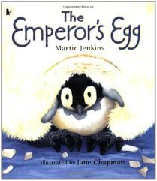 | Retell- The Enormous Turnip  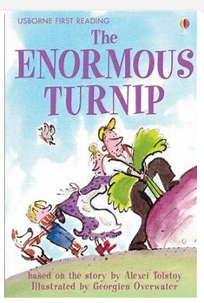 | 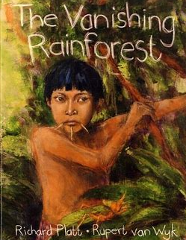  Setting Description |  | Diary Entry | Non -Chronological Report- How do Humans Harm the World  (2 weeks)  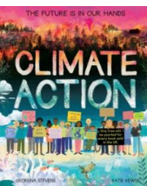 |  | 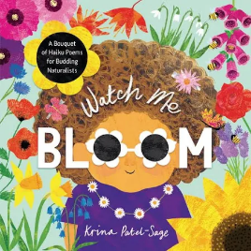  Poetry  Haiku on the seasons
Year 3 Genre Progression | Title to make the reader want to read the story  Using paragraphs to organise my writing  Include simple speech with inverted commas. Limited speech  Detailed description of character OR setting | Title to make the reader want to read the story  Using paragraphs to organise my writing  Include simple speech with inverted commas. Limited speech  Detailed description of character OR setting | Similes and metaphors  Fronted adverbials for place and manner  Adjective, adjective  Powerful verbs |  | Past perfect and present progressive tenses. Experiment with future tense. Informal voice. Paragraphs for events. Varied language to convey thoughts and feelings. Adverbs as openers. Addresses the diary directly. Includes opinions and facts  Informal, chatty language  Ambitious words to describe people and settings. Talks about secret / private feelings and opinions  Includes events that are important to the writer. Use paragraphs to organise events | Teacher led research (content provided by teacher)  Use given sub-headings but arrange information independently  Generate captions for given images  Begin to use the 5w’s in the introduction  Provided reason for processes |  | Haiku – Language poetry  3 lines long  The syllables in each line match the format 5,7,5  Haiku poems are often about nature or the seasons and how we  feel about them  Haiku is traditional poetry in Japan
Year 4 Genre Progression | Including build-up, problem, resolution (Story-map)  Independently structuring paragraphs around an idea  Show not tell for character’s emotions. Detailed description of character and setting  Direct speech to move the action on. 3 part speech – what they said, who said it and how they said it (adverb). Still limit speech | Including build-up, problem, resolution (Story-map)  Independently structuring paragraphs around an idea  Show not tell for character’s emotions. Detailed description of character and setting  Direct speech to move the action on. 3 part speech – what they said, who said it and how they said it (adverb). Still limit speech | What did they see?  Simile as a sentence opener  Show don’t tell to convey a character’s emotion  Beginning to use personification to describe things in my writing |  | Introduction to set the scene and create atmosphere. Events described from the author’s perspective. Talks about feelings, reactions an opinion. Author explains reason for their actions. Ends with the authors present situation, wondering what they will do next. Select events thinking about the audience. Varied language to convey thoughts and feelings and opinions (Show don’t tell). Justify why things happened. Select and maintain the appropriate tense (within given paragraphs)  Use a rhetorical question with a subordinating conjunction. | Select from a choice of sub-headings  Include multiple paragraphs for each sub-heading  Use 5w’s independently  Follow given structure  Technical vocabulary  Factual language  Conjunctions for cause  These can be used at the beginning or the middle of a sentence | Haiku – Language poetry  3 lines long  The syllables in each line match the format 5,7,5  Haiku poems are often about nature or the seasons and how we  feel about them  Haiku is traditional poetry in Japan
Year 3  Grammar and Punctuation | Start a new paragraph when the setting changes in narrative writing. | Use prepositions to express place. | Consolidation of previously taught skills. |  | Use the Present Perfect Tense. | Use prepositions to express time.  Use conjunctions for place (Where and Wherever). | Consolidation of previously taught skills
Year 4  Grammar and Punctuation | Use a mixture of short sentences, simple sentences, compound and complex sentences. | Consolidation of previously taught skills. | Consolidation of previously taught skills. |  | Identify the difference between simple past and simple present tense.  I can explain how to use Present Perfect Tense and use irregular verbs. | Understand the difference between the use of conjunctions, adverbs and prepositions and can explain this. | Consolidation of previously taught skills
Handwriting Year 3 - My handwriting style is consistent throughout my work.
Handwriting Year 4 - Use a fluent, consistent style and write at speed

