- All new vocabulary will be displayed on Working Walls in the classroom environment.  - WAGOLL to use for whole class teaching demonstrating the skills and vocabulary expectations.  - Learning is progressive and therefore texts and skills need to be taught in chronological order.  - New ambitious vocabulary will be introduced and pre taught by staff weekly using a range of adjectives, verbs, nouns, adverbs. |  |  |  |  | “Dictation gives children opportunities to practise and apply their spelling knowledge and segmenting skills, without having to compose sentences by themselves. It requires them to distinguish between the sounds they hear in order to choose the correct graphemes to represent the sounds and to form the letters correctly.” Research and Review, May 2023
Autumn 1
Geography – What was Glossop like in the Past? |  |  |  |  | Science -Parts of the Body
Text and Genre | Letter Formation | 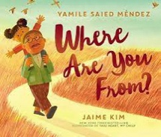  Retell- Where are you From? | 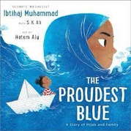  Retell- The Proudest Blue | 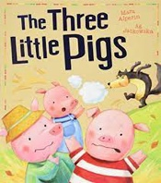  Character Description – The Three Little Pigs | 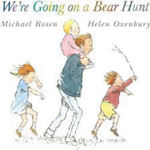  Retell – We’re Going on a Bear Hunt | 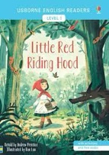  Retell —Little Red Riding Hood | 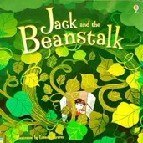  Instructions- How to get up the bean stalk.
Year 1 Genre Progression | Week 1- Letter Formation. | Use past tense  Title  Include beginning, middle end  Chronological order  Story language; Once upon a time, one sunny day etc  Simple sentences  Structure needs to be correct  (Not to rewrite word for word / use said.) | Use past tense  Title  Include beginning, middle end  Chronological order  Story language; Once upon a time, one sunny day etc  Simple sentences  Structure needs to be correct  (Not to rewrite word for word / use said.) | Wanted poster  Picture annotated  Name of character  What they look like  Simple adjectives (colour and size)  Appearance and personality (appropriate  words)  Actions – what does your character do in  the story?  Present tense | Use past tense  Title  Include beginning, middle end  Chronological order  Story language; Once upon a time, one sunny day etc  Simple sentences  Structure needs to be correct  (Not to rewrite word for word / use said.) | Use past tense  Title  Include beginning, middle end  Chronological order  Story language; Once upon a time, one sunny day etc  Simple sentences  Structure needs to be correct  (Not to rewrite word for word / use said.) | Title  Numbered steps  Each step on a new line  Time adverbial as an  opener  Present tense
Year 2 Genre Progression | Week 1- Letter Formation. | May create a story map or use pictures as prompts  Description of the character and setting  No comma would be used after the fronted adverbial opener until Year 3. | May create a story map or use pictures as prompts  Description of the character and setting  No comma would be used after the fronted adverbial opener until Year 3. | Present tense Describe how the character looks using adjectives and simple similes Use because / when to describe their personality and actions Use an ! in an exciting sentence Include how other characters feel about the character I am describing Say what I like / dislike about the character. Identify where – using prepositions Select effective vocabulary and up level. Begin to experiment with word order in sentence structure, -ly adverbs to describe how an action was performed | May create a story map or use pictures as prompts  Description of the character and setting  No comma would be used after the fronted adverbial opener until Year 3. | May create a story map or use pictures as prompts  Description of the character and setting  No comma would be used after the fronted adverbial opener until Year 3. | Title with question  What you need  Introduction with a  question  Command sentence /  Imperative verbs as  openers  Link to fictional writing
Year 1  Grammar and Punctuation | Sit at a table properly and hold my pencil correctly.  I form lower case letters correctly, starting and finishing in the right place.  All letters sit on the line.  Tall letters (ascenders) touch the line above. | Think, say and remember a sentence that starts with a time adverbial.  (First, Next, Then, Finally).  Write a sentence starting with a time adverbial and ending with a full stop (fiction)  Write in the past tense. | Think, say and remember a sentence that starts with a time adverbial.  (First, Next, Then, After that, Finally).  Write a sentence starting with a time adverbial and ending with a full stop (fiction)  Write in the past tense. | Think, say and remember a sentence that starts with an opener.  Adjective to describe a noun. (Size/ Colour/ Shape) | Think, say and remember a sentence that starts with an opener.  (He/ She).  Write a sentence starting with a time adverbial and ending with a full stop (fiction)  Write in the past tense. | Think, say and remember a sentence that starts with an opener.  (He/ She, It, The, They).  Write a sentence starting with a time adverbial and ending with a full stop (fiction)  Write in the past tense. | Write in the present tense  (instructions).  Write a sentence starting  with a time adverbial and  ending with a full stop  (non-fiction)
Year 2  Grammar and Punctuation | My letters are close together when I write a word (snuggle my letters).  I fill the line with my writing.  Lower case letters are the same height. I am able to form all my capital letters correctly. I am able to write all of the Year 1 CEW correctly. | Use a wider range of time adverbs at the start of my sentences.  Eg. Later that cold day, A few minutes later.  Use the past tense correctly. | Use a wider range of exciting openers at the start of my sentences.  Use the past tense correctly. | Use an expanded noun phrase (noun phrase) using one or more adjectives. | Use a wider range of openers.  Correctly spell words with the –ed suffix when the root word does not change. | Use a wider range of question openers and end with a question mark.  Eg. Where, Who? | Recognise and write a command sentence with a imperative (bossy) verb and punctuate it with an exclamation mark or a full stop.
Handwriting Year 1 -Sit at a table properly and hold my pencil correctly. I form lower case letters correctly, starting and finishing in the right place. All letters sit on the line. Tall letters (ascenders) touch the line above. Use short letters. Use finger spaces between words.
Handwriting Year 2 - Lower case letters are the same height

Autumn 2
Geography- Mexico
Text and Genre | Retell – My tree and Me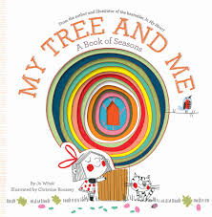 | 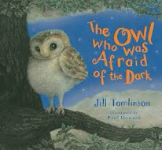  Retell- The Owl who was afriad of the dark. | Diary – The Owl who was afraid of the dark | 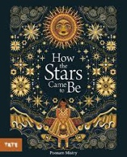  . Retell- How the Stars came to be. | 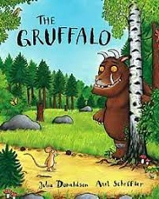  Instructions – Find a Gruffalo | Retell- The Gruffalo  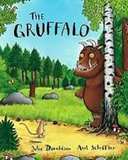 |   Poetry- Acrostic poem on Christmas
Year 1 Genre Progression | Use past tense  Title  Include beginning, middle end  Chronological order  Story language; Once upon a time, one sunny day etc  Simple sentences  Structure needs to be correct  (Not to rewrite word for word / use said.) | Use past tense  Title  Include beginning, middle end  Chronological order  Story language; Once upon a time, one sunny day etc  Simple sentences  Structure needs to be correct  (Not to rewrite word for word / use said.) | Simple recount of a day  First person  Past tense  Dear Diary | Use past tense  Title  Include beginning, middle end  Chronological order  Story language; Once upon a time, one sunny day etc  Simple sentences  Structure needs to be correct  (Not to rewrite word for word / use said.) | Title  Numbered steps  Each step on a new line  What you need with bullet points  Time adverbial as an opener  Present tense  Linked to oral instructions when playing | Use past tense  Title  Include beginning, middle end  Chronological order  Story language; Once upon a time, one sunny day etc  Simple sentences  Structure needs to be correct  (Not to rewrite word for word / use said.) | Identify sounds within words (syllables)  Acrostic poems using adjectives
Year 2 Genre Progression | May create a story map or use pictures as prompts  Description of the character and setting  No comma would be used after the fronted adverbial opener until Year 3. | May create a story map or use pictures as prompts  Description of the character and setting  No comma would be used after the fronted adverbial opener until Year 3. | Dear Diary and date  Add in private / secret thoughts and feelings  First person (I, We, My)  Openers –  Past tense  Use time adverbials to show when things happened  Chronological order  Informal language (contractions) | May create a story map or use pictures as prompts  Description of the character and setting  No comma would be used after the fronted adverbial opener until Year 3. | Title with question  What you need  Introduction with a question  Command sentence / Imperative verbs as openers  -ly adverb at the start of the sentence  Top tip / warning  Link to fictional writing | May create a story map or use pictures as prompts  Description of the character and setting  No comma would be used after the fronted adverbial opener until Year 3. | Identify rhyming patterns (rhyming couplets)  Write own version of a given poem  Conjunctions – and, that, When, If, or, because  Tease the reader  Commas in a list  Adjectives
Year 1  Grammar and Punctuation | Write a sentence starting with an opener and ending with a full stop.  Use adjectives to describe a noun (size and colour). | Write a sentence starting with an opener and ending with a full stop.  Use the conjunction ‘and’ | Use the personal pronoun ‘I’ (when writing a personal recount).  To write in the first person, I, My, We, They, me). | Use a capital letter for names of people.  Use the conjunction ‘and’ to join two words. (The tree was tall and green). | Write in the present tense (instructions).  Write a sentence starting with a time adverbial and ending with a full stop (non-fiction)  Include the conjunction ‘and’ | Include an exclamation mark to demarcate exciting sentences (Suddenly, Quickly, As quick as a flash). | -s or –es suffix  Adjectives to improve a sentence
Year 2  Grammar and Punctuation | Use the conjunction ‘but’. | Use ‘when’ as an opener/at the start of a sentence.  Use the conjunction ‘and’ | Use informal language by including contractions. | Use the conjunctions ‘because’ in fiction writing. | Use commas in a list (to list nouns in a sentence). | Use a wider range of exclamative openers and end with a exclamation mark. | -ing suffix  Adjectives to improve a sentence
Handwriting Year 1 - Form uppercase letters correctly, starting and finishing in the right place.
Handwriting Year 2 - Leave equal spaces between words

Spring 1
Science – Seasons |  |  |  | History – Who is my area has achieved extraordinary things?
Text and Genre | Retell- Percy the Park Keeper  0ne snowy night.  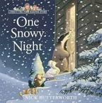 | Diary  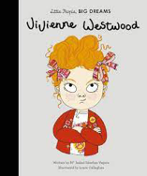 | Retell – The Dot  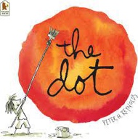 |   Season Non-chronological Report | 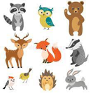  Animal Riddles | Recount – Alan Turing  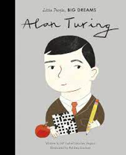
Year 1 Genre Progression | Use past tense  Title  Include beginning, middle end  Chronological order  Story language; Once upon a time, one sunny day etc  Simple sentences | Simple recount of a day  First person  Past tense  Dear Diary | Use past tense  Title  Include beginning, middle end  Chronological order  Story language; Once upon a time, one sunny day etc  Simple sentences | Facts gathered as a class  Topic related vocabulary  Given title  Labelled pictures  Present tense | Riddle  What am I?  Openers  New clue, new line.  Present tense.  Conjunctions – and  Tease the reader.  Adjectives | Use third person.  Use time words. Chronological.  Use information based on a real event/experience.
Year 2 Genre Progression | May create a story map or use pictures as prompts  Description of the character and setting  No comma would be used after the fronted adverbial opener until Year 3. | Dear Diary and date  Add in private / secret thoughts and feelings  First person (I, We, My)  Openers –  Past tense  Use time adverbials to show when things happened  Chronological order  Simple conclusion looks ahead to the future (future tense using the conjunction ‘If’) | May create a story map or use pictures as prompts  Description of the character and setting  No comma would be used after the fronted adverbial opener until Year 3. | Title  Introduction  Include question  Subheadings (given)  Paragraphs (from given structure)  Ending/closing sentence  Scientific/technical language | Riddle  What am I?  Openers  New clue, new line.  Present tense.  , but  Conjunctions – and, that, When, If, or, because.  Tease the reader.  Commas in a list.  Adjectives | Chronological events  5w’s to introduce  Use proper nouns  Final statement  Details to interest the reader  Exclamative sentence to close
Year 1  Grammar and Punctuation | Use a wider variety of openers (Once upon a time…)  Increase use of a variety of time adverbials (Later, Soon, At last….) | Use adjectives to describe thoughts and feelings (diary entry). | Use a question mark to demarcate a question sentence starting with Will and What. | Use the conjunction  ‘and’ in non-fiction  writing.  Use non-fiction openers | Use new sentence openers - I have, I am, You (riddles). | Conjunction ‘but’
Year 2  Grammar and Punctuation | Apostrophe’s for possession. | Use ‘If’’ as an opener/at the start of a sentence.  Statement sentences. | Use a question mark to demarcate a question sentence.  Question sentences | Use a question in non-fiction writing.  Use the conjunctions ‘because’, and ‘and’ in non-fiction writing.  Use a wider range of non-fiction openers | Use commas in a list (to list adjectives in a sentence).  Use a wider variety of sentence openers.  E.g., Often, Sometimes, Usually… | I can use an apostrophe to show contraction in my written work. (Non-fiction)  .
Handwriting Year 1 - My letters are close together when I write a word (snuggle my letters).
Handwriting Year 2 - Start using some of the horizontal strokes to join letters.

Spring 2
DT – Materials |  |  |  | Geography – What do people do for jobs in Norway?
Text and Genre | 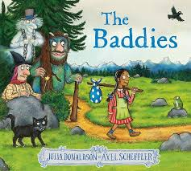  Wanted Poster- The Baddies | 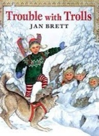  Instructions - How to trick Trolls | Recount –World Book Day  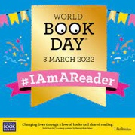 | 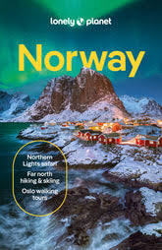  Setting Description- Norway | 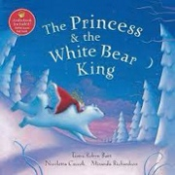  Retell – The Princess and the White Bear King. | World Poerty Day Spring List Poem  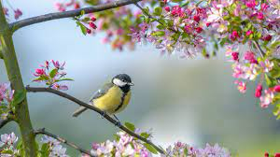
Year 1 Genre Progression | Wanted poster  Picture annotated  Name of character  What they look like  Simple adjectives (colour and size)  Appearance and personality (appropriate  words)  Actions – what does your character do in  the story?  Present tense | Title  Numbered steps  Each step on a new line  What you need with bullet points  Time adverbial as an opener  Present tense  Linked to oral instructions when playing | Use first person.  Use time words. Chronological.  Use information based on a real event/experience. | Use past tense  Title  Include beginning, middle end  Chronological order  Story language; Once upon a time, one sunny day etc  Simple sentences  Structure needs to be correct  (Not to rewrite word for word / use said.) | Use past tense  Title  Include beginning, middle end  Chronological order  Story language; Once upon a time, one sunny day etc  Simple sentences  Structure needs to be correct  (Not to rewrite word for word / use said.) | A ‘list poem’ gets its name from the fact that most of the poem is made up of a long list of things. A list poem usually has a few lines at the beginning, a list in the middle and a few lines at the end.  Rainforest List poem.  Under the enormous canopy many creatures hide.  There might be...  Colourful parrots squawking,  chattering monkeys swinging,  sleeping sloths slouching,  tiny millipedes marching,  sneaky snakes slithering,  Their magical world is a mystery to us all!
Year 2 Genre Progression | Present tense Describe how the character looks using adjectives and simple similes Use because / when to describe their personality and actions Use an ! in an exciting sentence Include how other characters feel about the character I am describing Say what I like / dislike about the character. Identify where – using prepositions Select effective vocabulary and up level. Begin to experiment with word order in sentence structure, -ly adverbs to describe how an action was performed | Title with question  What you need  Introduction with a question  Command sentence / Imperative verbs as openers  -ly adverb at the start of the sentence  Top tip / warning  Link to fictional writing | Chronological events  5w’s to introduce  Use proper nouns  Emotions to describe feelings (I was excited when….)  Final statement (My favourite part was…)  Details to interest the reader  Exclamative sentence to close | May create a story map or use pictures as prompts  Description of the character and setting  No comma would be used after the fronted adverbial opener until Year 3. | May create a story map or use pictures as prompts  Description of the character and setting  No comma would be used after the fronted adverbial opener until Year 3.
Year 1  Grammar and Punctuation | Question openers- 5Ws  Correct use of a question mark | Time adverbial as an opener. | Use adjectives to describe thoughts and feelings. | Use adjectives to describe a noun. | Consolidation of using ‘and’ to join words and to join clauses in sentences. | Adding –ing to the root word.
Year 2  Grammar and Punctuation | Co-ordinating conjunction ‘or’ | -ly adverb at the start of a sentence. | Subordinating conjunction  ‘When’ | Expanded noun phrases | Wider range of openers  E.g., In the street..  Add the suffix -ly to change a word from an adjective to an adverb and use as a sentence openers. | Use a or an correctly before a noun
Handwriting Year 1 - I fill the line with my writing.
Handwriting Year 2 - Start using some of the horizontal strokes to join letters.

Summer 1
Science- Can you name and describe a variety of materials. |  |  | History – What impact did WW2 have on life in Britain during and after the war?
Text and Genre | 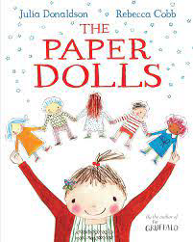  Informal Letter | SATs  Cover a Year 1 skill and text from the Reading For pleasure spine.  This is TBD based on skills teachers believe need covering. | 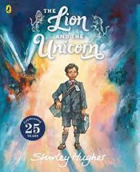  Retell- The Lion and the Unicorn | Diary Entry – Lion and the Unicorn | 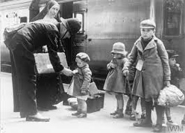  Non-chronological report about WW2 (everyday life)
Year 1 Genre Progression | Simple format (To, From)  First person  An informal greeting (Hi)  Add a few sentences  First sentence starts on a new line  From on a new line and add my  name For example, from  Goldilocks to the bears Date |  | Use past tense  Title  Include beginning, middle end  Chronological order  Story language; Once upon a time, one sunny day etc  Simple sentences  Structure needs to be correct  (Not to rewrite word for word / use said.) | Simple recount of a day  First person  Past tense  Dear Diary | Facts gathered as a class  Topic related vocabulary  Given title  Labelled pictures  Present tens
Year 2 Genre Progression | Address and date (Given)  Greeting (From a choice)  Past tense  Introduction (why you are writing)  More details  Final sentence written in the  present tense (what the sender  wants the  recipient to do next)  Signing off (given)  Personal thoughts and feelings  Informal (use contractions) |  | May create a story map or use pictures as prompts  Description of the character and setting  No comma would be used after the fronted adverbial opener until Year 3. | Dear Diary and date  Add in private / secret thoughts and feelings  First person (I, We, My)  Openers –  Past tense  Use time adverbials to show when things happened  Chronological order  Simple conclusion looks ahead to the future (future tense using the conjunction ‘If’) and includes a rhetorical question  Informal language (contractions) | Title  Introduction  Include question  Subheadings (given)  Paragraphs (from given structure)  Ending/closing sentence  Scientific/technical language
Year 1  Grammar and Punctuation | ‘-ed’ suffix |  | Focus on using the question words – Where and Who to begin a question sentence. | I can write in the past tense.  I can use personal pronouns. | Revision of using capital letter for names of places and the days of the week.
Year 2  Grammar and Punctuation | Consolidate contractions (present and past tense). |  | Use the conjunction ‘or’.  Linked to a question. Will the boy get home or will he be stranded on the moon? | Use personal pronouns.  Use the conjunction ‘that’ | Use apostrophes for possession.  Organise my writing into paragraphs
Handwriting Year 1 - Fill the line with writing and start a new line when there is not enough space to write the complete word.
Handwriting Year 2 -- Start to join handwriting.

Summer 2
DT – joining and decorating material. |  |  |  |  | Geography – What do people do at the Seaside
Text and Genre | Character Description  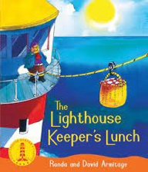 | Instructions to stop the seagulls stealing Mr. Grindling’s Lunch. | 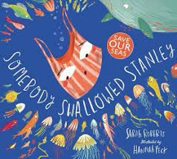  Setting Description- The Beach | Somebody Stanley – Retell | 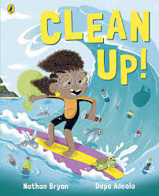  Retell | Riddles  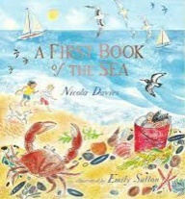 | Letter to New Teacher  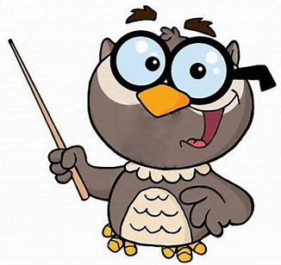
Year 1 Genre Progression | Wanted poster  Picture annotated  Name of character  What they look like  Simple adjectives (colour and size)  Appearance and personality (appropriate words)  Actions – what does your character do in the story?  Present tense | Title  Numbered steps  Each step on a new line  What you need with bullet points  Time adverbial as an opener  Linked to personal experience  Present tense  Linked to oral instructions when playing | Use past tense  Title  Include beginning, middle end  Chronological order  Story language; Once upon a time, one sunny day etc  Simple sentences  Structure needs to be correct  (Not to rewrite word for word / use said.) | Use past tense  Title  Include beginning, middle end  Chronological order  Story language; Once upon a time, one sunny day etc  Simple sentences  Structure needs to be correct  (Not to rewrite word for word / use said.) | Use past tense  Title  Include beginning, middle end  Chronological order  Story language; Once upon a time, one sunny day etc  Simple sentences  Structure needs to be correct  (Not to rewrite word for word / use said.) | Riddle  What am I?  Openers  New clue, new line.  Present tense.  Conjunctions – and,  Tease the reader.  Adjectives | Simple format (To, From)  First person  An informal greeting (Hi)  Add a few sentences  First sentence starts on a new line  From on a new line and add my name  Date
Year 2 Genre Progression | Past tense  Describe how the character looks using adjectives and simple similes  Use because / when to describe their personality and actions  Use an ! in an exciting sentence  Include how other characters feel about the character I am describing  Say what I like / dislike about the character. Identify where – using prepositions Select effective vocabulary and up level. Begin to experiment with word order in sentence structure, -ly adverbs to describe how an action was performed | Title with question  What you need  Introduction with a question  Command sentence / Imperative verbs as openers  -ly adverb at the start of the sentence  Top tip / warning  Link to fictional writing | Present tense Describe how the character looks using adjectives and simple similes Use because / when to describe their personality and actions Use an ! in an exciting sentence Include how other characters feel about the character I am describing Say what I like / dislike about the character. Identify where – using prepositions Select effective vocabulary and up level. Begin to experiment with word order in sentence structure, -ly adverbs to describe how an action was performed | May create a story map or use pictures as prompts  Description of the character and setting  No comma would be used after the fronted adverbial opener until Year 3. | May create a story map or use pictures as prompts  Description of the character and setting  No comma would be used after the fronted adverbial opener until Year 3. | Riddle  What am I?  Openers  New clue, new line.  Present tense.  , but  Conjunctions – and, that, When, If, or, because.  Tease the reader.  Commas in a list.  Adjectives | Address and date (Given)  Greeting (From a choice)  Past tense  Introduction (why you are writing)  More details  Final sentence written in the present tense (what the sender wants the recipient to do next)  Signing off (given)  Personal thoughts and feelings  Informal (use contractions)
Year 1  Grammar and Punctuation | Addition of adjective to improve a sentence. | -est suffix | Conjunction ‘and’ | Conjunction ‘but’ | Exclamative openers | Use new sentence openers - I have, I am, You (riddles). | Spell words beginning un
Year 2  Grammar and Punctuation | Use an apostrophe to show singular possession.  To use effective word choices and create a list of adjectives to describe a noun. | Imperative verbs | Expanded noun phrase | Conjunctions- Range- and/ but/ or/ so/ that/ because | Exclamative openers | Use commas in a list to list adjectives. | Contractions
Handwriting Year 1 - Fill the line with writing and start a new line when there is not enough space to write the complete word.
Handwriting Year 2 -- Start to join handwriting.

