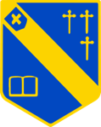
Duke of Norfolk CE Primary School Book Spine 2024 to 2026

Within this document, there are a variety of Book Spines which we would like you to use to support the teaching, learning of reading and writing.
Whole Class Reads/Literature Spine
This spine contains a selection of high-quality books which we would like you to read to your class on a daily basis, during 10 Magical Minutes.
These are books which will form the basis of a literature curriculum and the collection has been designed to introduce children to a growing range of texts. Whilst some children in the class may not be able to read all of the books independently, and important function of the collection is to give them access to a wider range of titles, authors and genres that they might not otherwise meet. This collection offers and increasingly challenging material and books are likely to be:
- Multi-layered (capable of being read at different levels)
- Books that deal with increasingly complex themes
- Books which use language in lively and inventive ways
- Books by a wide range of diverse and skilful authors and illustrators
- A mixture of contemporary and ‘classics’ of children’s literature
- Stories with diverse cultural settings and diverse, positive protagonists
- Texts that promote reflection and discussion

English Curriculum Spine
This spine includes carefully selected and progressive texts which are used as a basis for teaching our English units of work. These texts are selected as excellent examples of the chosen genres and serve as effective vehicles to deliver teaching on conventions of language, text structure, vocabulary, and grammar/punctuation etc.
Curriculum Spine
This spine includes high-quality, interesting texts which should be accessible in the classroom to support learning in the wider curriculum. Extracts of these could also be used to support learning in Book Talk lessons. These books are intended to broaden children’s subject/background knowledge and to develop experiential vocabulary.
Poetry & Playscript* (*KS2 only) Spine
This spine includes a range of classical and contemporary poetry, rhyme, performance poetry, and plays from a diverse range of authors and poets. It should be used regularly alongside whole class reads. This spine should also be used to support learning in Book Talk and English lessons where appropriate.

Additional Reading for Pleasure Spine (EYFS and KS1)
This spine has been included for EYFS and KS1 who require a larger bank of short texts/picture books to draw upon (in the absence of longer chapter books). These texts are high quality books which do not link directly to the curriculum, but support children in their early reading. These books are likely to:
- Memorable texts that feature repetition and encourage predictions
- Texts with relatable or familiar themes, characters, and stories
- Texts with rhythm and rhyme
- Texts that allow children to apply their phonic knowledge
- Texts with strong story shapes and structures
- Texts which positively reflect children’s interests and backgrounds
- Texts which offer a window into a diverse range of cultures, lifestyles, and backgrounds

Aims of the Book Spine
We know that to raise achievement and enjoyment in reading in later stages, early reading instruction must combine knowledge of decoding with specific and explicit instruction in vocabulary, conventions of language, and knowledge of the world.
This spine has been designed so that teachers have a bank of high-quality texts, which are appropriately challenging to use as class reads, starting points for teaching writing, recommendations for book corners, and extracts for reading lessons. The intention is that by the time children reach Year 6, they have developed a wide, rich vocabulary, and have a broader knowledge of the world.
Book Selections
The texts in the spine have been selected through recommendation from CLPE, National Literacy Trust, national award long and shortlists, The Book Trust, and considerations for all areas of learning covered in the curriculum.
This is a working document and will be adapted regularly to meet the needs of our children and curriculum, and to include newly released books.

EYFS Book Spine

EYFS
The EYFS spine is set up differently to reflect the way the Early Years operates. Whole Class Reads (for 10 Magical Minutes etc) are already linked to curriculum themes, and a number of these books will be used as starting points for teaching and learning. Non-fiction texts are also linked to curriculum themes. Children are expected to revisit these texts repeatedly, so they become familiar favourites. As EYFS children will hear several stories per day, teachers should supplement these with texts from the ‘Additional Reading for Pleasure’ spine’ and the ‘Poetry and Rhyme’ spine.

EYFS Autumn 1: Texts to Support Curriculum Themes: Who Am I?
Fiction
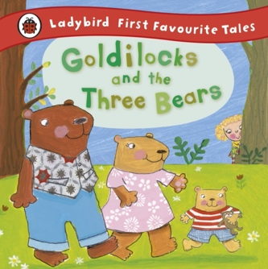 | 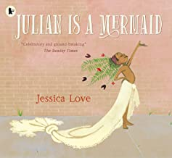 | 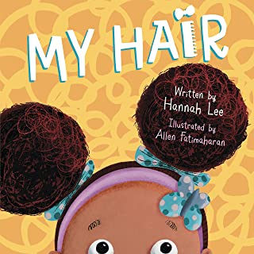 | 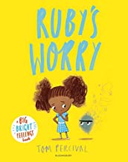 | 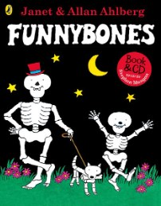 | 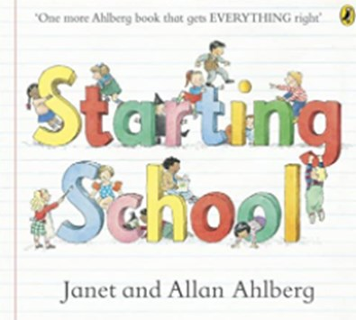
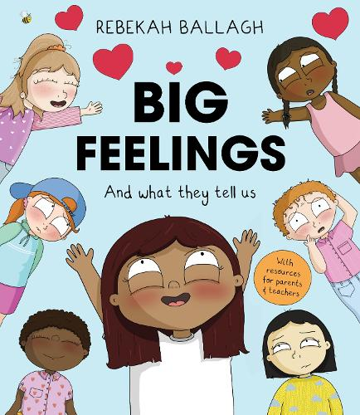 | 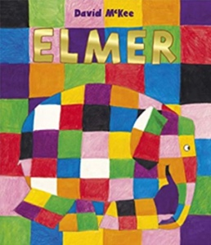 | 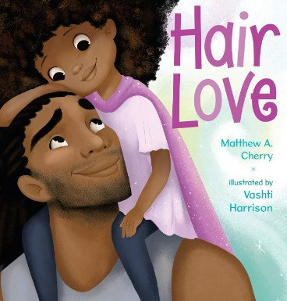 | 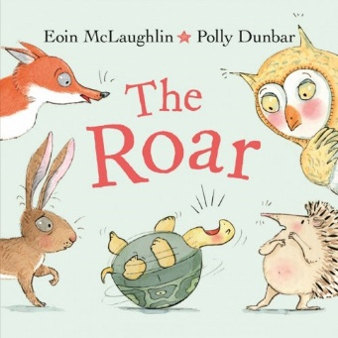 | 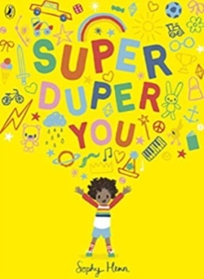 | 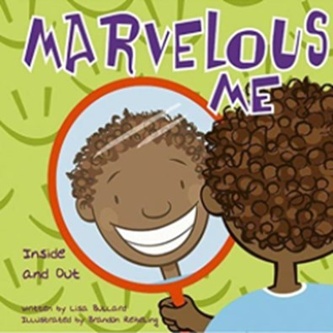
Non-Fiction
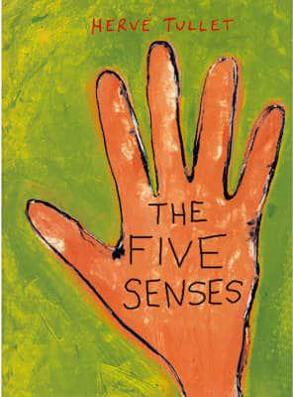 | 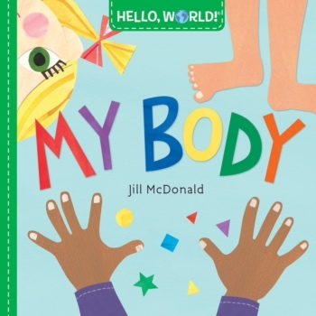 | 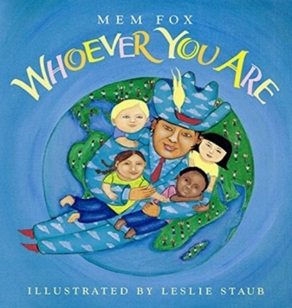 | 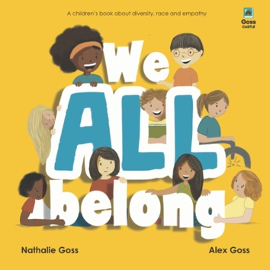 | 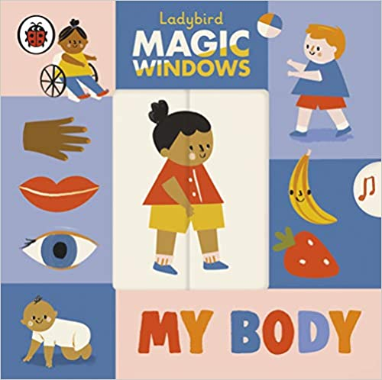 | 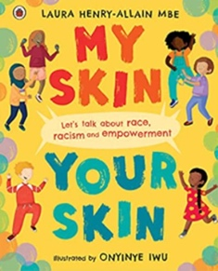

EYFS Autumn 2: Texts to Support Curriculum Themes: Light and Dark
Fiction
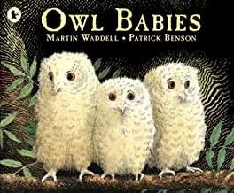 | 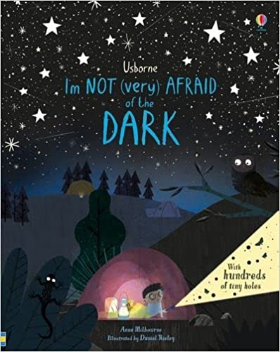 | 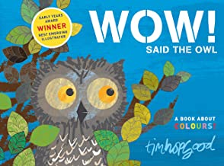 | 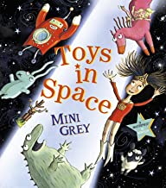 | 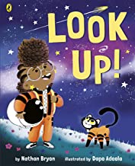 | 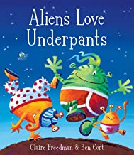
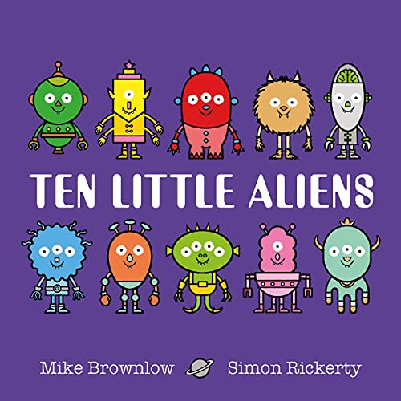 | 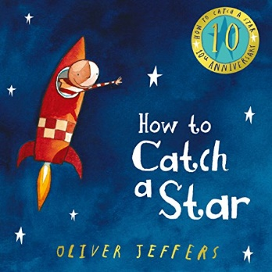 | 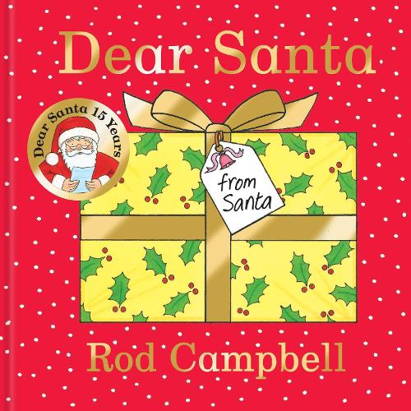 | 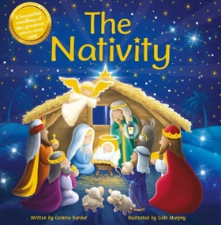 | 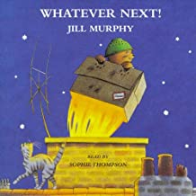 | 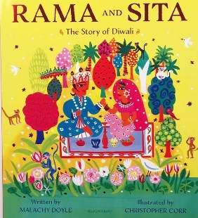
Non-Fiction
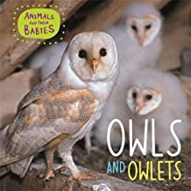 | 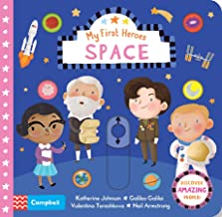 | 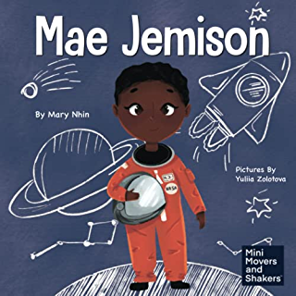 | 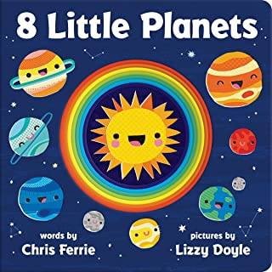 | 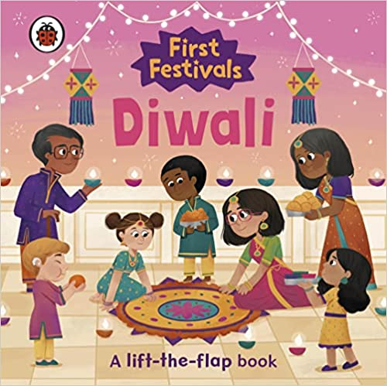 | 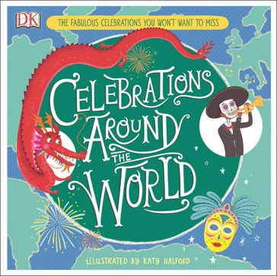

EYFS Spring 1: Texts to Support Curriculum Themes: Home and Away/Winter
Fiction
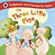 | 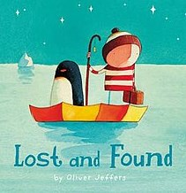 |  | 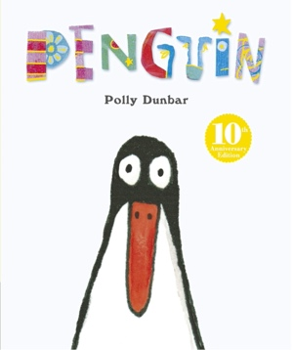 |  | 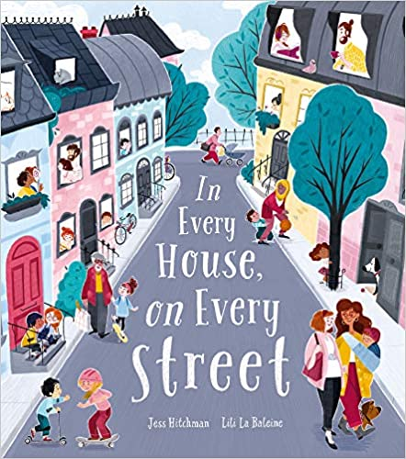 |  | 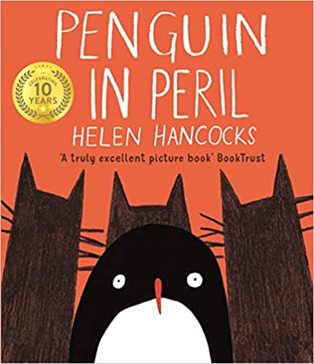 |  | 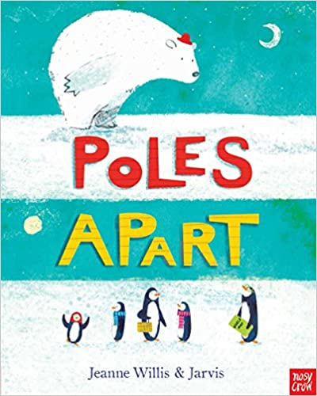
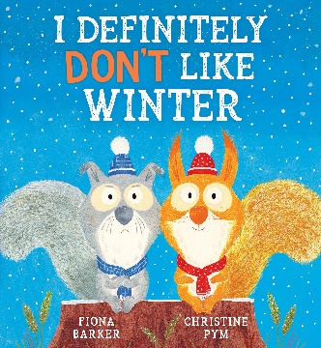 | 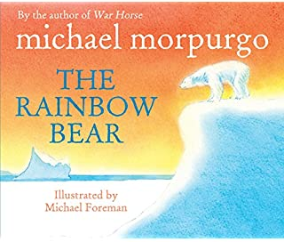 |  | 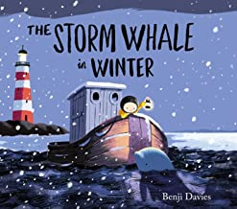 |  | 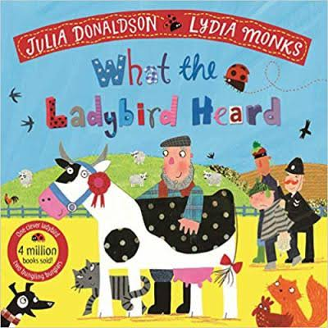 |  | 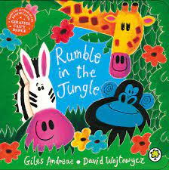 |  | 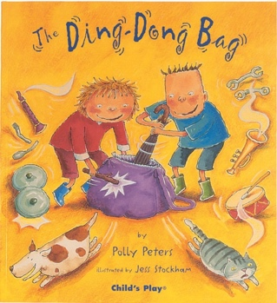
Non-Fiction
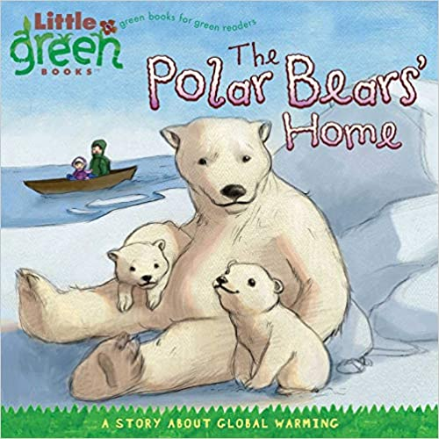 |  | 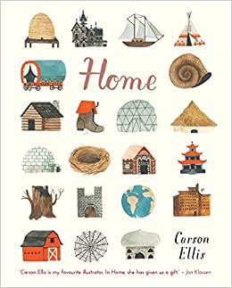 |  | 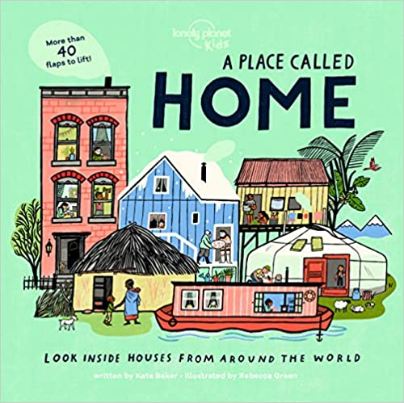 |  | 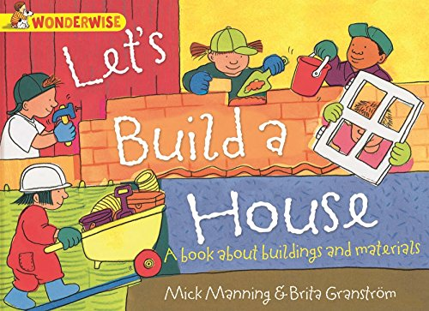 |  | 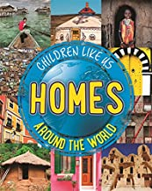

EYFS Spring 2: Texts to Support Curriculum Themes: Toys/People Who Help Us
Fiction
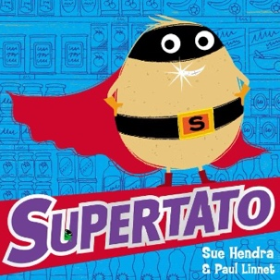 | 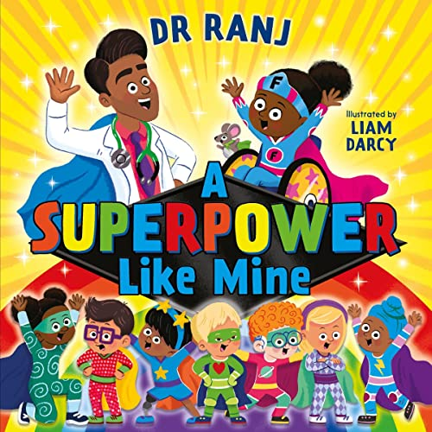 | 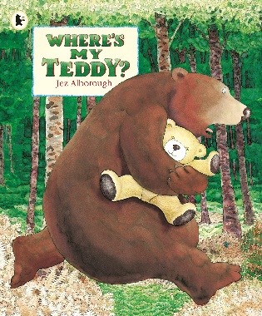 | 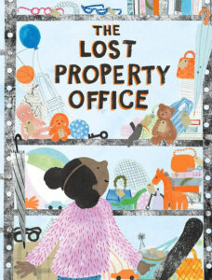 | 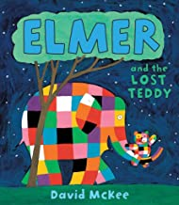 | 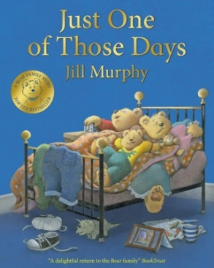
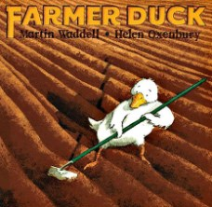 | 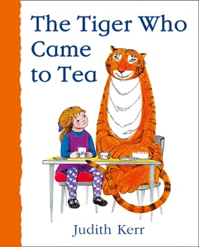 | 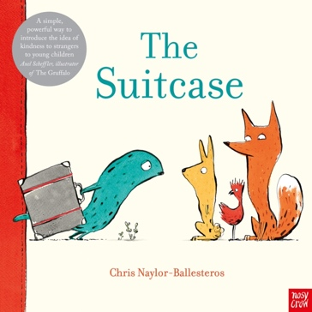 | 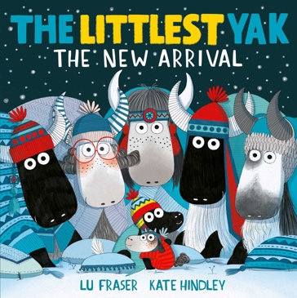 | 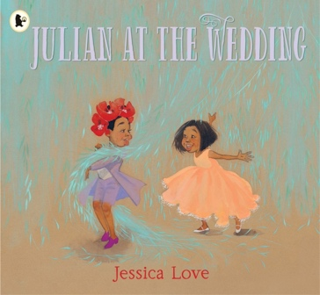 | 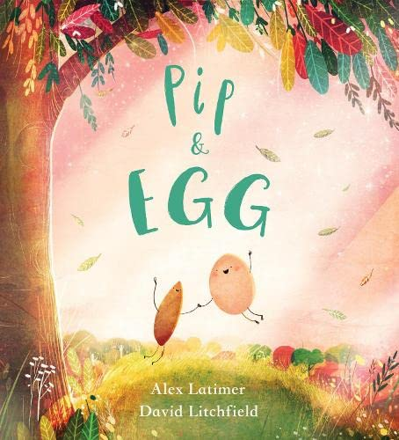
Non-Fiction
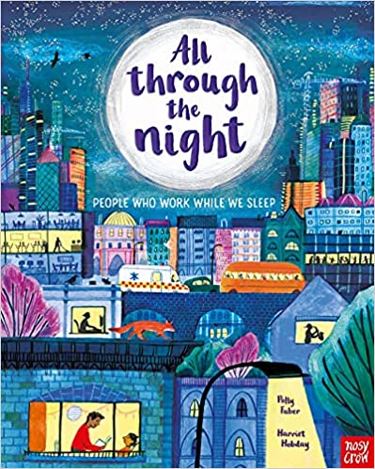 |  | 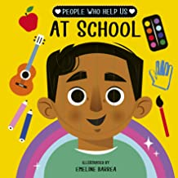 | 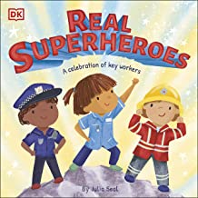 | 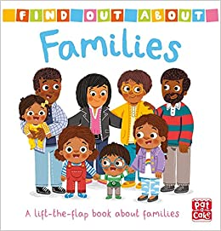 | 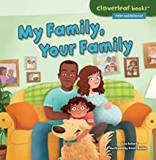

EYFS Summer 1: Texts to Support Curriculum Themes: Plants/Growing
Fiction
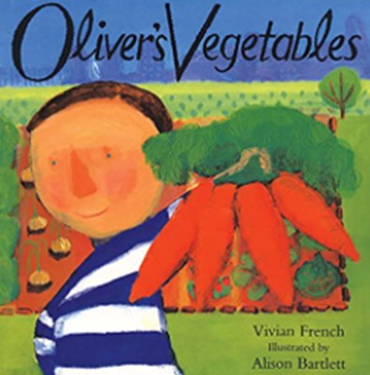 | 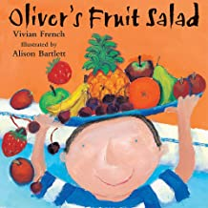 |  | 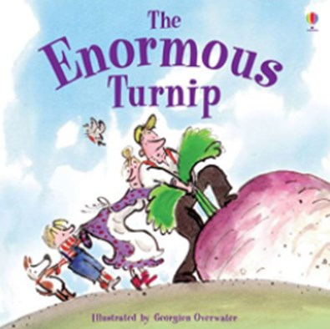 |  | 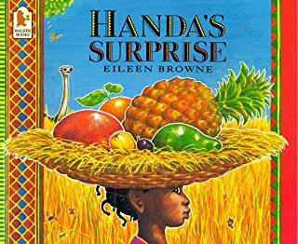 |  | 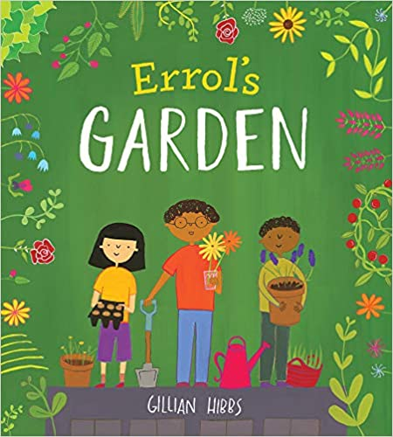 |  | 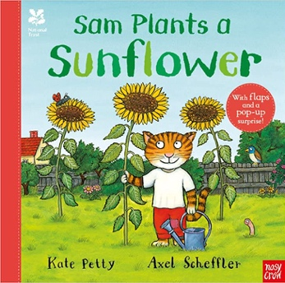
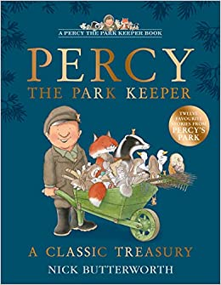 | 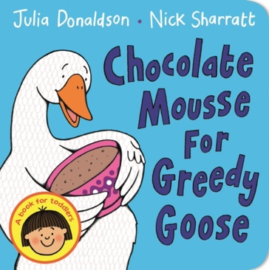 |  | 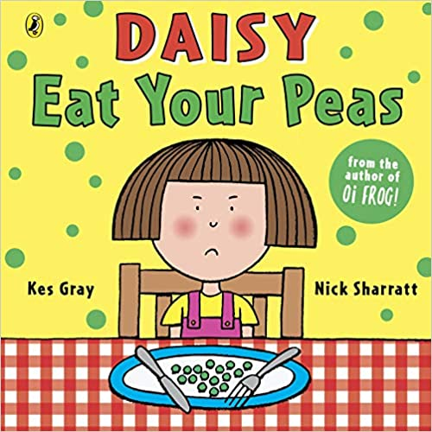 |  | 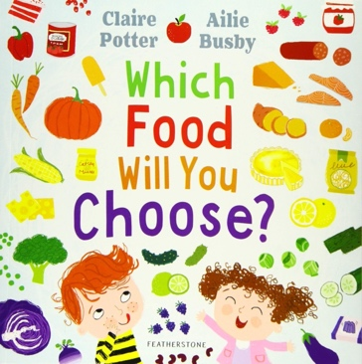 |  | 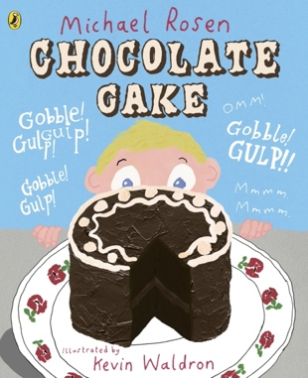 |  | 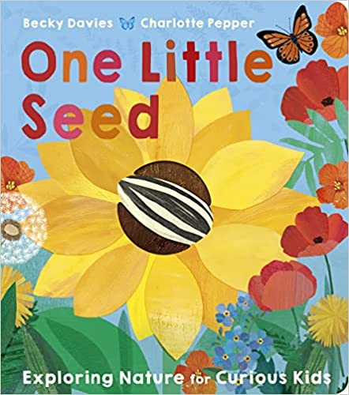
Non-Fiction
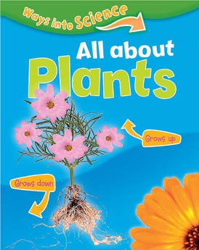 |  | 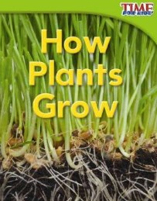 |  | 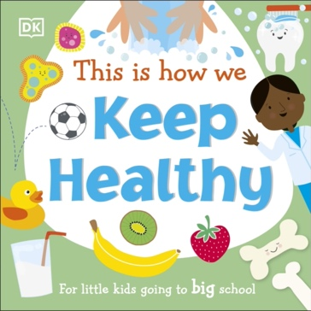 |  | 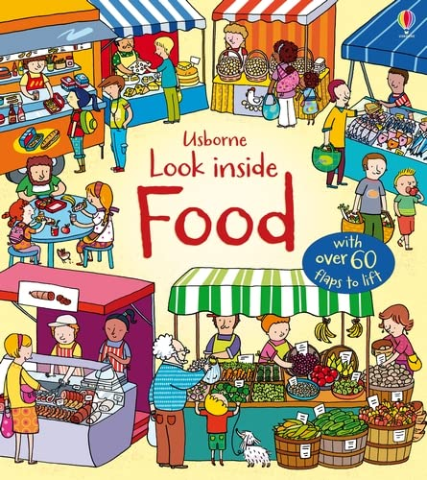 |  | 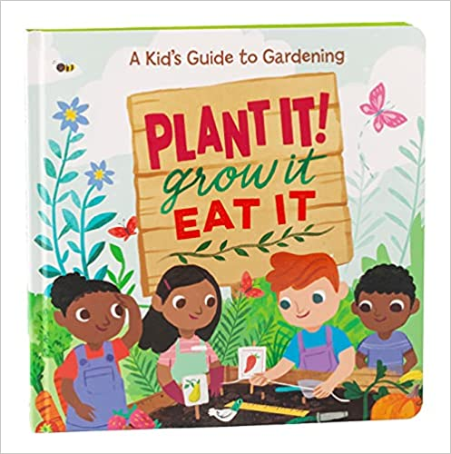

EYFS Summer 2: Texts to Support Curriculum Themes: Animals/Minibeasts
Fiction
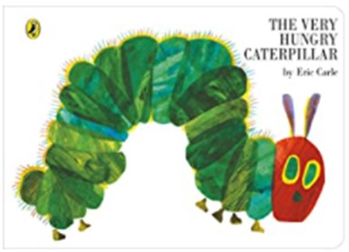 | 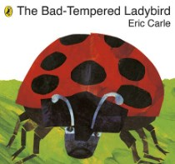 | 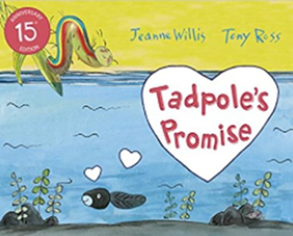 | 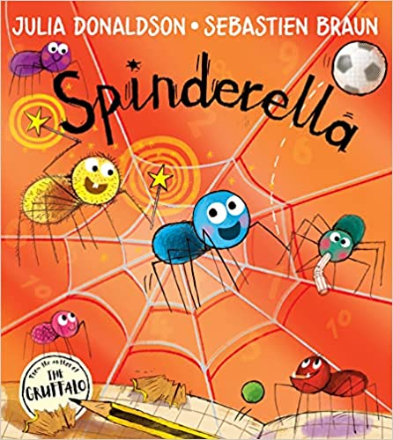 | 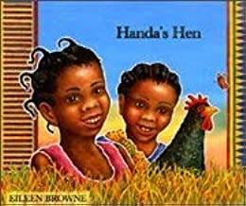 | 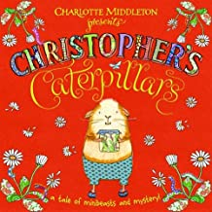
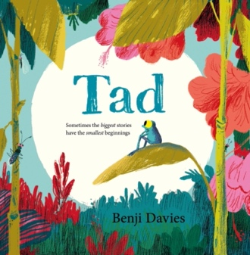 | 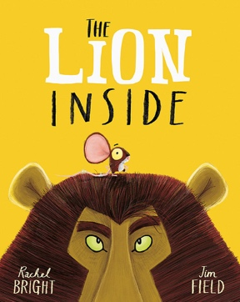 | 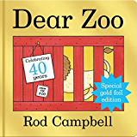 | 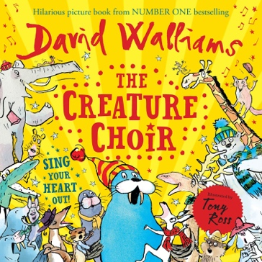 | 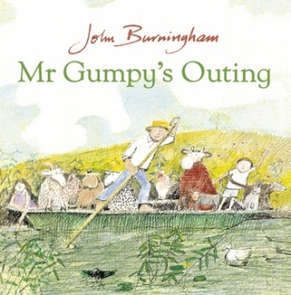 | 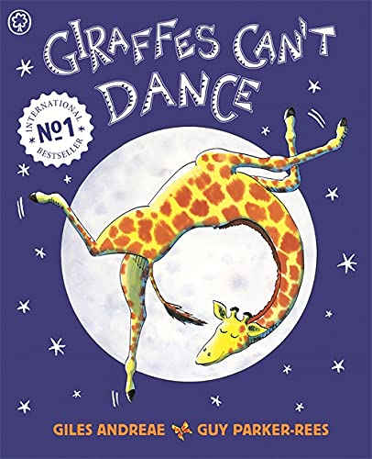
Non-Fiction
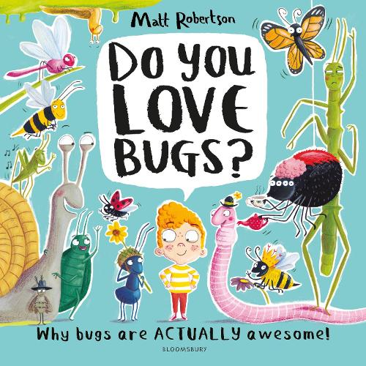 | 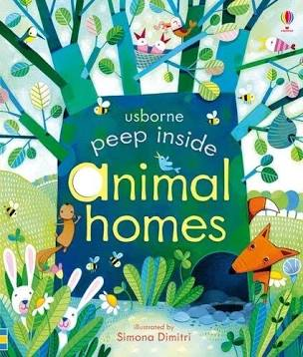 | 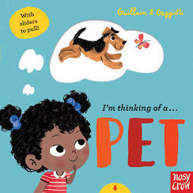 | 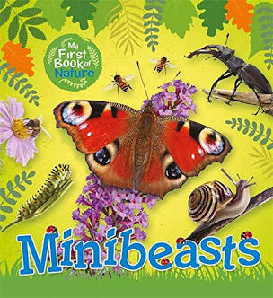 | 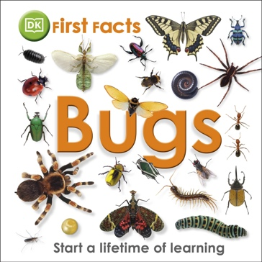 | 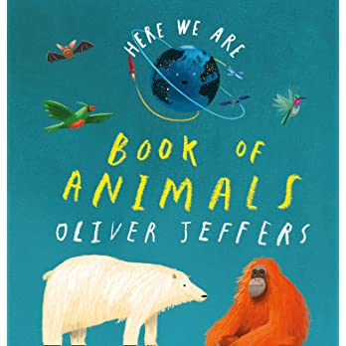

EYFS Additional Reading for Pleasure, including Poetry and Rhyme
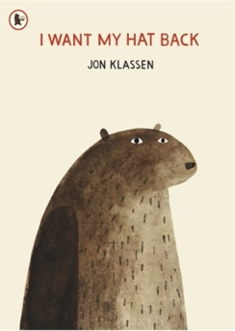 | 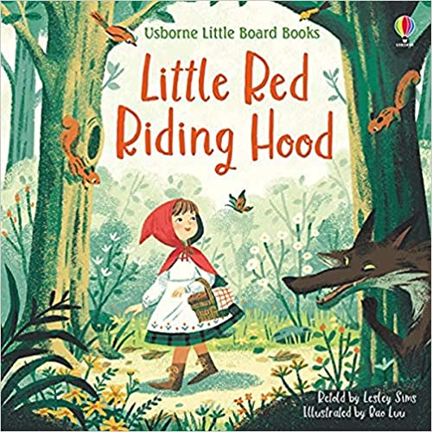 | 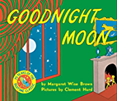 | 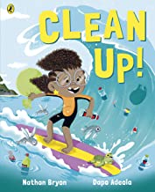 | 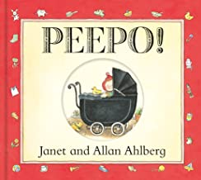 | 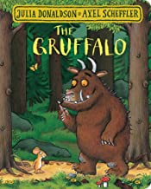
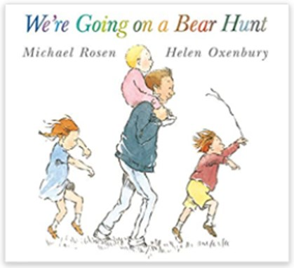 | 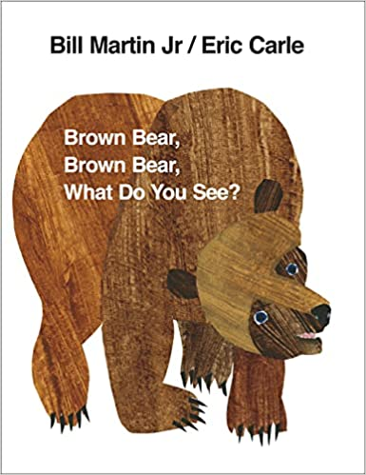 | 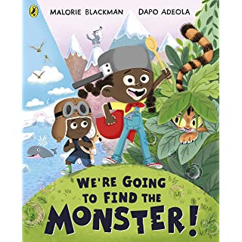 | 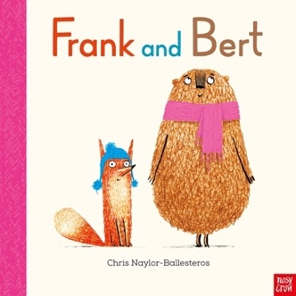 | 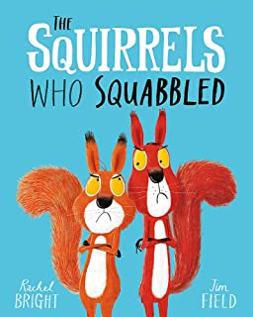 | 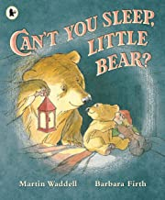
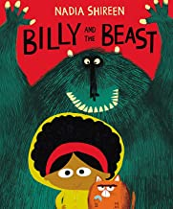 | 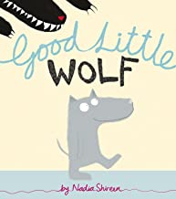 | 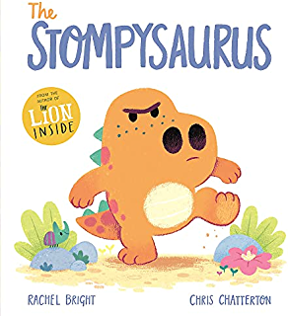 | 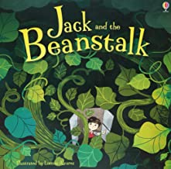 | 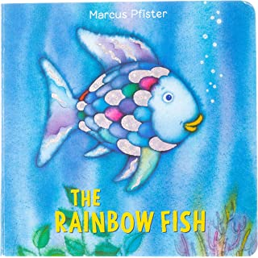 | 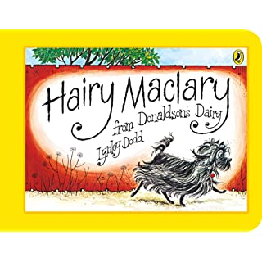
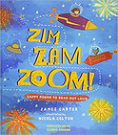 | 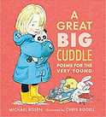 | 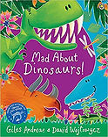 | 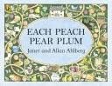 | 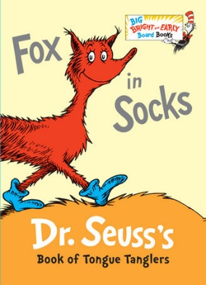 | 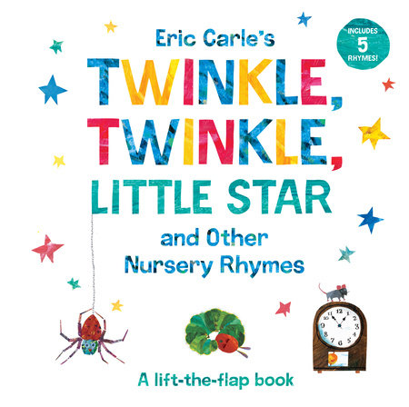
Year 1 & Year 2 Book Spine

Year 1 & Year 2 Whole Class Reads/Literature Spine – Cycle 1
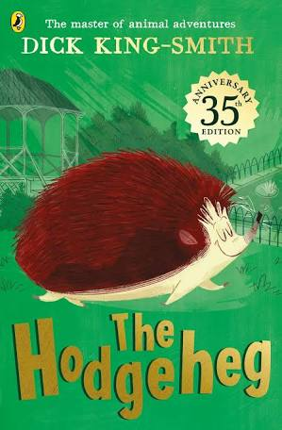 | 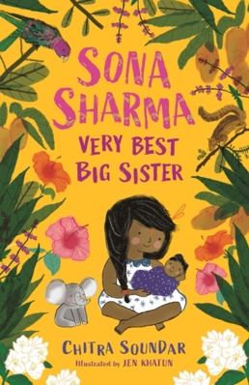 | 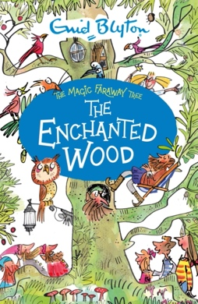 | 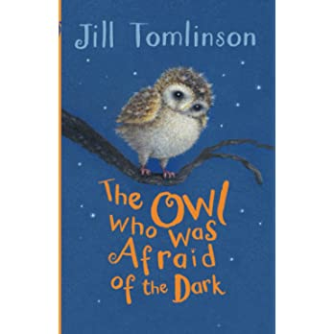 | 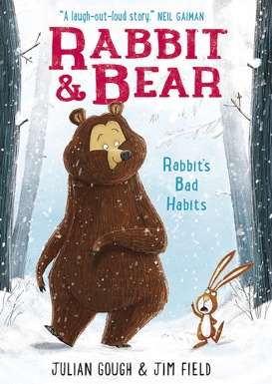 | 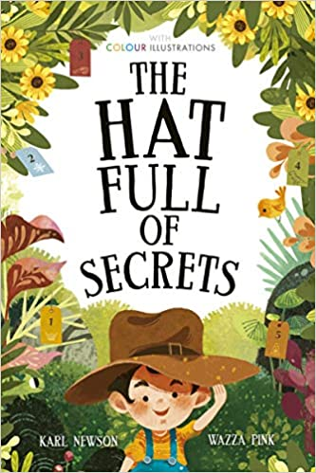
The Hodgeheg | Sona Sharma Very Best Big Sister | The Enchanted Wood | The Owl who was Afraid of the Dark | Rabbit and Bear: Rabbit’s Bad habits | The Hat Full of Secrets
Dick King-Smith | Chitra Soundar | Enid Blyton | Jill Tomlinson | Julian Gough & Jim Field | Karl Newson & Wazza Pink

Year 1 & Year 2 Whole Class Reads/Literature Spine – Cycle 2
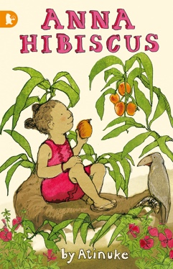 | 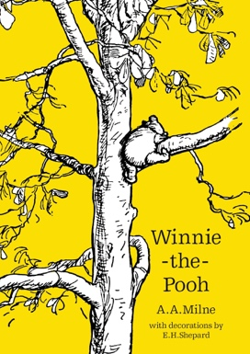 | 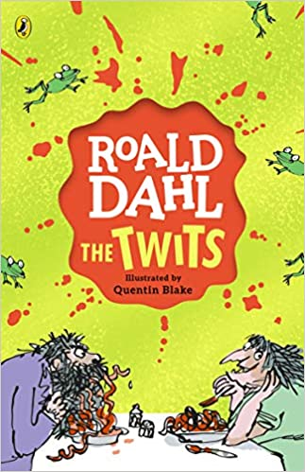 | 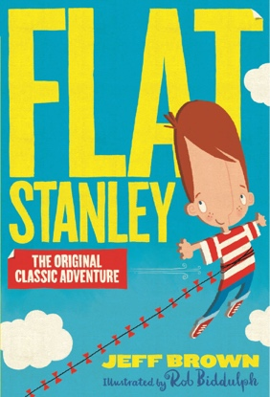 | 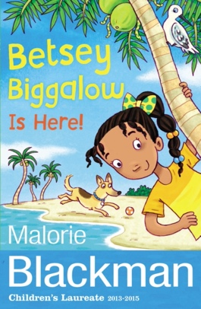 | 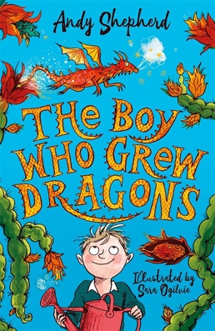
Anna Hibiscus | Winnie the Pooh | The Twits | Flat Stanley | Betsy Biggalow | The Boy Who Grew Dragons
Atinuke | A.A. Milne | Roald Dahl | Jeff Brown | Malorie Blackman | Andy Shepherd

Year 1 & Year 2 English Curriculum Texts – Autumn 1- Cycle 1
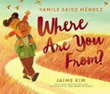 | 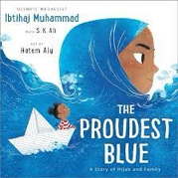 | 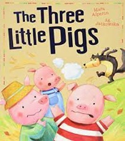 | 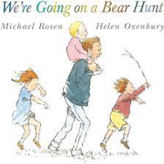 | 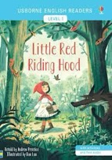 | 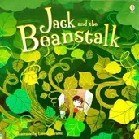
Where are you from? | The Proudest Blue | Three Little Pigs | We’re Going On a Bear Hunt | Little Red Riding Hood | Jack and the Beanstalk
Jaime Kin | Ibtihaj Muhammad | Mara Alperin & Ag Jatkowski | Michael Rosen & Helen Oxenbury | Usborne Classic | Usborne Young Readers

Year 1 & Year 2 English Curriculum Texts – Autumn 2- Cycle 1
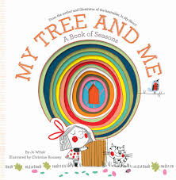 | 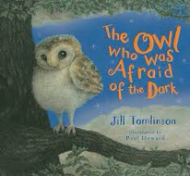 | 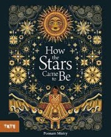 | 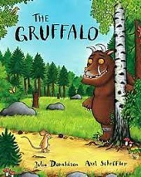
My Tree and Me | The Owl who was Afraid of the Dark | How the stars came to be | The Gruffalo
Jo Witek | Jill Tomlinson | Poonam Mistry | Julia Donaldson

Year 1 & Year 2 English Curriculum Texts – Spring 1- Cycle 1
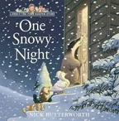 | 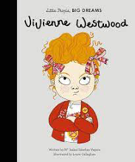 | 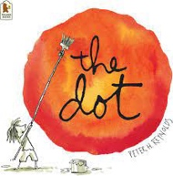 | 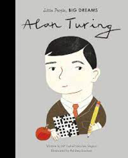
One Snowy Night | Vivienne Westwood | The Dot | Alan Turing
Nick Butterworth | Isabel Sanchez Vegara | Peter H. Reynolds | Isabel Sanchez Vegara

Year 1 & Year 2 English Curriculum Texts – Spring 2- Cycle 1
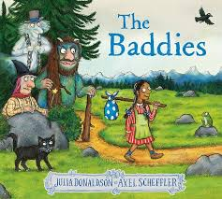 | 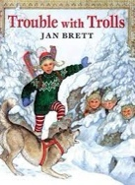 | 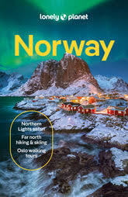 | 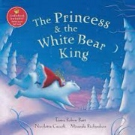
The Baddies | Trouble with Trolls | Travel Guide to Norway | The Princess and the White Bear King
Julia Donaldson | Jan Brett | Lonely Planet | Tanya Robyn Batt

Year 1 & Year 2 English Curriculum Texts – Summer 1- Cycle 1
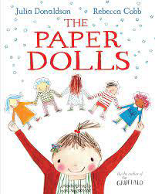 | 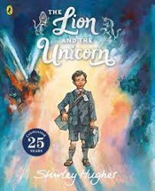
Paper Dolls | The Lion and the Unicorn
Julia Donaldson | Shirley Hughes

Year 1 & Year 2 English Curriculum Texts – Summer 2- Cycle 1
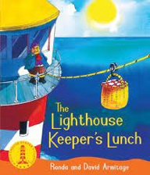 | 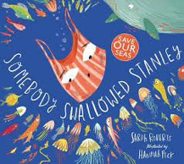 | 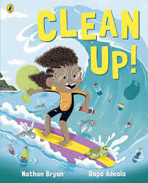 | 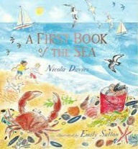
The Lighthouse Keepers Lunch | Somebody Swallowed Stanley | Clean Up | A First Book of the Sea
David and Ronda Armitage | Sarah Roberts | Nathan Bryan | Nicole Davies

Year 1 & Year 2 English Curriculum Texts – Autumn 1- Cycle 2
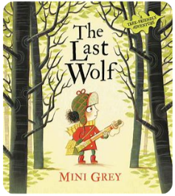 | 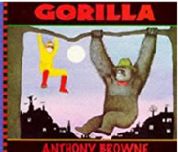 | 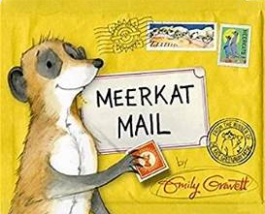 | 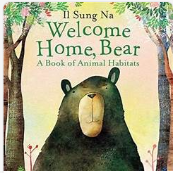 | 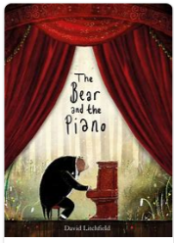
The Last Wolf | Gorilla | Meerkat Mail | Welcome Home Bear | The Bear and the Piano
Mini Grey | Anthony Browne | Emily Gravett | Il Sang Na | David Litchfield

Year 1 & Year 2 English Curriculum Texts – Autumn 2- Cycle 2
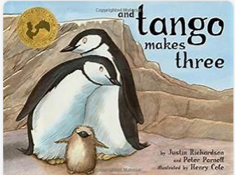 | 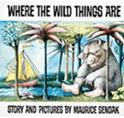 | 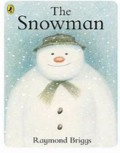
And Tango Makes Three | Where the Wild Things Are | The Snowman
Justin Richardson and Peter Parnell | Maurice Sendak | Raymond Briggs

Year 1 & Year 2 English Curriculum Texts – Spring 1- Cycle 2
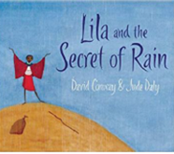 | 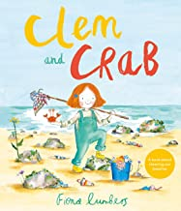 | 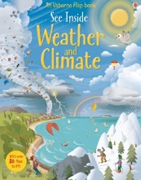
Lila and the Secret of Rain | Clem and Crab | See Inside Weather and Climate
David Conway and Jude Darby | Fiona Lumbers | Katie Daynes

Year 1 & Year 2 English Curriculum Texts – Spring 2- Cycle 2
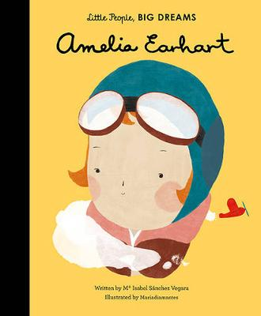 | 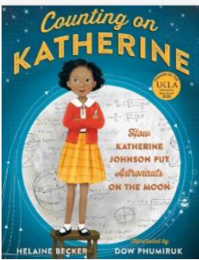 | 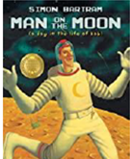 | 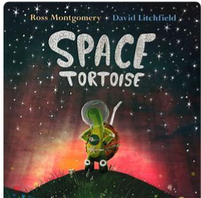 | 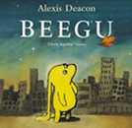 | 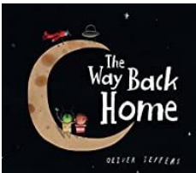
Amelia Earhart | Counting on Catherine | Man on the moon | Space Tortoise | Beggu | The Way Back Home
Isabel Sanchez Vegara | Melanie Becker | Simon Bartram | Ross Montgomery | Alexis Deacon | Oliver Jeffers

Year 1 & Year 2 English Curriculum Texts – Summer 1- Cycle 2
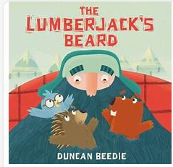 | 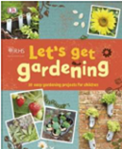 | 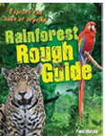
The Lumberjack’s Beard | Let’s get gardening | Rainforest Rough Guide
Duncan Beedie | Royal Horticultural Society | Paul Mason

Year 1 & Year 2 English Curriculum Texts – Summer 2- Cycle 2
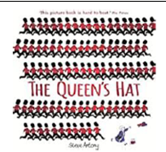 | 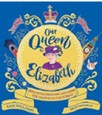 | 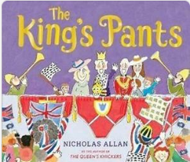
The Queen’s Hat | Our Queen Elizabeth | The Kings Pants
Steve Antony | Kate Williams | Nicholas Allan

Year 1 & Year 2 Curriculum Spine – Cycle 1
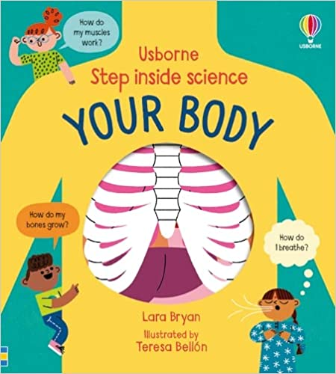 | 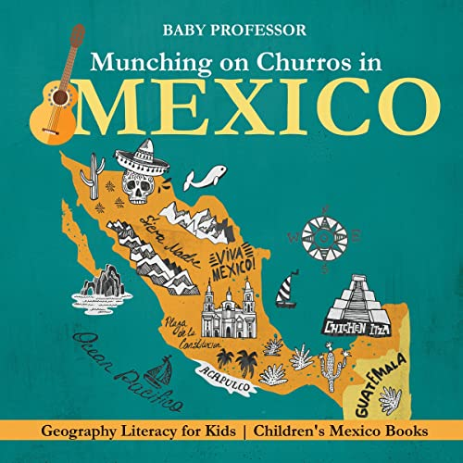 | 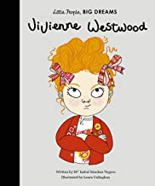 | 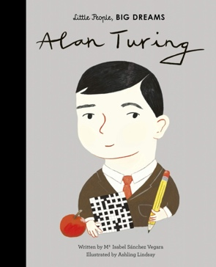 | 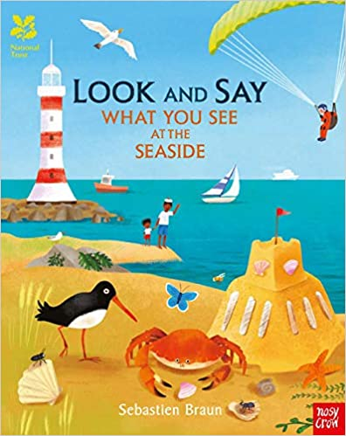 | 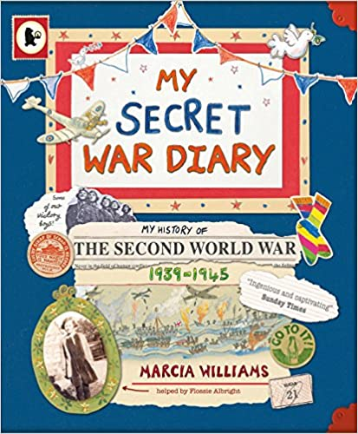
Your Body | Munching on Churros in Mexico | Vivienne Westwood | Alan Turing | Look and Say What you See at the Seaside | My Secret War Diary
Lara Bryan | Baby Professor | Isabel Sanchez Vegara | Isabel Sanchez Vegara | Sebastien Braun | Marcia Williams

Year 1 & Year 2 Curriculum Spine – Cycle 2
 | 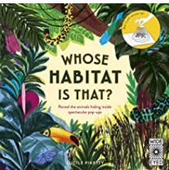 | 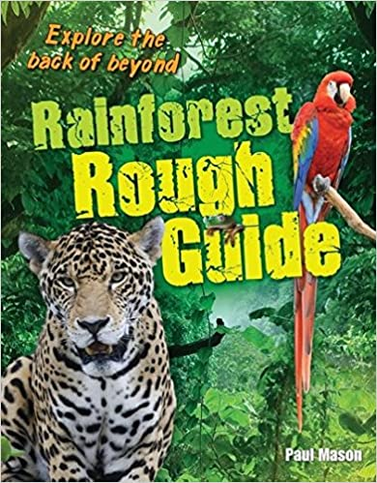 | 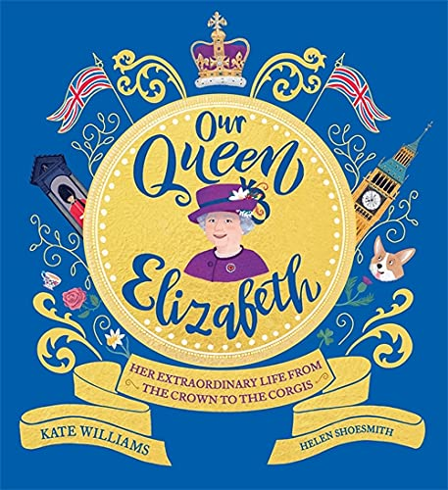 | 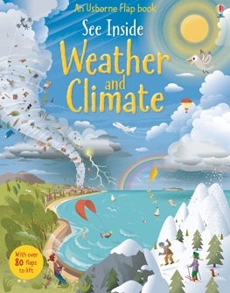 | 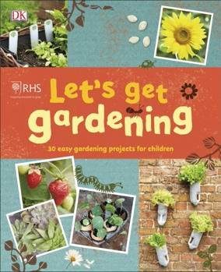
Amelia Earhart | Whose Habitat is That? | Rainforest Rough Guide | Our Queen Elizabeth | See Inside Weather and Climate | Let’s Get Gardening
Isabel Sanchez Vegara | Lucile Piketty | Paul Mason | Kate Williams & Helen Shoesmith | Katie Daynes | DK
Year 1 &Year 2 Poetry Spine – Cycle 1
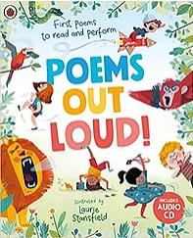 | 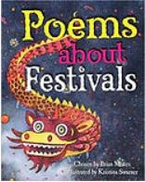 | 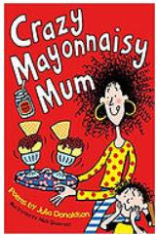 | 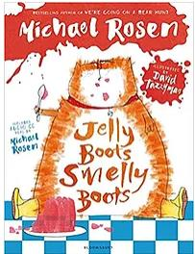 | 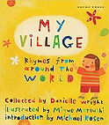
Poems Out Loud | Poems About Festivals | Crazy Mayonnaisy Mum | Jelly Boots Smelly Boots | My Village: Rhymes from Around the World
Laurie Stansfield | Brian Moses & Kristina Swarner | Julia Donaldson | Michael Rosen | Ed. Danielle Wright

Year 1 & Year 2 Poetry Spine - Cycle 2
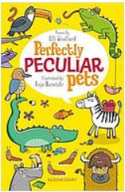 | 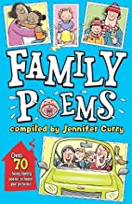 | 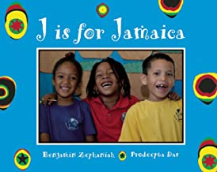 | 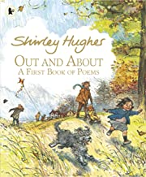 | 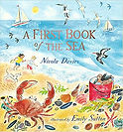
Perfectly Peculiar Pets | Family Poems | J is for Jamaica | Out and About | A First Book of the Sea
Elli Woollard & Anja Boretzki | Ed. Jennifer Curry | Benjamin Zephaniah | Shirley Hughes | Nicole Davies

Year 1 & Year 2 Additional Reading for Pleasure Spine
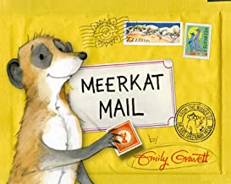 | 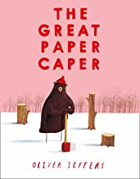 | 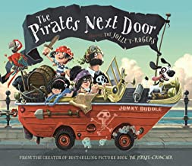 | 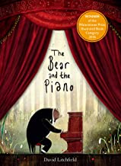 | 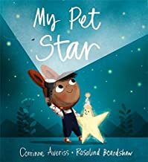 | 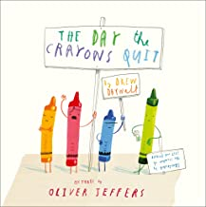
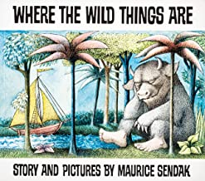 | 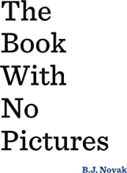 | 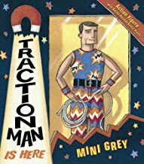 | 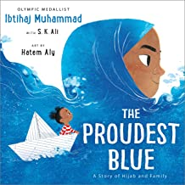 | 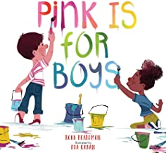 | 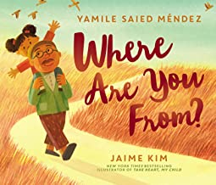
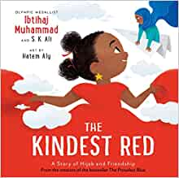 | 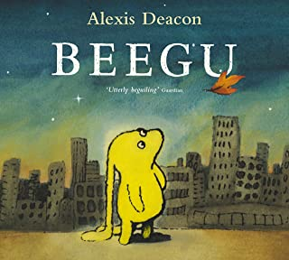 | 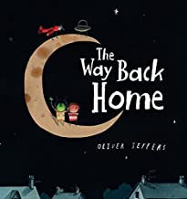 | 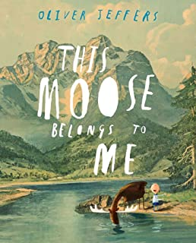 | 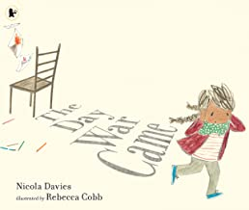 | 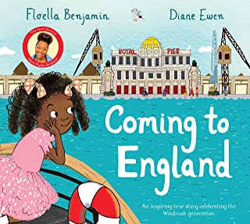
Year 1 & Year 2 Additional Reading for Pleasure (continued)
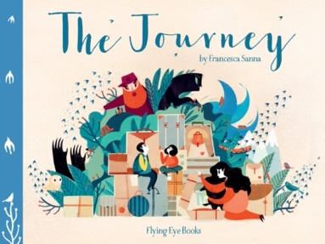 | 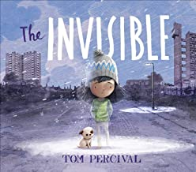 | 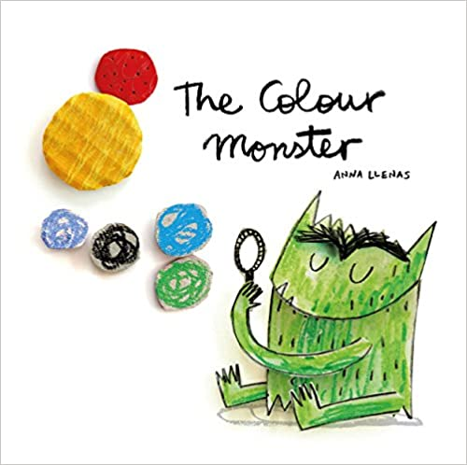 | 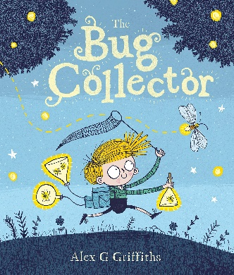 | 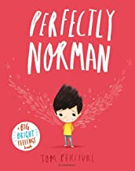 | 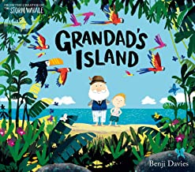
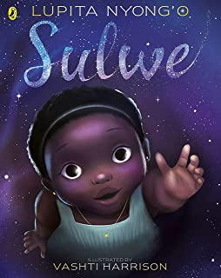 | 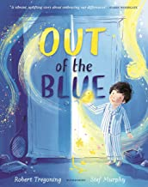 | 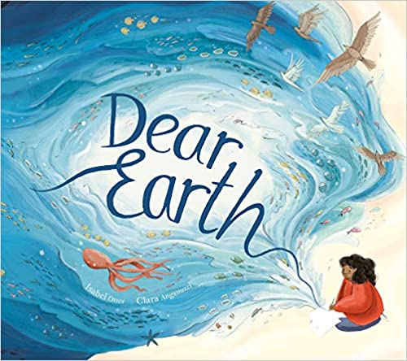 | 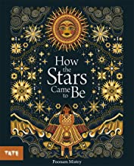 | 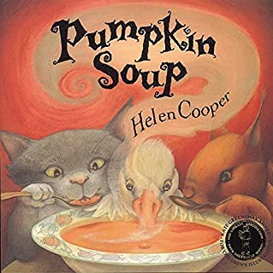 | 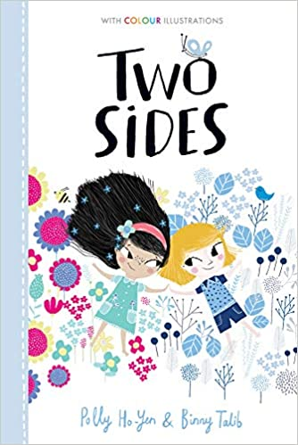

Year 3 & Year 4 Book Spine

Year 3 & Year 4 Whole Class Reads/Literature Spine – Cycle 1
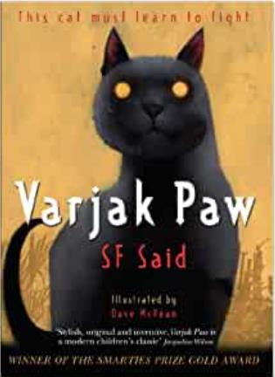 | 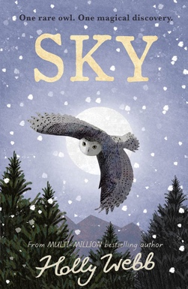 | 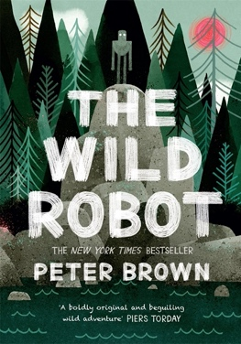 | 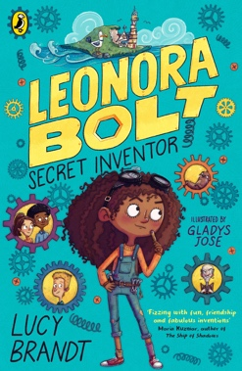 | 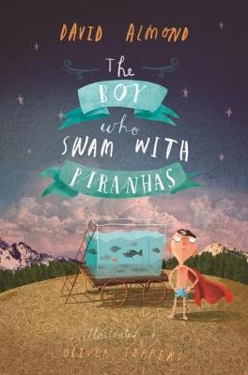 | 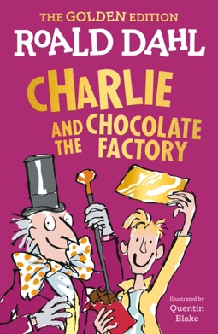
Varjak Paw | Sky | The Wild Robot | Leonora Bolt: Secret inventor | The Boy Who Swam with Piranhas | Charlie and the Chocolate Factory
SF Said | Holly Webb | Peter Brown | Lucy Brandt | David Almond | Roald Dahl

Year 3 & Year 4 Whole Class Reads/Literature Spine – Cycle 2
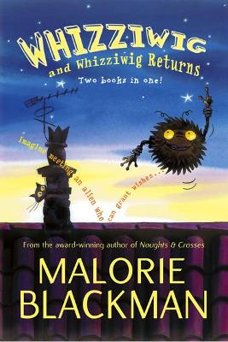 | 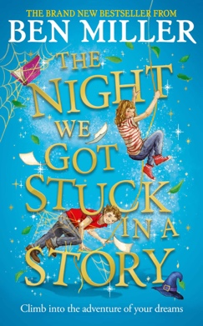 | 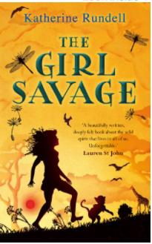 | 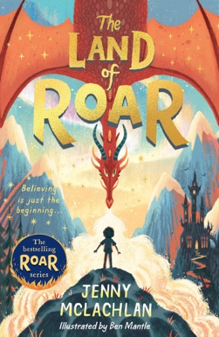 | 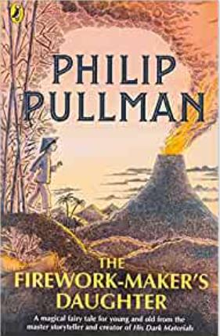 | 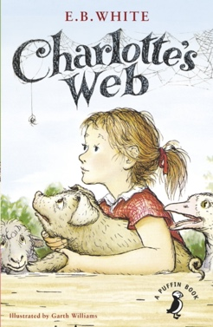
Whizziwig and Whizziwig Returns | The Night We Got Stuck in a Story | The Girl Savage | The Land of Roar | The Firework- Makers Daughter | Charlotte’s Web
Malorie Blackman | Ben Miller | Katherine Rundell | Jenny McLachlin | Phillip Pullman | E. B. White

Year 3 & Year 4 English Curriculum Texts – Autumn 1- Cycle 1
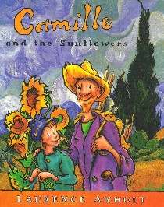 | 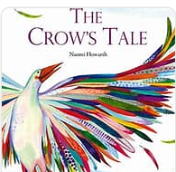 | 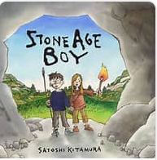 | 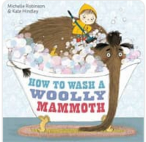 | 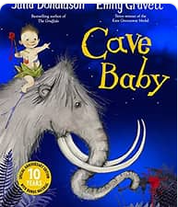
Camille and the Sunflowers | The Crows Tale | Stone Age Boy | How to wash a Woolly Mammoth | Cave Baby
Laurence Anholt | Naomi Howarth | Sitoshi Katamura | Michelle Robinson | Julia Donaldso

Year 3 & Year 4 English Curriculum Texts – Autumn 2- Cycle 1
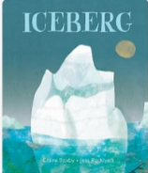 | 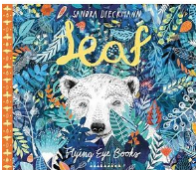 | 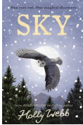
Iceberg | Leaf | Sky
Claire Saxby | Sandra Dieckmann | Holly Webb

Year 3 & Year 4 English Curriculum Texts – Spring 1- Cycle 1
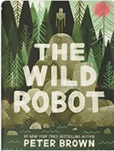 | 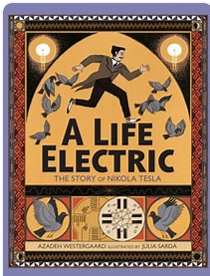
The Wild Robot | A Life Electric
Peter Brown | Azadeh Westergaard

Year 3 & Year 4 English Curriculum Texts – Spring 2- Cycle 1
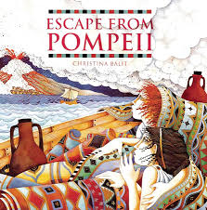 | 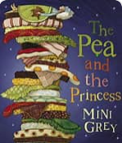
Escape from Pompeii | The Pea and the Princess
Christina Balitt | Mini Grey

Year 3 & Year 4 English Curriculum Texts – Summer 1- Cycle 1
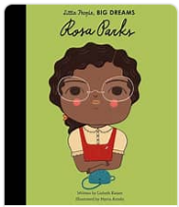 | 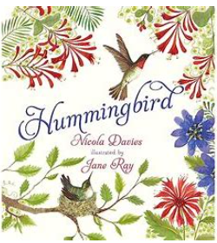
Rosa Parks | Hummingbird
Isabel Sanchez Vegara | Nicola Davies

Year 3 & Year 4 English Curriculum Texts – Summer 2- Cycle 1
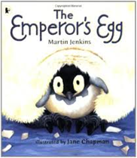 | 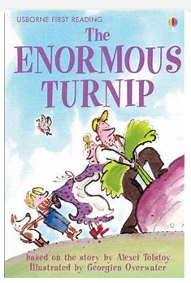 | 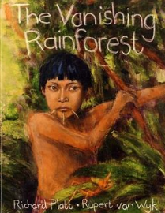 | 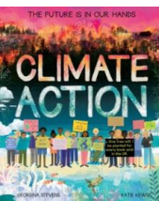 | 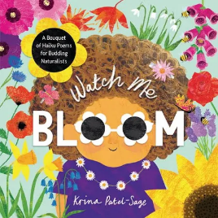
The Emperors Egg | The Enormous Turnip | The Vanishing Rainforest | Climate Action | Watch Me Bloom
Martin Jenkins | Usborne Classic | Richard Platt | Georgina Stevens | Krina Patel- Sage

Year 3 & Year 4 English Curriculum Texts –Autumn 1- Cycle 2
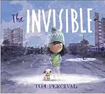 | 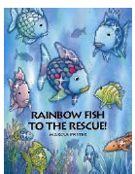 | 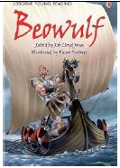 | 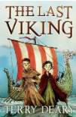
The Invisible | Rainbow Fish to the Rescue | Beowulf | The Last Viking
Tom Percival | Marcus Pfitser | Rob Llloyd Jones | Terry Dears

Year 3 & Year 4 English Curriculum Texts –Autumn 2- Cycle 2
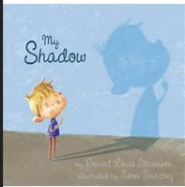 | 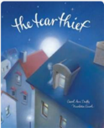 | 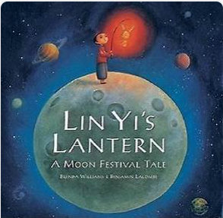
My Shadow | The Tear Thief | Lin Yi’s Lantern
Robert Louis Stephenson | Carol Ann Duffy | Brenda Williams

Year 3 & Year 4 English Curriculum Texts –Spring 1- Cycle 2
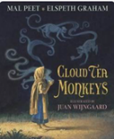 | 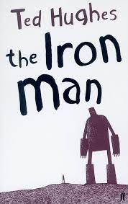 | 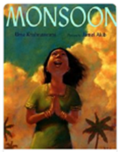 | 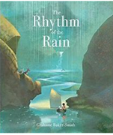
Cloud Tea Monkeys | Iron Man | Monsoon | The Rhythm of the Rain
Mal Peet | Ted Hughes | Uma Krishnaswami | Grahame Baker- Smith

Year 3 & Year 4 English Curriculum Texts –Spring 2- Cycle 2
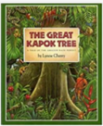
The Great Kapok Tree | The Vanishing Rainforest
Lynne Cherry | Richard Platt

Year 3 & Year 4 English Curriculum Texts –Summer 1- Cycle 2
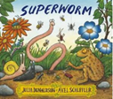 | 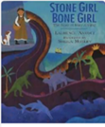 | 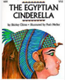
Superworm | Stone Girl Bone Girl | The Egyptian Cinderella
Julia Donaldson | Laurence Anholt | Shirley Climo

Year 3 & Year 4 English Curriculum Texts –Summer 2- Cycle 2
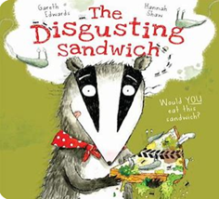 | 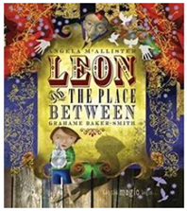
The Disgusting Sandwich | Leon and the place between
Gareth Edwards | Angela McAllister

Year 3 & Year 4 Curriculum Spine – Cycle 1
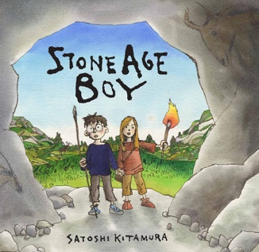 | 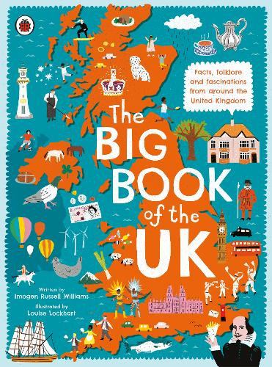 |  | 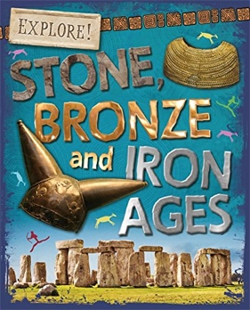 |  | 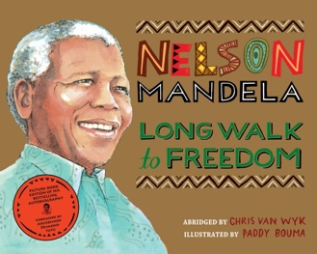 | 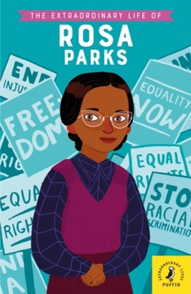 | 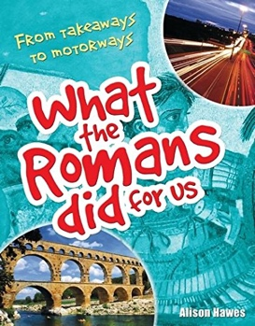
Stone Age Boy | A Big Book of the UK | Stone, Bronze, and Iron Ages |  | Nelson Mandela: Long Walk to Freedom |  | The Extraordinary Life of Rosa Parks | What the Romans did for Us
Satoshi Kitamura | Imogen Russell Williams | Sonya Newland |  | Chris Van Wyk |  | Dr Sheila Kanani | Alison Hawes

Year 3 & Year 4 Curriculum Spine – Cycle 2
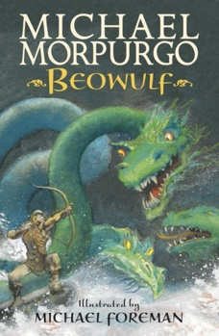 | 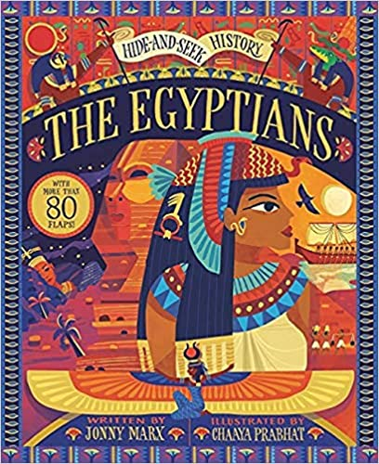 | 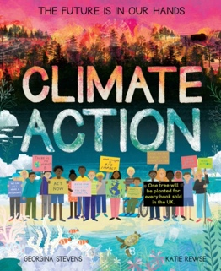 | 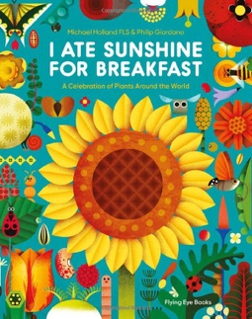 | 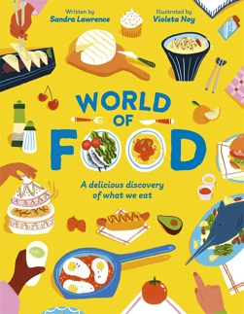 | 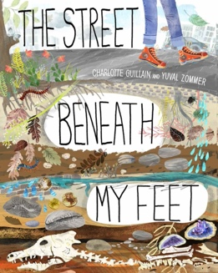
Beowulf | The Egyptians | Climate Action | I Ate Sunshine for Breakfast | World of Food | The Street Beneath My Feet
Michael Morpurgo | Jonny Marx | Georgina Stevens & Katie Rewse | Michael Holland & Philip Giordano | Sandra Lawrence | Charlotte Guillain & Yuval Zommer
Year 3 & Year 4 Poetry and Playscripts Spine – Cycle 1
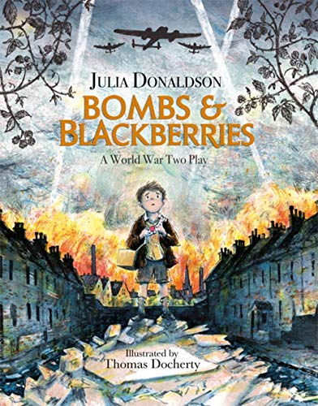 | 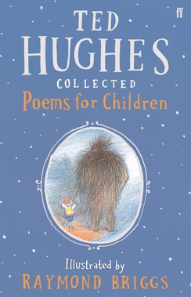 | 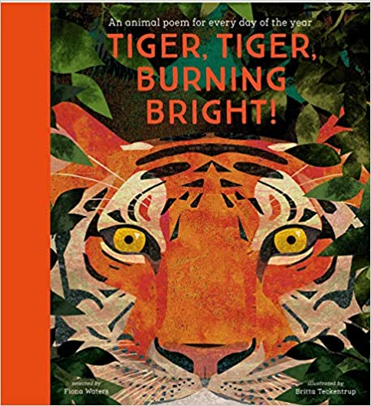 | 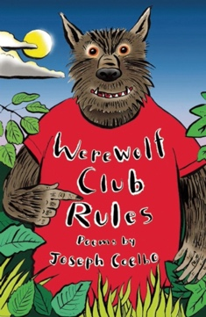 | 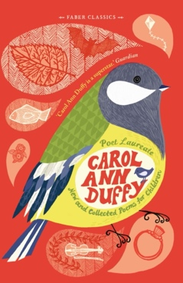 | 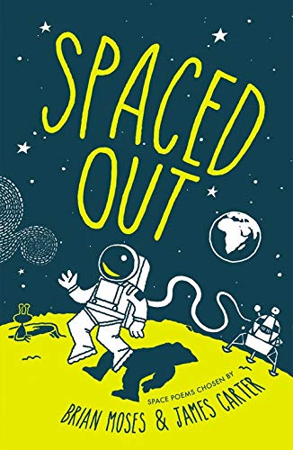
Bomb and Blackberries: A WW2 Play | Collected Poems for Children | Tiger, Tiger Burning Bright | Werewolf Club Rules | New and Collected Poems for Children | Spaced Out
Julia Donaldson | Ted Hughes | Fiona Waters | Joseph Coelho | Carol Ann Duffy | Ed. Brian Moses & James Carter

Year 3 & Year 4 Poetry and Playscripts Spine – Cycle 2
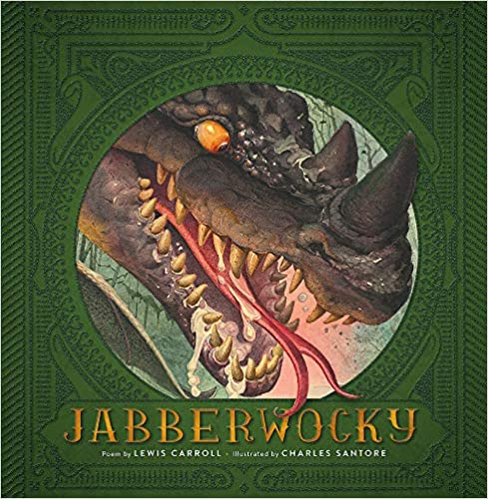 | 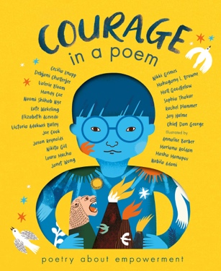 | 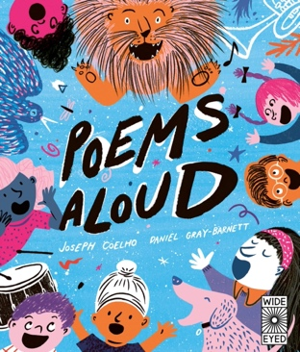 | 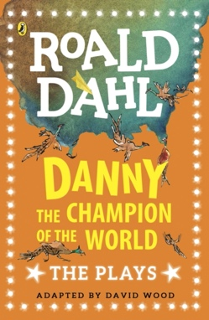 | 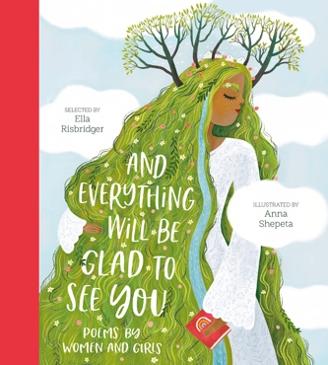 | 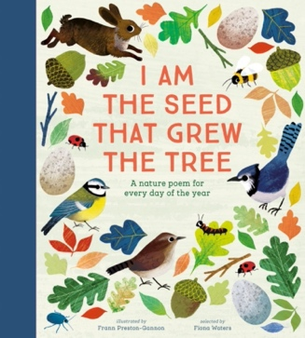
Jabberwocky | Courage in a Poem | Poems Aloud | Danny the Champion of the World: The Plays | And Everything Will Be Glad to See You | I am the Seed that Grew the Tree
Lewis Carroll | Various | Joseph Coelho | Roald Dahl | Ed. Ella Risbridger | Ed. Fiona Waters

Year 5 & Year 6 Book Spine
Year 5 & Year 6 Whole Class Reads/Literature Spine – Cycle 1
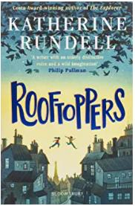 | 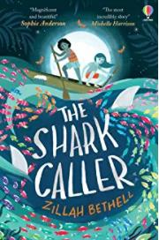 | 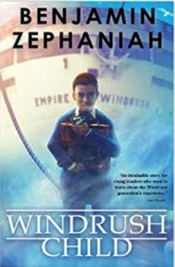 | 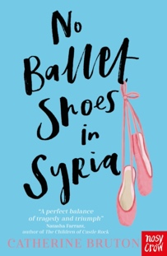
Rooftoppers | The Shark Caller | Windrush Child | No Ballet Shoes in Syria
Katherine Rundell | Zillah Bethell | Benjamin Zephaniah | Catherine Bruton

Year 5 & Year 6 Whole Class Reads/Literature Spine – Cycle 2
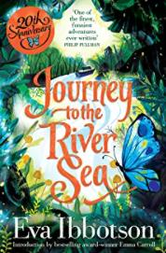 | 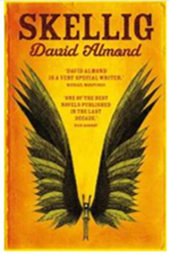 | 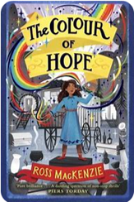 | 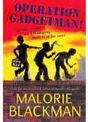
Journey to the River Sea | Skellig | The Colour of Hope | Operation Gadgetman
Eva Ibbotson | David Almond | Ross Mackenzie | Malorie Blackman

Year 5 & Year 6 English Curriculum Texts – Autumn Term - Cycle 1
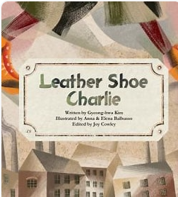 | 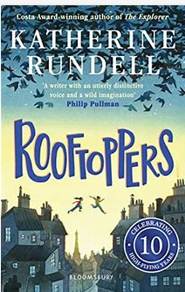 | 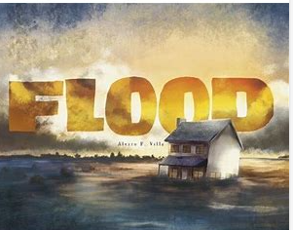 | 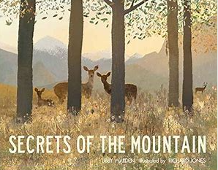
Leather Shoe Charlie | Rooftoppers | Flood | Secrets of the Mountain
Gyeong Hwa Kim | Katherine Rundell | Alvara F Villa | Libby Walden

Year 5 & Year 6 English Curriculum Texts – Spring Term - Cycle 1
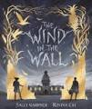 | 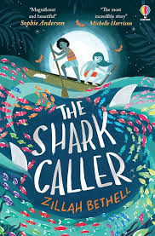 | 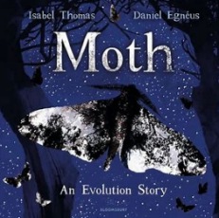 | 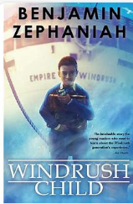
The Wind in the Wall | The Shark Caller | Moth | The Windrush Child
Sally Gardner | Zillah Bethell | Isabel Thomas | Benjamin Zephaniah

Year 5 & Year 6 English Curriculum Texts – Summer Term - Cycle 1
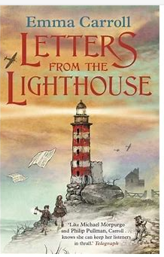 | 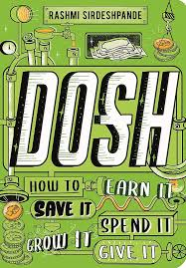 | 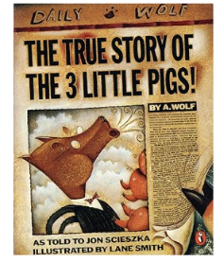 | 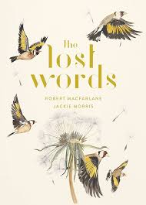
Letters From The Lighthouse | Dosh | The True Story of the 3 little pigs | The Lost Words
Emma Carroll | Rashmi Sirdeshpande | Jon Scieszka | Robert Macfarlane

Year 5 & Year 6 English Curriculum Texts –Autumn 1- Cycle 2
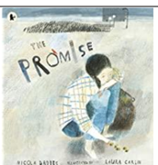 | 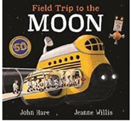 | 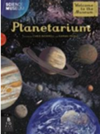
The Promise | Field Trip to the Moon | Planetarium
Nicola Davies | John Hare | Raman Prinja

Year 5 & Year 6 English Curriculum Texts –Autumn 2- Cycle 2
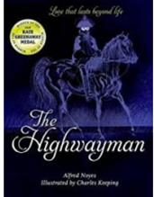 | 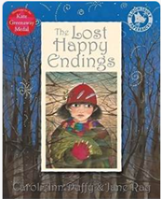 | 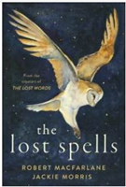
The Highwayman | The Lost Happy Endings | The Lost Spells
Alfred Noyes | Carol Ann Duffy | Robert Macfarlane

Year 5 & Year 6 English Curriculum Texts –Spring 1- Cycle 2
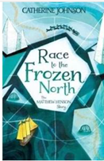 | 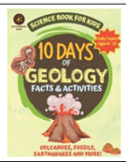 | 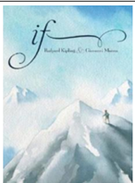
Race to the Frozen North | 10 days of Geology Facts and Activities | If- Poem
Catherine Johnson | Dr Ref | Rudyard Kipling

Year 5 & Year 6 English Curriculum Texts –Spring 2 & Summer 1- Cycle 2
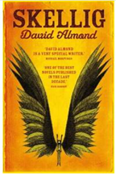
Skellig | The Colour of Hope
David Almond | Ross Mackenzie

Year 5 & Year 6 English Curriculum Texts –Summer 2- Cycle 2
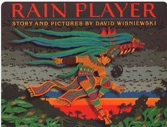 | 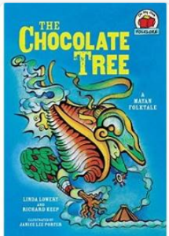 | 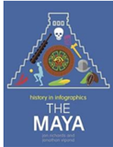
Rain Player | The Chocolate Tree | The Maya
David Wisniewski | Linda Lowery & Richard Keep

Year 5 and Year 6 Curriculum Spine – Cycle 1
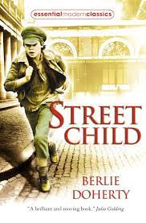 | 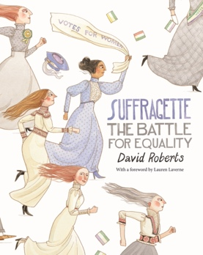 | 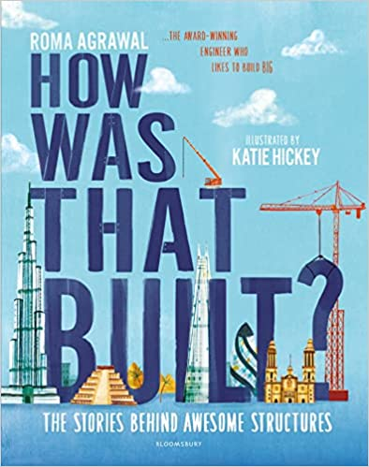 | 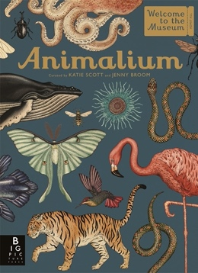 | 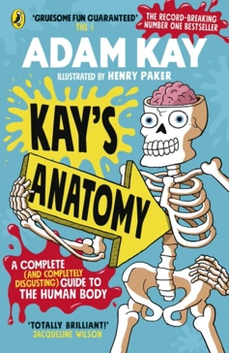 | 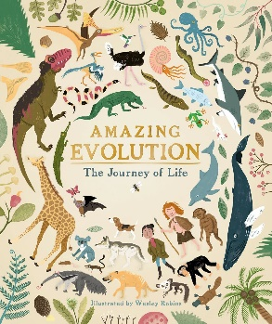
Street Child | Suffragette: The Battle for Equality | How Was That Built? | Animalium | Kaye’s Anatomy | Amazing Evolution
Berlie Doherty | David Roberts | Katie Hickey | Jenny Broom | Adam Kaye | Wesley Robins

Year 5 and Year 6 Curriculum Spine – Cycle 2
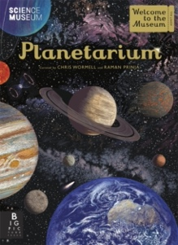 | 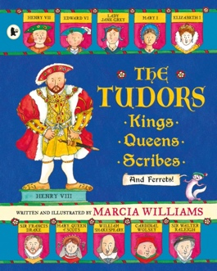 | 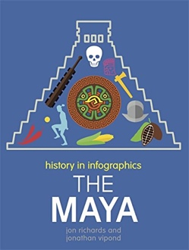 | 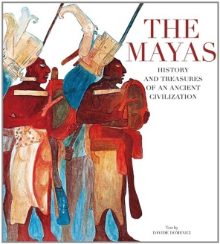 | 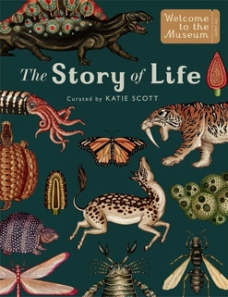 | 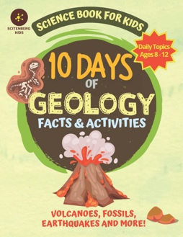
Planetarium | The Tudors: Kings, Queens, Scribes and Ferrets! | The Maya | The Mayas | The Story of Life | 10 Days of Geology
Chris Wormell & Raman Prinja | Marcia Williams | Jon Richards & Jonathon Vipond | Davide Domenici | Katie Scott | Dr. Ref

Year 5 and Year 6 Poetry/Playscripts Spine – Cycle 1
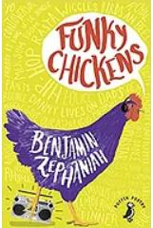 | 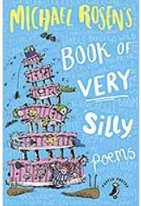 | 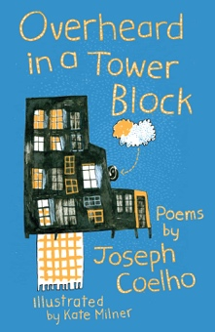 | 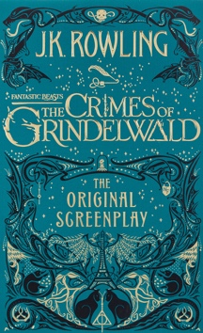 | 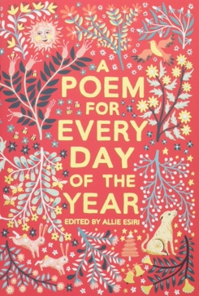 | 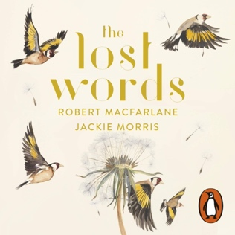
Funky Chicken | Book of very silly poems | Overheard in a Tower Block | The Crimes of Grindlewald: The Original Screenplay | A Poem for Every Day of the Year | The Lost Words
Benjamin Zephaniah | Michael Rosen | Joseph Coelho | J.K. Rowling | Ed. Allie Esiri | Robert MacFarlane & Jackie Morris

Year 5 and Year 6 Poetry/Playscripts Spine – Cycle 2
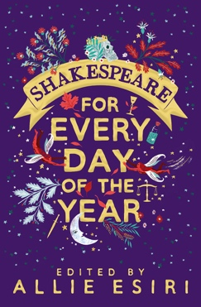 | 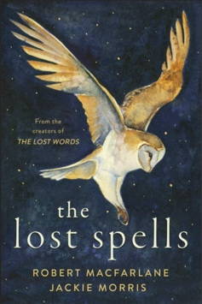 | 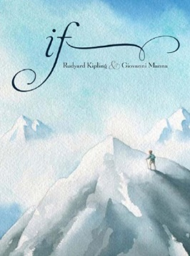 | 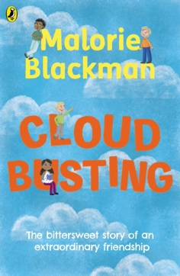 | 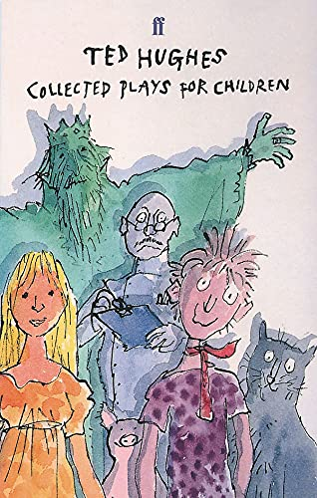 | 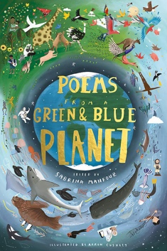
Shakespeare Every Day of the Year | The Lost Spells | If | Cloud Busting | Collected Plays for Children | Poems from a Green and Blue Planet
Ed. Allie Esiri | Robert MacFarlane & Jackie Morris | Rudyard Kipling | Malorie Blackman | Ted Hughes | Ed. Sabrina Mahfouz

